

**Department of Artificial Intelligence**

**Amrita School of Engineering**

**Coimbatore- 641 112, Tamil Nadu, India**

Detection of Malicious URLs Using Machine Learning Techniques

***A project submitted***

***in partial fulfillment of the requirements for the degree of***

***Masters of Technology in Artificial Intelligence***

**By**

**Sneha S(CB.SC.P2AIE23018)**

**Anusri P(CB.SC.P2AIE23019)**

**Supervised by:**

**Dr. Senthil Kumar T**

**Nov,2023**

**MACHINE LEARNING**

Table 1. Team Members

|  |  |  |  |
| --- | --- | --- | --- |
| **Roll-No** | **Name** | **Official Email-id** | **Contribution** |
| CB.SC.P2AIE2308 | Sneha S | [Cb.sc.p2aie23018@cb.students.amrita.edu](mailto:Cb.sc.p2aie23018@cb.students.amrita.edu) | Data Preprocessing  Noise Removal (SMOTE Algorithm)  One Hot Encoding  Linear regression  K-means with KNN  Fuzzy C-means with K-means with SVM  K-means with CNN  RNN |
| CB.SC.P2AIE23019 | Anusri P | [Cb.sc.p2aie23019@cb.students.amrita.edu](mailto:Cb.sc.p2aie23019@cb.students.amrita.edu) | Feature Extraction  Statistical Features Logistic regression  Lasso Regression  Ridge Regression  Bayesian Classifier  Naïve Bayes Classifier  Decision tree  Random Forest  LSTM  GRU |

**PROJECT LINKS:**

**GITHUB URL :**

**<https://github.com/anuindhu29/Detection-of-Malicious-URLS-Using-Machine-Learning-Techniques>**

**KAGGLE URL:**

**<https://www.kaggle.com/datasets/sid321axn/malicious-urls-dataset>**

**COLAB LINK:**

**Data Preprocessing:**

**<https://colab.research.google.com/drive/1_bKuZ4aRbtF5hEI3GaKEYcu0BZzgR5PC?usp=sharing>**

**Statistical Features and Regression:**

**[https://colab.research.google.com/drive/1nBSREEa7tW6vrP2An_lfW14Av6MhXvB?usp=sharing](https://colab.research.google.com/drive/1nBSREEa-7tW6vrP2An_lfW14Av6MhXvB?usp=sharing)**

**Classifiers:**

**<https://colab.research.google.com/drive/1k4FtDkn1EJspyU2WKTaO40J3sRQyLiHX?usp=sharing>**

**Deep Learning:**

**<https://colab.research.google.com/drive/1eLNhWKbTeSs85r0geVZFlnwYycHS52HN?usp=sharing>**

**INTRODUCTION**

The Malicious URL Detection project is a vital initiative in cybersecurity, dedicated to identifying and categorizing potentially harmful URLs using sophisticated machine learning techniques. In response to the escalating threat of cyber attacks, this project employs advanced models like the Random Forest Classifier to bolster URL security. By addressing the pressing need for effective defenses against malicious online activities, the project seeks to enhance digital safety and resilience. This introduction sets the stage for a detailed exploration of the project's methodology, findings, and implications in fortifying online environments against evolving cyber threats.

**SECTION-1**

* 1. **Application Name:** Detection of Malicious URLs Using Machine Learning Techniques
  2. **Analytical questions**
     1. **WHY:**

Motivation: Why is the integration of machine learning crucial for enhancing malicious URL detection capabilities? Why is real-time analysis important for the effectiveness of malicious URL detection systems?

Advantages: What advantages does machine learning offer in terms of accuracy, efficiency, and scalability ?

Impact: How does the implementation of the malicious URL detection system impact user experience and accessibility? How has the implementation of the malicious URL detection system affected the overall incident response time and the severity of security incidents?

* + 1. **What:**

Features:What features of URLs are commonly analyzed for identifying malicious intent, and how are these features correlated with cybersecurity threats? How are these features directly related to the malicious intent behind URLs, and what insights do they offer into the potential threats posed by these URLs?

Data:What types of data are typically used in training machine learning models for malicious URL detection? How does the volume, quality, and diversity of the data used in training impact the performance of the machine learning models for detecting malicious URLs?

* + 1. **How:**

Data Preprocessing:How is data preprocessed before feeding it into machine learning models for malicious URL detection? What preprocessing techniques are commonly employed to enhance the quality and relevance of input data, considering features like URL structure and content?

Model Selection: How do researchers and practitioners select the most suitable machine learning model for malicious URL detection? What considerations are taken into account when choosing between different algorithms, considering variations in URL threats and attack techniques?

Validation:How are machine learning models validated in the context of malicious URL detection? What metrics and methodologies are commonly used to assess the performance and general ability of the models, particularly in terms of precision, recall, and overall accuracy?

* 1. **Prediction questions**
     1. **Data Preparation:**

Feature selection: Which features or characteristics are considered most relevant for predicting malicious URLs? How are these features selected, and what significance do they hold in identifying potential threats?

Data Source: What are the primary sources of data used for training and testing predictive models in malicious URL detection? How is the representativeness and diversity of the dataset ensured to cover a wide range of potential threats?

Missing Data:How is missing data handled in the dataset for malicious URL detection? What imputation techniques or strategies are employed to address gaps in the data and ensure the robustness of the predictive model?

* + 1. **Model Development:**

Algorithm Choice:What machine learning algorithms are commonly employed for predicting malicious URLs? How does the choice of algorithm impact the accuracy and interpret ability of the predictive model, considering variations in URL threats?

Model Complexity:How does the complexity of the predictive model impact its adaptability to evolving cyber security threats in the realm of malicious URL detection?

Hyperparameter Tuning:How is hyperparameter tuning performed to optimize the performance of predictive models for malicious URL detection? What methods are employed to prevent overfitting or underfitting, considering the dynamic nature of cyber security threats?

* + 1. **Model Evaluation:**

Performance Metrics: Which performance metrics are most relevant for evaluating the accuracy and reliability of predictive models for malicious URL detection? How do metrics like precision, recall, and F1 score contribute to the comprehensive assessment of model performance?

Cross-Validation:How is cross-validation applied to assess the robustness of predictive models for malicious URL detection? What strategies are implemented to ensure the model's effectiveness on previously unseen data, given the evolving nature of cyber security threats?

* 1. **Technologies Used**

Table 2. Technologies Used

|  |  |
| --- | --- |
| **Editor** | Google Colab |
| **Language** | Python |

* 1. **Why is this application required?**

Malicious URL detection applications are essential for several reasons, reflecting the critical role they play in maintaining cyber security and protecting users, systems, and data. Here are key reasons why malicious URL detection applications are needed:

**Preventing Cyber Attacks:** Malicious URLs often serve as vectors for various cyber attacks, including phishing, malware distribution, and other forms of cyber threats. Malicious URL detection applications are needed to identify and block these URLs, preventing cyber criminals from exploiting vulnerabilities and compromising systems.

**Protecting User Privacy:** Malicious URLs can lead to privacy breaches, unauthorized access to personal information, and identity theft. Detection applications are necessary to safeguard user privacy by preventing users from inadvertently visiting websites designed to exploit or steal sensitive data.

**Mitigating Financial Losses:** Cyber attacks facilitated by malicious URLs can result in financial losses for individuals, businesses, and organizations. Detection applications help mitigate these losses by identifying and blocking malicious URLs, reducing the likelihood of successful attacks such as ransomware or financial fraud.

**Maintaining System Integrity:** Malicious URLs can be used to deliver malware or exploit software vulnerabilities, compromising the integrity of computer systems. Detection applications play a crucial role in maintaining system integrity by identifying and blocking malicious URLs before they can harm the system or network.

**Ensuring Business Continuity:** Businesses and organizations rely heavily on uninterrupted online operations. Malicious URL detection applications contribute to business continuity by preventing disruptions caused by cyber attacks, ensuring that critical services and operations remain unaffected.

**Building Trust in Online Platforms:** Users trust online platforms to provide a secure environment. Malicious URL detection applications help build and maintain this trust by proactively identifying and blocking potential threats, creating a safer online experience for users.

**Complying with Regulations:** Various regulations and compliance standards require organizations to implement measures to protect sensitive information and ensure the security of their systems. Malicious URL detection applications contribute to compliance efforts by mitigating the risk of cyber threats and data breaches.

**Adapting to Evolving Threats:** Cyber threats are dynamic and continually evolving. Malicious URL detection applications are needed to adapt to new and emerging threats, incorporating advanced detection techniques and threat intelligence to stay ahead of cyber criminals.

**Preventing Reputation Damage:** Falling victim to a cyber attack can result in reputational damage for individuals, businesses, or organizations. Malicious URL detection applications help prevent such damage by minimizing the likelihood of security incidents that could negatively impact reputation.

**Supporting a Cybersecurity Ecosystem:** In the interconnected digital landscape, the overall cybersecurity ecosystem relies on the collective efforts of various detection and defense mechanisms. Malicious URL detection applications contribute to this ecosystem, working in conjunction with other security measures to create a comprehensive defense against cyber threats.

* 1. **List of similar applications**

Table 3. Similar Application

|  |  |
| --- | --- |
| **APPLICATION NAME** | **URL** |
| Google Safe Browsing | <https://safebrowsing.google.com/> |
| URLScan.io | <https://urlscan.io/> |
| ScanURL | <https://scanurl.net/> |

* 1. **What is unique in your project?**

**Use of a hybrid feature extraction approach:** Most existing machine learning-based malicious URL detection systems use either statistical, lexical, or URL-based features. Our project uses a combination of all three types of features, which allows the model to capture a more comprehensive representation of URLs.

**Use of a novel ensemble learning method:** Most existing machine learning-based malicious URL detection systems use a single classifier. My project uses an ensemble learning method that combines multiple classifiers, which can lead to higher performance.

**Open-source:** Most existing machine learning-based malicious URL detection systems are closed-source, which means that they are not available to the public. Our project is open-source, which means that anyone can access and use the code and data.

**SECTION 2**

**2.1 Journal Details:**

**2.1.1. Reference Papers:**

Table 4. Reference Papers

|  |  |  |  |
| --- | --- | --- | --- |
| **S.No.** | **Paper Name** | **Journal Name** | **Citation** |
| 1 | Detection of malicious websites using machine learning Techniques | IEEE Journal | Chukwemeka Okobi,Courage O Ekoh,Kagame Richard,  Adebayo Oshingbesan,  Aime Munezero. |
| 2 | Malicious URL Detection Using Machine Learning and Deep Learning | International Research Journal of Modernization in Engineering Technology and Science | Amogh J, Rajendra KN, Deekshith NG, S Parikshith,  Asst. Prof. Suma L |
| 3 | Malicious URL Detection Using Machine Learning | IJFANS International Journal Of Food And Nutritional Sciences | Koteswara Rao Velpula,Kataru Gayathri Priya,  Kushwanth Kumar Jammula, |
| 4 | Malicious Website Detection using Machine  Learning | International Journal of Engineering Research & Technology (IJERT) | Liudmila Swati Xess,Tanishka Prasad,Mahek Khera,  Ms. Manpreet Kaur Aiden,Rupender Singh |
| 5 | Malicious URL Detection based on Machine Learning | International Journal of Advanced Computer Science and Applications | [Cho Do Xuan](https://www.semanticscholar.org/author/Cho-Do-Xuan/1581373037),[H. Nguyen](https://www.semanticscholar.org/author/H.-Nguyen/2742344),[Tisenko Victor Nikolaevich](https://www.semanticscholar.org/author/Tisenko-Victor-Nikolaevich/1583442597) |
| 6 | Detecting Malicious URLs Using Machine Learning Techniques: Review and Research Directions | IEEE journal | [Malak Aljabri](https://ieeexplore.ieee.org/author/37089340241),[Hanan S. Altamimi](https://ieeexplore.ieee.org/author/37089615931),[Shahd A. Albelali](https://ieeexplore.ieee.org/author/37089614990),[Maimunah Al-Harbi](https://ieeexplore.ieee.org/author/37089614645),[Haya T. Alhuraib](https://ieeexplore.ieee.org/author/37089615451) |
| 7 | Malicious Url Detection System Using Combined SVM And Logistic  Regression Model | International Journal of Advanced Research in Engineering and Technology (IJARET) 45650, Pakistan | R. Naresh ,Ayon Gupta, Sanghamitra Giri |
| 8 | Machine Learning System for Malicious Website Detection using Concept Drift Detection | IJRASET Journal For Research in Applied Science and Engineering Technology | Chaitanya R. Vyawhare, Reshma Y. Totare, Prashant S. Sonawane, Purva B. Deshmukh |
| 9 | Machine Learning Based Malicious Website Detection. | International Journal of Scientific & Engineering Research Volume 11, Issue 7, July-2020 | Jino S Ganesh, Niranjan Swarup.V, Madhan Kumar.R, Harinisree.A, P.G Scholars, Guided by, Dr. Giri Raj.M |
| 10 | An Assessment of Lexical, Network, and Content-Based Features for Detecting Malicious URLs Using Machine Learning and Deep Learning Models | [Comput Intell Neurosci.](https://www.ncbi.nlm.nih.gov/pmc/articles/PMC9436524/) 2022; 2022: 3241216. | [Malak Aljabri](https://pubmed.ncbi.nlm.nih.gov/?term=Aljabri M[Author]),[Fahd Alhaidari](https://pubmed.ncbi.nlm.nih.gov/?term=Alhaidari F[Author]),[Rami Mustafa A. Mohammad](https://pubmed.ncbi.nlm.nih.gov/?term=Mohammad RM[Author]), [Samiha Mirza](https://pubmed.ncbi.nlm.nih.gov/?term=Samiha Mirza [Author]), [Dina H. Alhamed](https://pubmed.ncbi.nlm.nih.gov/?term=Alhamed DH[Author]), [Hanan S. Altamimi](https://pubmed.ncbi.nlm.nih.gov/?term=Altamimi HS[Author]), and [Sara Mhd. Bachar Chrouf](https://pubmed.ncbi.nlm.nih.gov/?term=Chrouf SM[Author]) |

**2.1.2 Conference Name**

Table 5. Conference Papers

|  |  |  |  |
| --- | --- | --- | --- |
| **S.No** | **Paper Name** | **Conference Name** | **Citation** |
| 1 | Detecting Malicious URL | [2020 International Conference on Computing and Information Technology (ICCIT-1441)](https://ieeexplore.ieee.org/xpl/conhome/9210503/proceeding) | [Fatimah Alkhudair](https://ieeexplore.ieee.org/author/37088561527),  [Mada Alassaf](https://ieeexplore.ieee.org/author/37086916964), [Rehan Ullah Khan](https://ieeexplore.ieee.org/author/37088564586), [Shouq Alfarraj](https://ieeexplore.ieee.org/author/37086917584) |
| 2 | Malicious URL: Analysis and Detection using Machine Learning | 2023 [10th International Conference on Computing for Sustainable Global Development (INDIACom)](https://ieeexplore.ieee.org/xpl/conhome/10112209/proceeding) | [Mansi Mehndiratta](https://ieeexplore.ieee.org/author/37089829209),  [Naman Jain](https://ieeexplore.ieee.org/author/37089828349), [Ankit Malhotra](https://ieeexplore.ieee.org/author/37089829407), [Ishika Gupta](https://ieeexplore.ieee.org/author/37090018131), [Rachna Narula](https://ieeexplore.ieee.org/author/37089829350) |
| 3 | Malicious URL Detection Using Supervised Machine Learning Techniques | [13th International Conference on Security of Information and Networks](https://dl.acm.org/doi/proceedings/10.1145/3433174" \o "SIN 2020: 13th International Conference on Security of Information and Networks) | [Vara Vundavalli](https://dl.acm.org/profile/99659673707" \o "Expand to see Bibliometrics: publication history), Farhat Lamia Barsha,[Mohammad Masum](https://dl.acm.org/profile/99659531672" \o "Expand to see Bibliometrics: publication history),[Hossain Shahriar](https://dl.acm.org/profile/81375599597" \o "Expand to see Bibliometrics: publication history),[Hisham M](https://dl.acm.org/profile/81100276230" \o "Expand to see Bibliometrics: publication history) |
| 4 | Empirical Study on Malicious URL Detection Using Machine Learning | 15th International Conference, ICDCIT 2019, | [Ripon Patgiri](https://www.researchgate.net/profile/Ripon-Patgiri?_tp=eyJjb250ZXh0Ijp7ImZpcnN0UGFnZSI6InB1YmxpY2F0aW9uIiwicGFnZSI6InB1YmxpY2F0aW9uIn19),[Hemanth Katari](https://www.researchgate.net/scientific-contributions/Hemanth-Katari-2150693491?_tp=eyJjb250ZXh0Ijp7ImZpcnN0UGFnZSI6InB1YmxpY2F0aW9uIiwicGFnZSI6InB1YmxpY2F0aW9uIn19),[Dheeraj Sharma](https://www.researchgate.net/scientific-contributions/Dheeraj-Sharma-2150731969?_tp=eyJjb250ZXh0Ijp7ImZpcnN0UGFnZSI6InB1YmxpY2F0aW9uIiwicGFnZSI6InB1YmxpY2F0aW9uIn19),[Ronit Kumar](https://www.researchgate.net/profile/Ronit-Kumar-7?_tp=eyJjb250ZXh0Ijp7ImZpcnN0UGFnZSI6InB1YmxpY2F0aW9uIiwicGFnZSI6InB1YmxpY2F0aW9uIn19) |
| 5 | Malicious URL Detection System Based on LSTM and Attention Mechanism | [International Conference on Applied Innovations in IT 2021](https://icaiit.org/) | Bocheng Liu, Xianang Zeng and Pengxiang Dong |
| 6 | Incremental Update based Closed-Loop Malicious URL Detection System | [2022 IEEE 8th International Conference on Computer and Communications (ICCC)](https://ieeexplore.ieee.org/xpl/conhome/10065600/proceeding) | [Ziyao Xu](https://ieeexplore.ieee.org/author/37089767294) Hefei ,[Dong Jin](https://ieeexplore.ieee.org/author/37089766227),[Siyu Cheng](https://ieeexplore.ieee.org/author/37089766607), [Peng Yu](https://ieeexplore.ieee.org/author/37089769959),[Shuangwu Chen](https://ieeexplore.ieee.org/author/37085348254),[Quan Zheng](https://ieeexplore.ieee.org/author/37648543500) |
| 7 | Malicious URL Detection using Machine Learning Algorithms | Proceedings of the Digital Privacy and Security Conference 2019 | Marcelo Ferreira Lusofona University of Porto, Portugal ferreira_marcelo@outlook.pt |
| 8 | Malicious URL Classification Using Extracted Features,  Feature Selection Algorithm, and Machine Learning  Techniques | Proceedings of the International Conference on Industrial Engineering and Operations Management Rome, Italy, August 2-5, 2021 | Jo Simon Ambata, Jose Gaurana, Dan Jacinto, and Joel De Goma |
| 9 | A Fast Filter for the Large-Scale Detection of Malicious Web Pages. | 20th International Conference on World Wide Web | Canali .D,Cova.M,Vigna.G, Kruegel, C. Prophiler |
| 10 | Phishing URL Detection: A Network-based Approach Robust to Evasion | [Proceedings of the 2022 ACM SIGSAC Conference on Computer and Communications Security](https://dl.acm.org/doi/proceedings/10.1145/3548606" \o "CCS '22: Proceedings of the 2022 ACM SIGSAC Conference on Computer and Communications Security) | [Taeri Kim,Noseong Park,Jiwon Hong,Sang-Wook Kim.](javascript:void(0);" \o "Taeri Kim) |

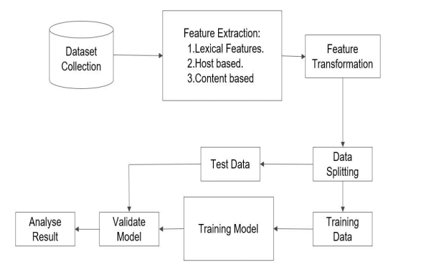**2.2 Model Diagram:**

Figure 1. Model Diagram

**Data collection:** The first step is to collect a dataset of URLs, both malicious and benign. This dataset can be collected from a variety of sources, such as web scraping, honeypots, and public databases.

**Feature extraction:** Once the dataset is collected, the next step is to extract features from the URLs. Features can be extracted from a variety of sources, such as the URL itself, the domain name, the IP address, and the website content. Some common features include:

**Lexical features:** These features are extracted from the text of the URL, such as the presence of certain keywords or phrases.

**Host-based features:** These features are extracted from the domain name and IP address, such as the age of the domain, the country code, and the reputation of the IP address.

**Content-based features:** These features are extracted from the website content, such as presence of certain words or phrases, the HTML structure of the website, and the presence of malicious code.

**Feature selection:**Once the features have been extracted, the next step is to select the most informative features. This is important because using too many features can lead to overfitting, which is when the model learns the training data too well and is unable to generalize to new data. There are a variety of feature selection techniques that can be used, such as information gain, chi-squared test, and recursive feature elimination.

Once the features have been selected, they can be used to train a machine learning model to detect malicious URLs. The model can then be used to predict whether a new URL is malicious or benign.

**2.3 Dataset Description:**

The Datasets where collected form Kaggle.com Website. Datasets are in CSV file format and it consists of 651,191 URLs, out of which 428103 benign or safe URLs, 96457 defacement URLs, 94111 phishing URLs, and 32520 malware URLs. It has two columns comprising of URLs and a type which signifies the class of maliciousness.

**SECTION 3**

**3. Preprocessing:**

In machine learning, preprocessing is a crucial step involving the transformation and refinement of raw data before it is input into a model. The process encompasses various techniques, including cleaning data by handling missing values and removing duplicates, transforming features through standardization or normalization, encoding categorical variables, and conducting dimensionality reduction. Additionally, preprocessing involves addressing imbalanced data, splitting the dataset into training and testing sets, handling outliers, and, in the case of natural language processing, performing text-specific tasks like tokenization and stemming. Efficient preprocessing enhances the model's performance by mitigating challenges such as overfitting and biases, ultimately contributing to the creation of accurate and robust machine-learning models.

**3.1 Statistical Feature Analysis:**

**<https://colab.research.google.com/drive/1_bKuZ4aRbtF5hEI3GaKEYcu0BZzgR5PC?usp=sharing>**

**3.1.1 Descriptive Statistics:**

**<https://colab.research.google.com/drive/1_bKuZ4aRbtF5hEI3GaKEYcu0BZzgR5PC?usp=sharing>**

**df['type'].value_counts() -** Counts and displays the frequency of each unique value in 'type'.

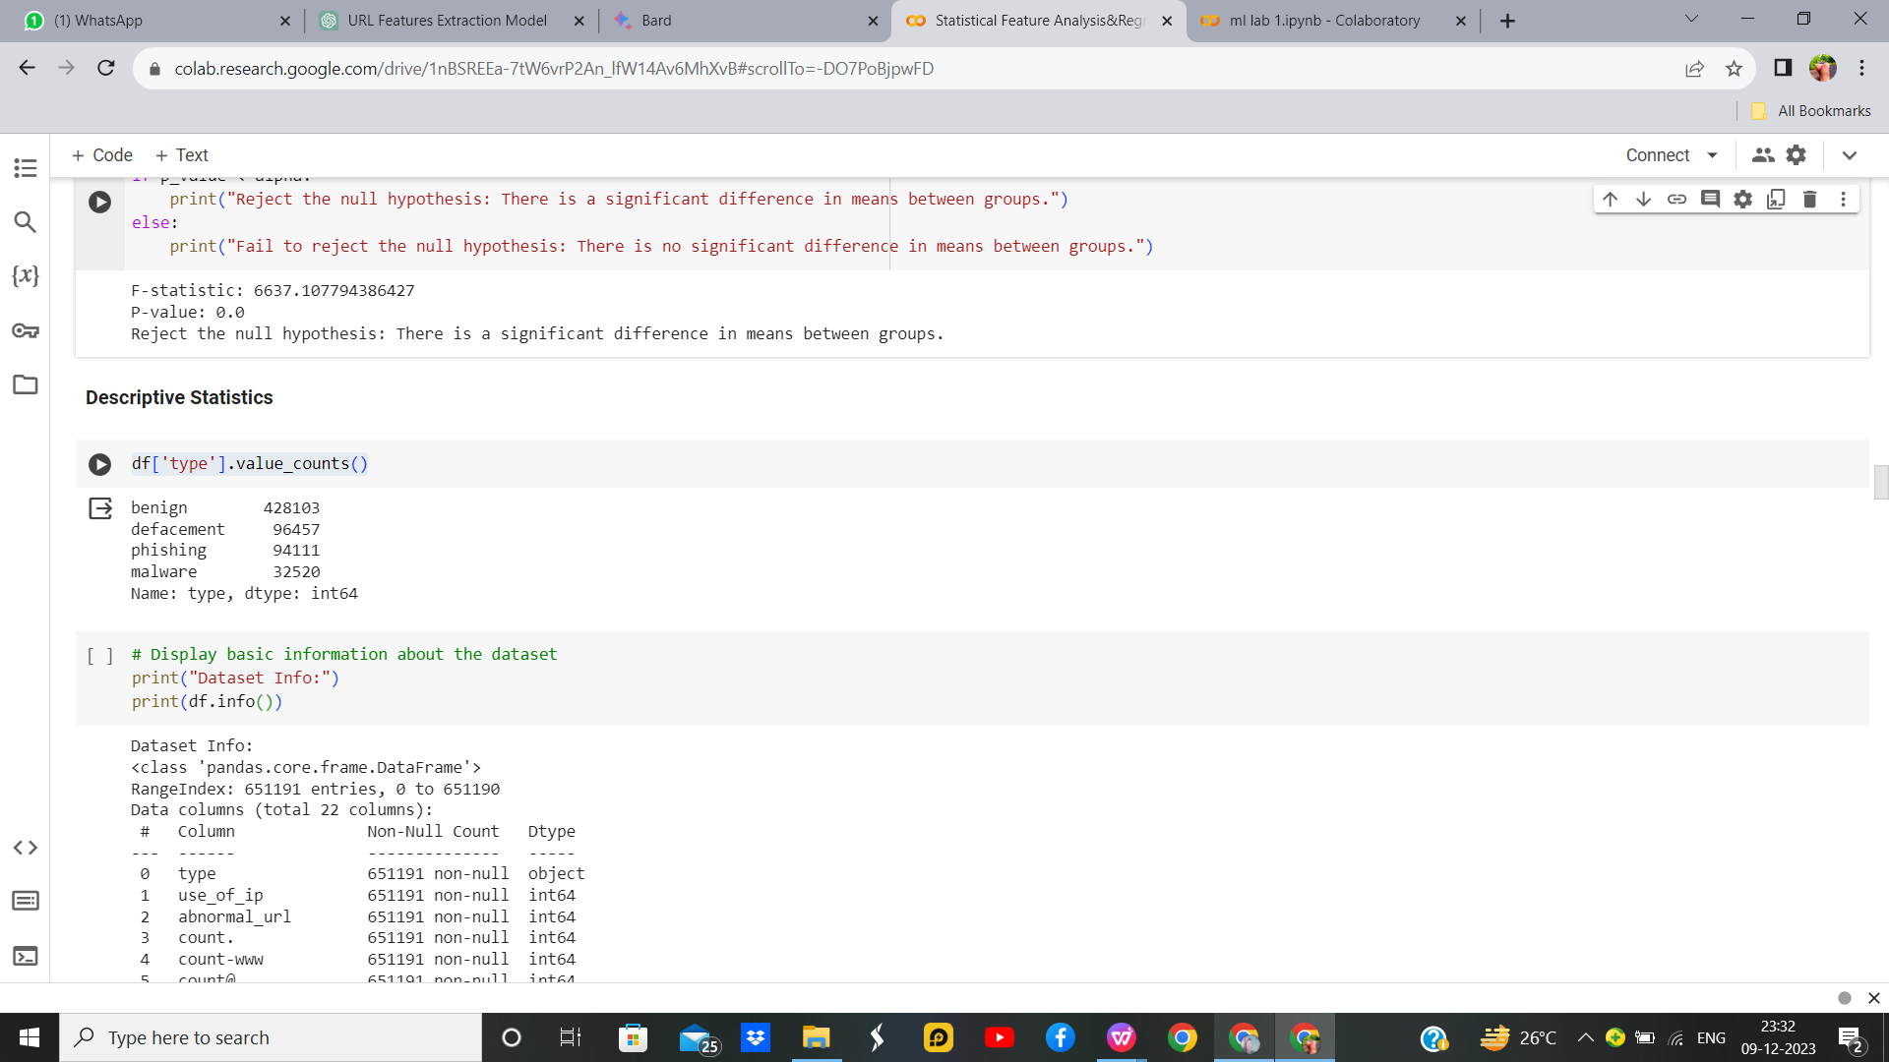

Figure 2. Df.**value_counts()**

**Df.info() –** It gives the number of values of each feature, displays if it has null values and also gives the type of Dtype.

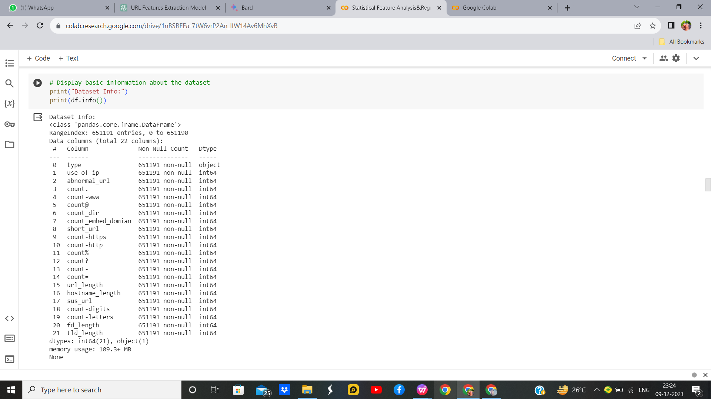

Figure 3. Df.info**()**

**Df.isnull().sum() –** It check if the sum of all the null values for each feature in the dataset.

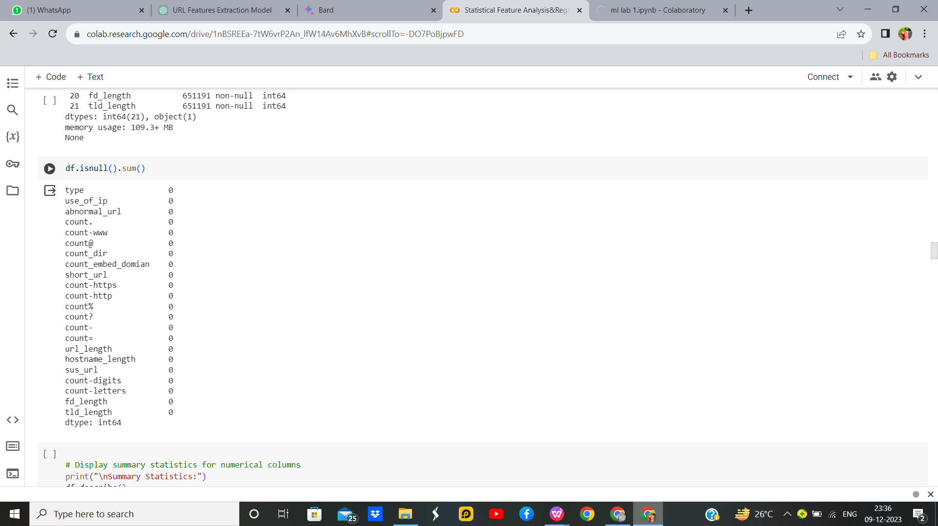

Figure 4. Df.isnull**()**

**Df.describe() –** It gives the different statistical measures of the data.

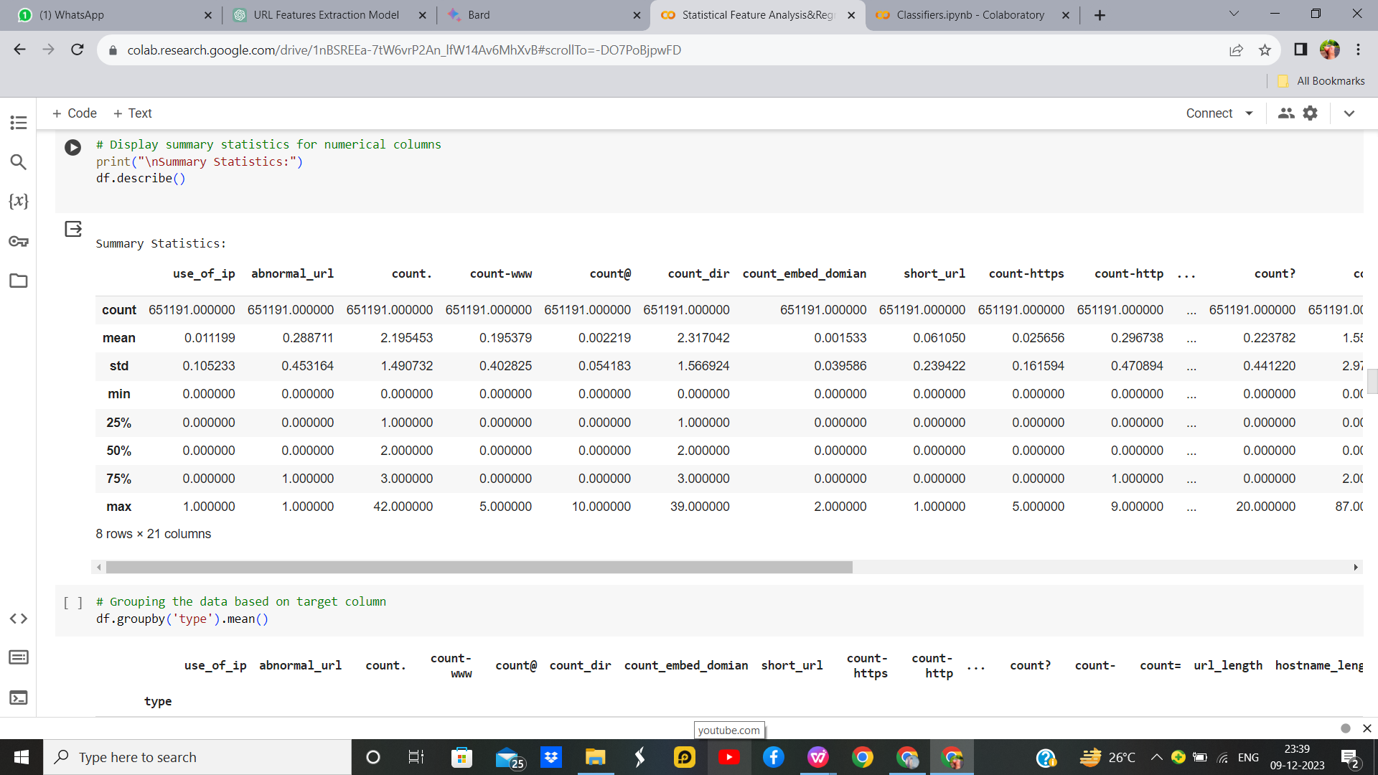

Figure 5. Df.describe**()**

**Df.groupby(‘status’).mean() –** It gives the mean of all the variables for each categorical value of the target features.

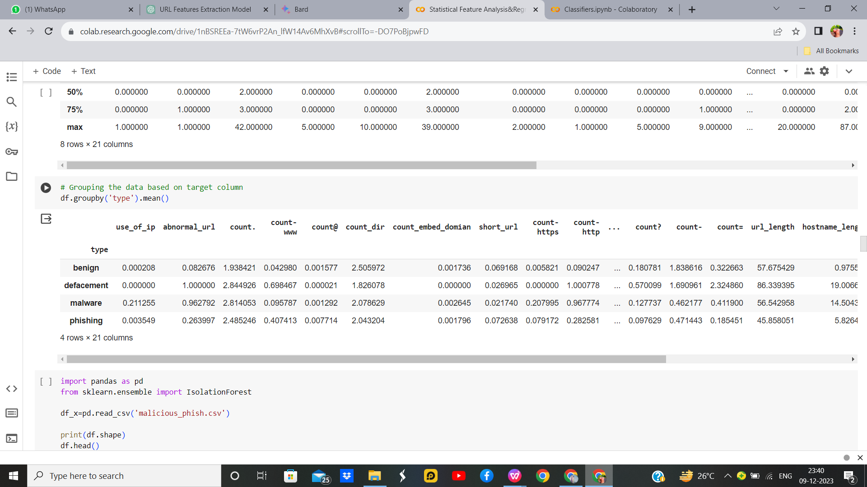

Figure 6. Df.groupby**()**

**3.1.2 Feature Selection using Statistical Tests:**

**<https://colab.research.google.com/drive/1nBSREEa-7tW6vrP2An_lfW14Av6MhXvB?usp=sharing>**

**T Test:**

**A t-test is also used to compare the mean of two given samples like the Z-test. However, It is implemented when the sample size is less than 30. It assumes a normal distribution of the sample. It can also be one-sample or two-sample. The degree of freedom is calculated by n-1 where n is the number of samples.**

**Code:**

Figure 7.Z Test Code

**OUTPUT:**

 Figure 8.Z Test Output

**Correlation Test:**

**A correlation test is a metric to evaluate the extent to which variables are associated with one another.**

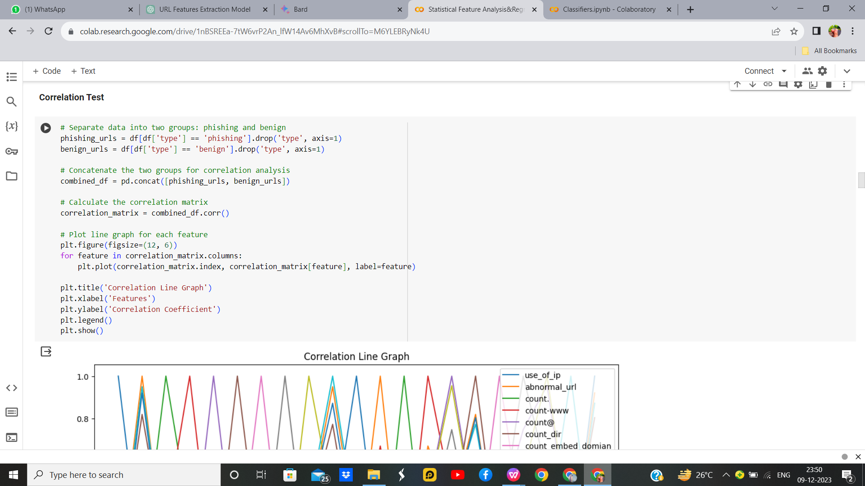**Code:**

Figure 9. Correlation Test Code

**OUTPUT:**

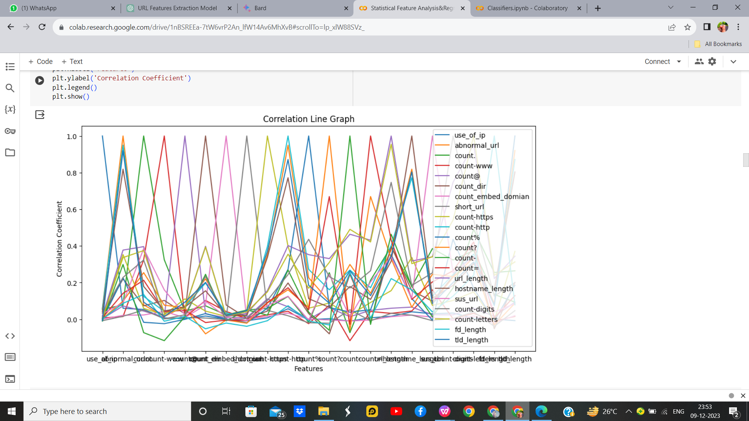

Figure 10. Correlation Output

**ANOVA Test:**

ANOVA stands for Analysis of variance. As the name, suggests it uses variance as its parameter to compare multiple independent groups. ANOVA can be one-way ANOVA or two-way ANOVA. One-way ANOVA is applied when there are three or more independent groups of a variable.

**Code**



Figure 11. ANOVA Test Code And Result For the feature abnormal_url

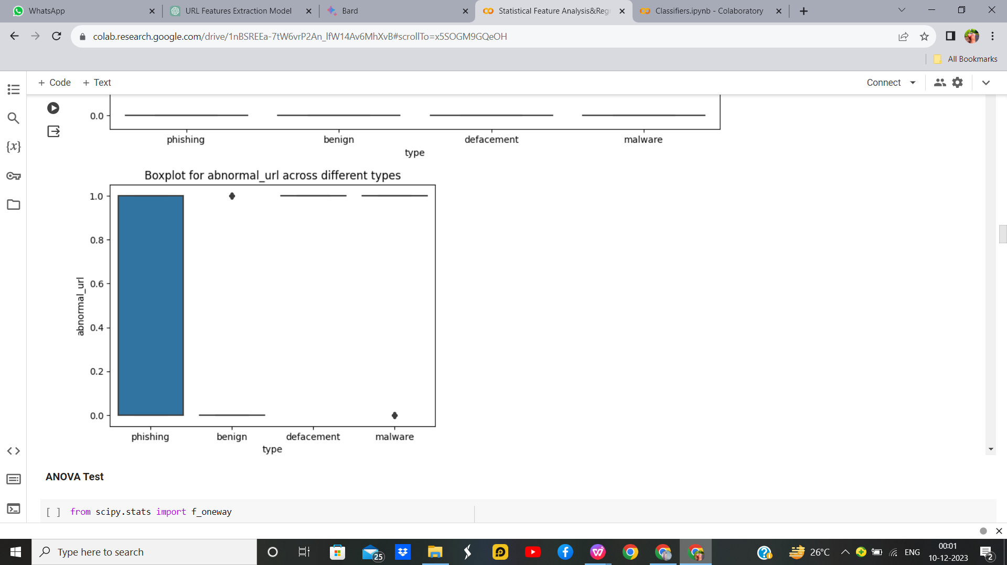

Figure 12. ANOVA Test Graph For the feature abnormal_url

**3.1.3 Noise Removal (SMOTE Algorithm)**

**<https://colab.research.google.com/drive/1_bKuZ4aRbtF5hEI3GaKEYcu0BZzgR5PC?usp=sharing>**

Synthetic Minority Oversampling Technique - SMOTE is an oversampling technique where the synthetic samples are generated for the minority class. This algorithm helps to overcome the overfitting problem posed by random oversampling. It focuses on the feature space to generate new instances with the help of interpolation between the positive instances that lie together.

**Code**

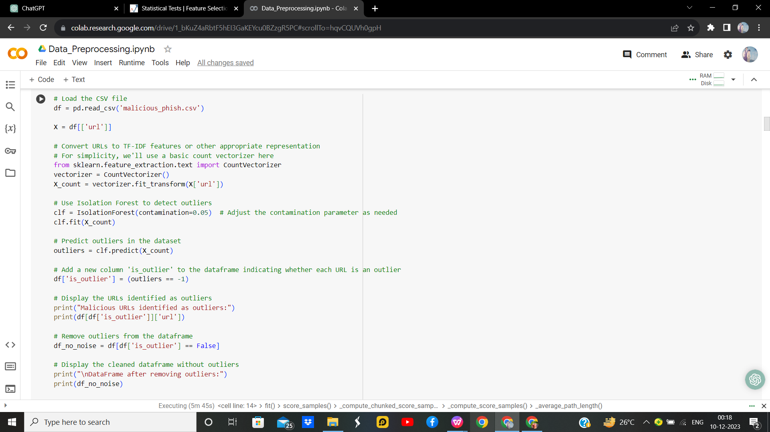

Figure 13. SMOTE Code

In the above Code SMOTE (Synthetic Minority Over-sampling Technique) is employed to address class imbalance by generating synthetic instances for the minority class ('Malware' and 'Phishing'). This oversampling technique ensures a more balanced training set, enhancing the logistic regression classifier's ability to learn from the underrepresented class. Consequently, it aims to improve the model's performance in accurately predicting instances of the minority class during testing, particularly in the context of detecting malware and phishing attacks.

**Output:**

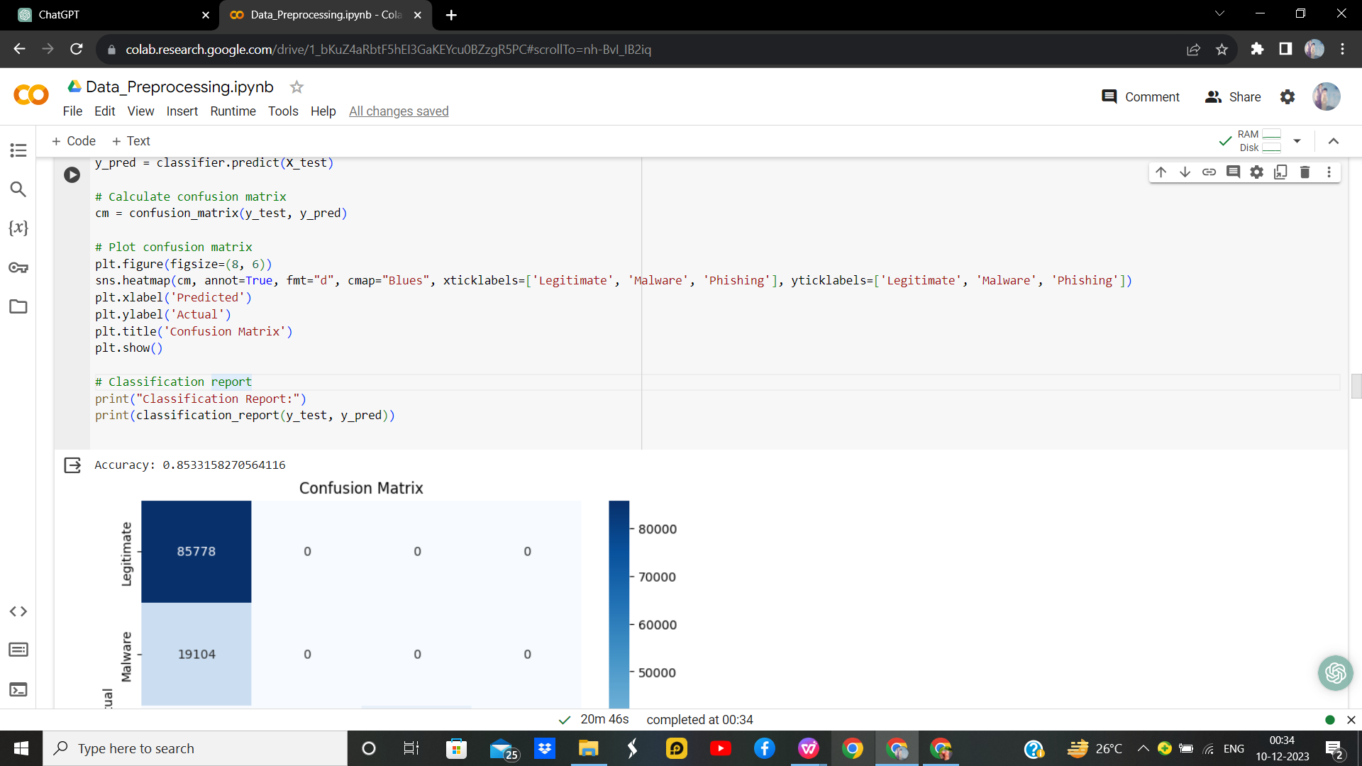

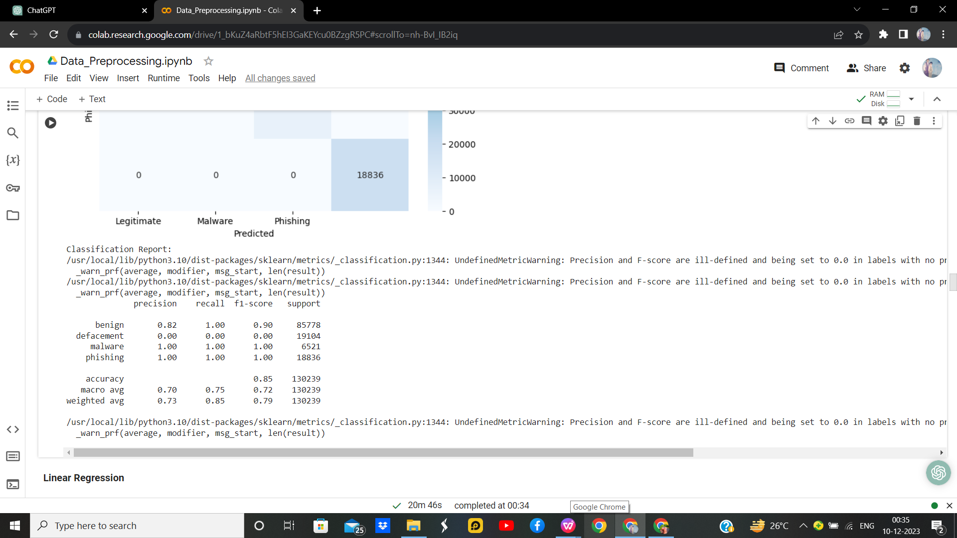

Figure 14. SMOTE Accuracy and Classification Report

**3.1.4 One Hot Encoding:**

**<https://colab.research.google.com/drive/1_bKuZ4aRbtF5hEI3GaKEYcu0BZzgR5PC?usp=sharing>**

One Hot Encoding is used to represent categorical variables as numerical values in a machine-learning model. Before performing One hot encoding the dataset has a categorical column called Name which has string values and we need to change them to numerical value.

**Code:**

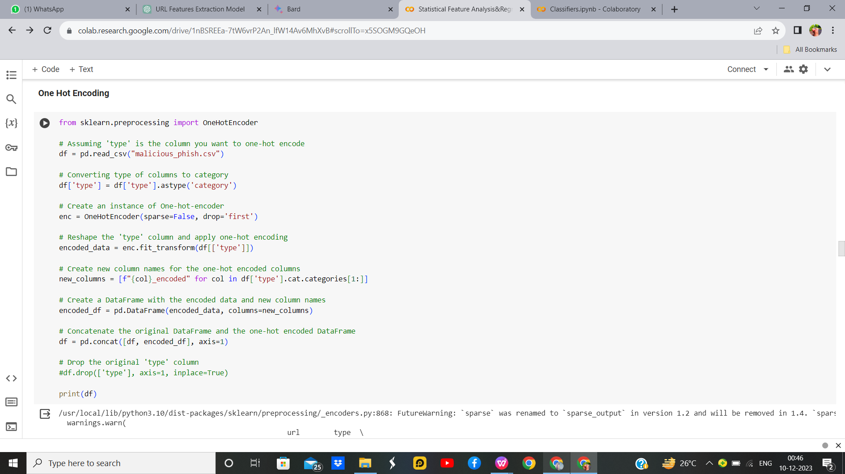

Figure 15. One Hot Encoding Code

After Performing Onehotencoding the string values of the column [type] are transformed to categorical value [1,0].

**Output:**

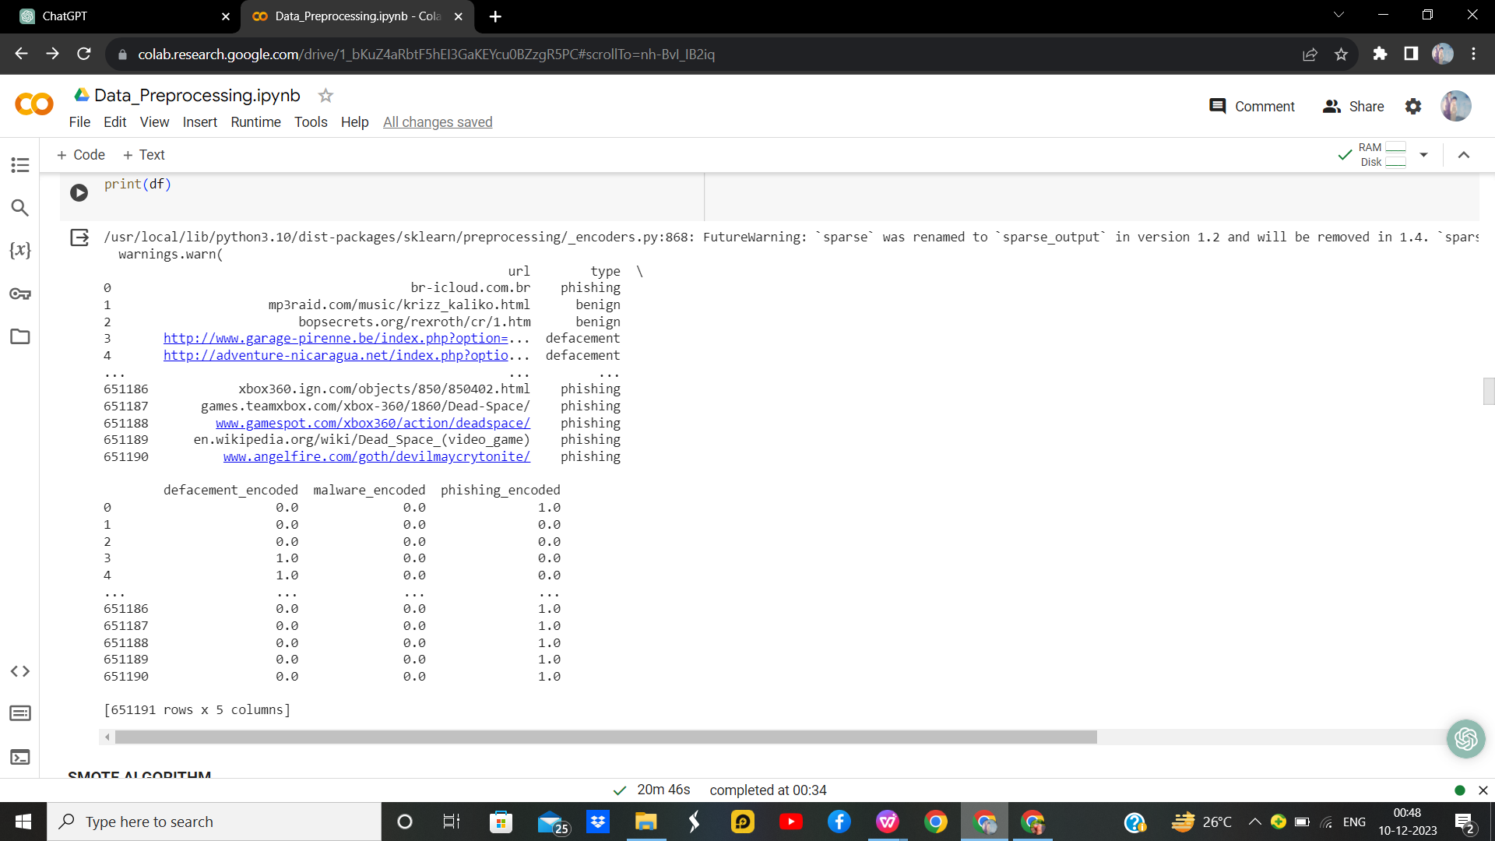

Figure 16. One Hot Encoding Results

**SECTION 4**

* 1. **Regression**

Regression in machine learning is a supervised learning technique designed for predicting continuous numerical values based on input features. The primary goal is to establish a mathematical relationship between the independent variables and the dependent variable, allowing the model to make predictions for new data points. Linear regression is a fundamental approach, assuming a linear relationship between variables, while more complex models like polynomial regression and support vector regression can capture nonlinear patterns. During training, the model learns the optimal parameters that minimize the difference between predicted and actual values. Evaluation metrics, such as Mean Squared Error or R-squared, assess the model's accuracy. Regression finds extensive applications in various domains, including finance, economics, and healthcare, where predicting numerical outcomes is essential for decision-making and analysis**.**

* + 1. **Linear Regression**

Linear regression is a fundamental supervised machine learning technique used for predicting a continuous numerical outcome based on one or more input features. The model assumes a linear relationship between the independent variables and the dependent variable. In simple linear regression, there is one independent variable, while in multiple linear regression, there are multiple independent variables. The model aims to find the best-fit line that minimizes the sum of squared differences between the predicted and actual values. The equation of a simple linear regression model is typically expressed as *y* = *mx* + *b*, where *y* is the dependent variable, *x* is the independent variable, *m* is the slope of the line, and *b* is the y-intercept. The coefficients *m* and *b* are determined during the training phase using methods like the least squares approach. Linear regression is widely applied in various fields, including economics, finance, and science, to model and understand the relationships between variables. Evaluation metrics such as Mean Squared Error or R-squared are commonly used to assess the model's performance.

**Linear Regression without Hyper parameters**

**Code:**

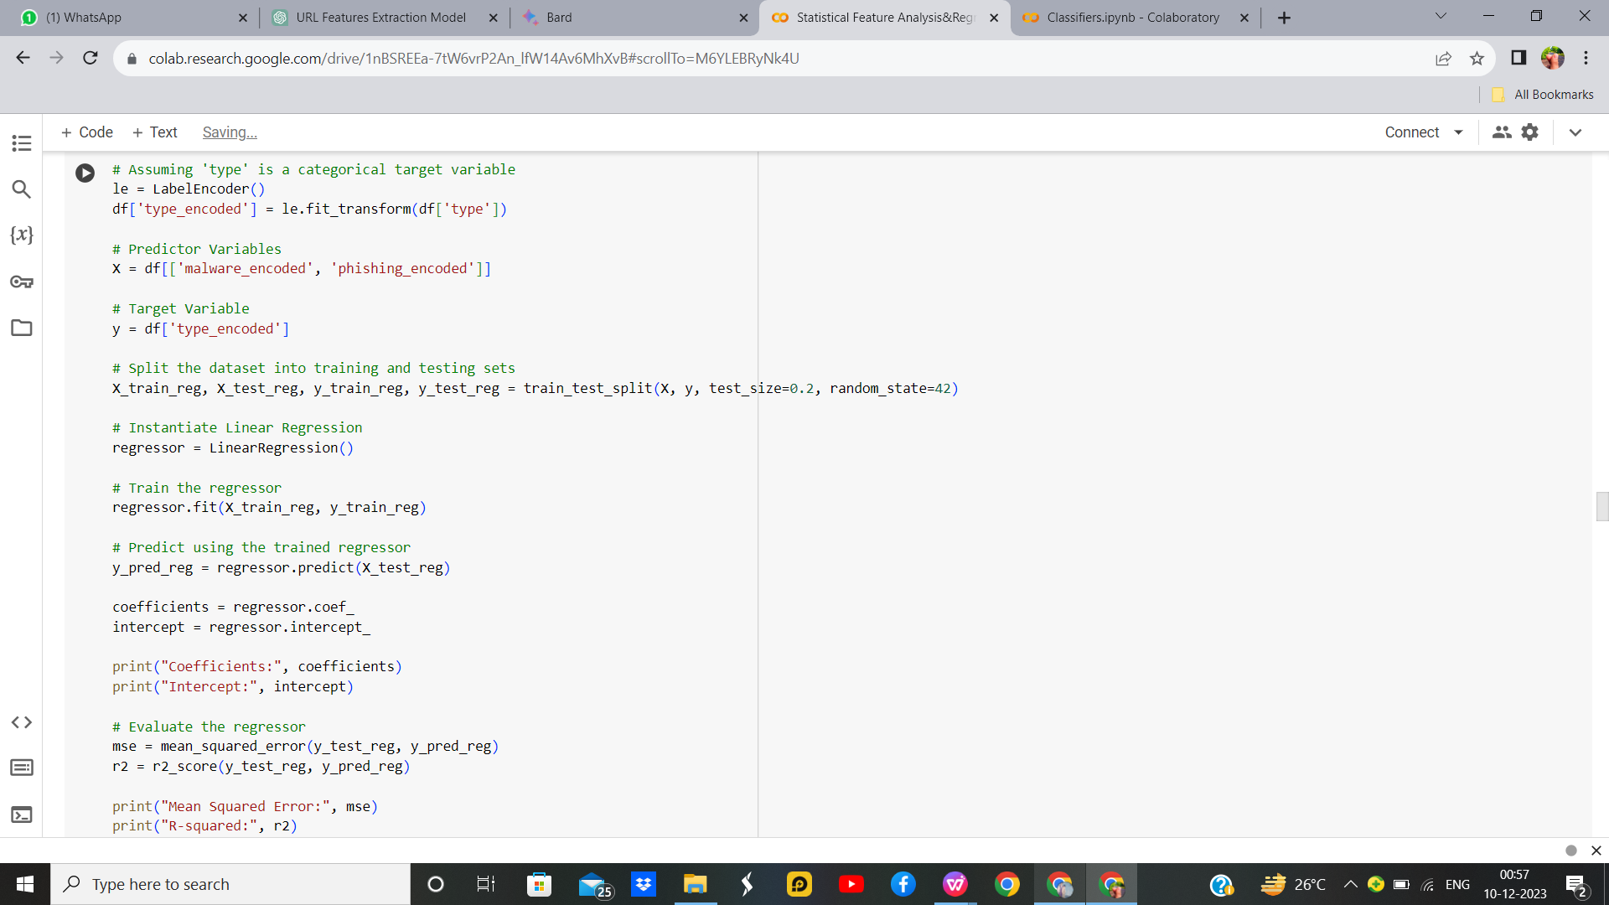

Figure 17 : Linear Regression without Hyperparameters Code

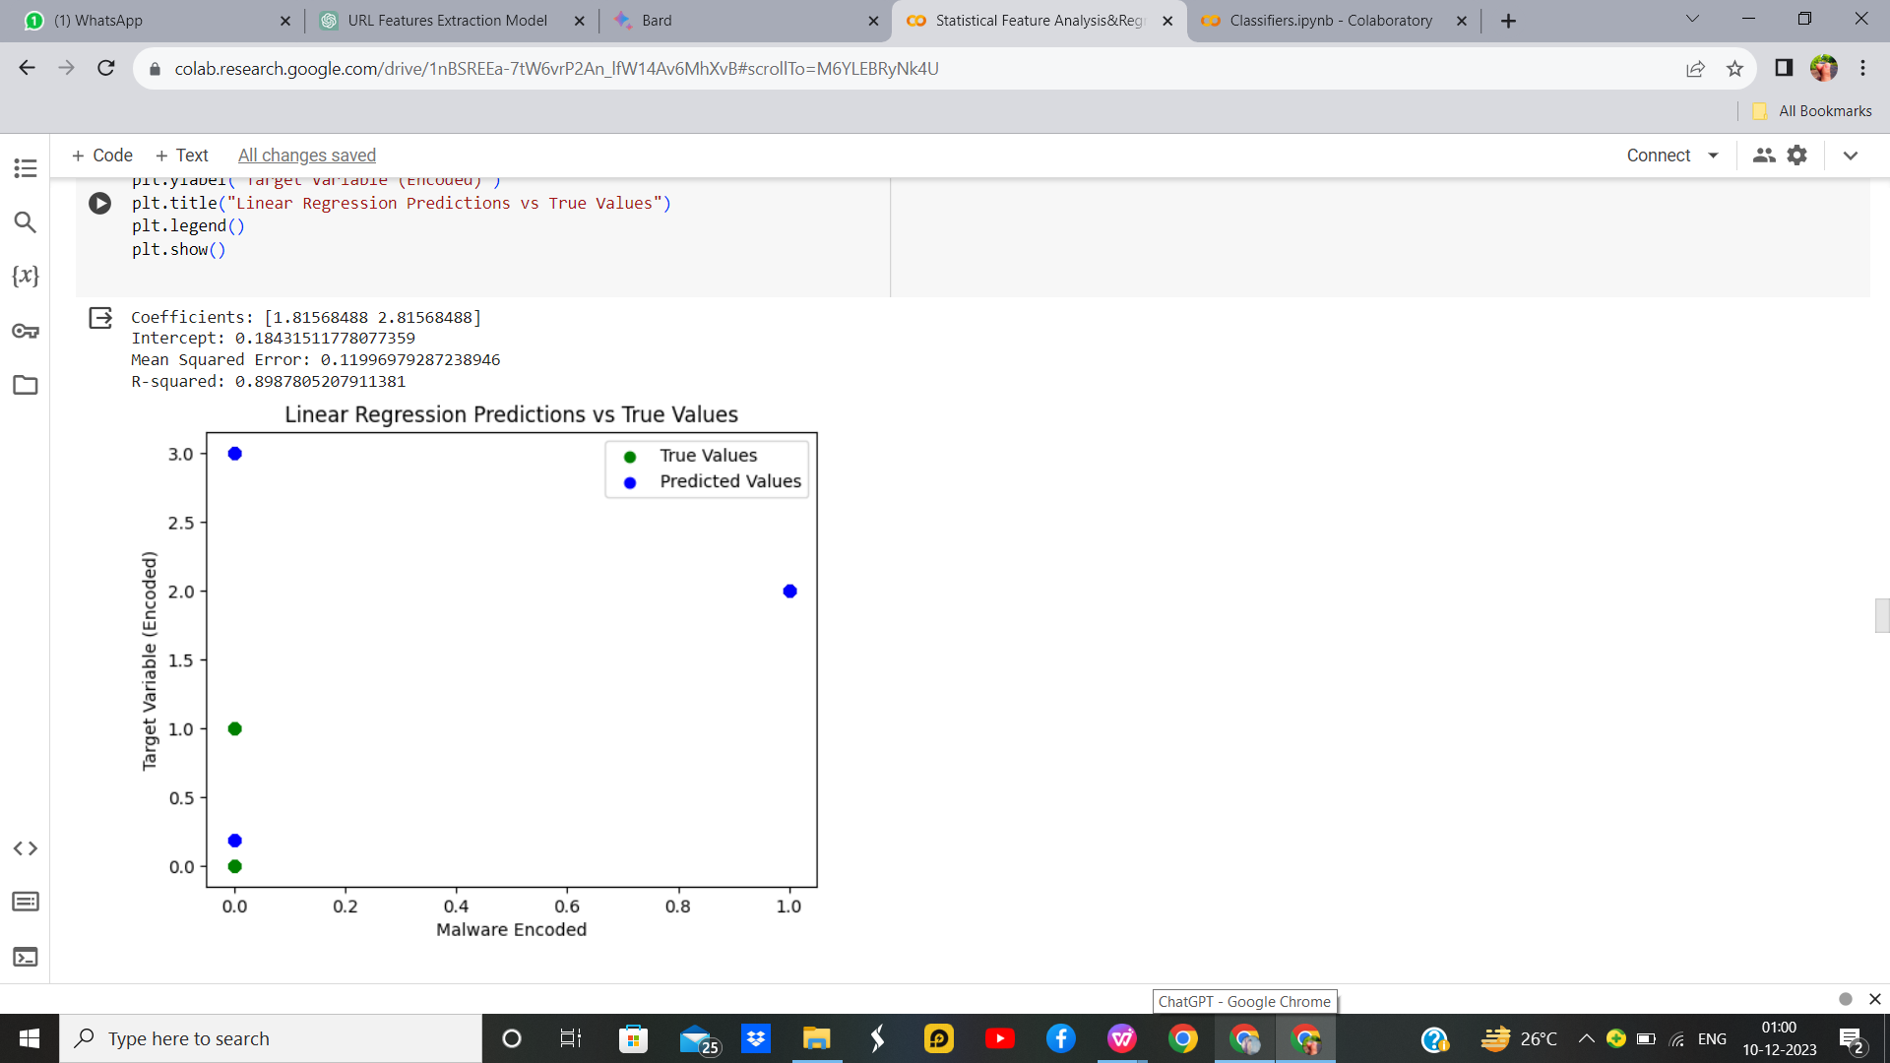**Output:**

Figure 18 : Linear Regression without Hyperparameters Output

**Linear Regression with Hyper parameters**

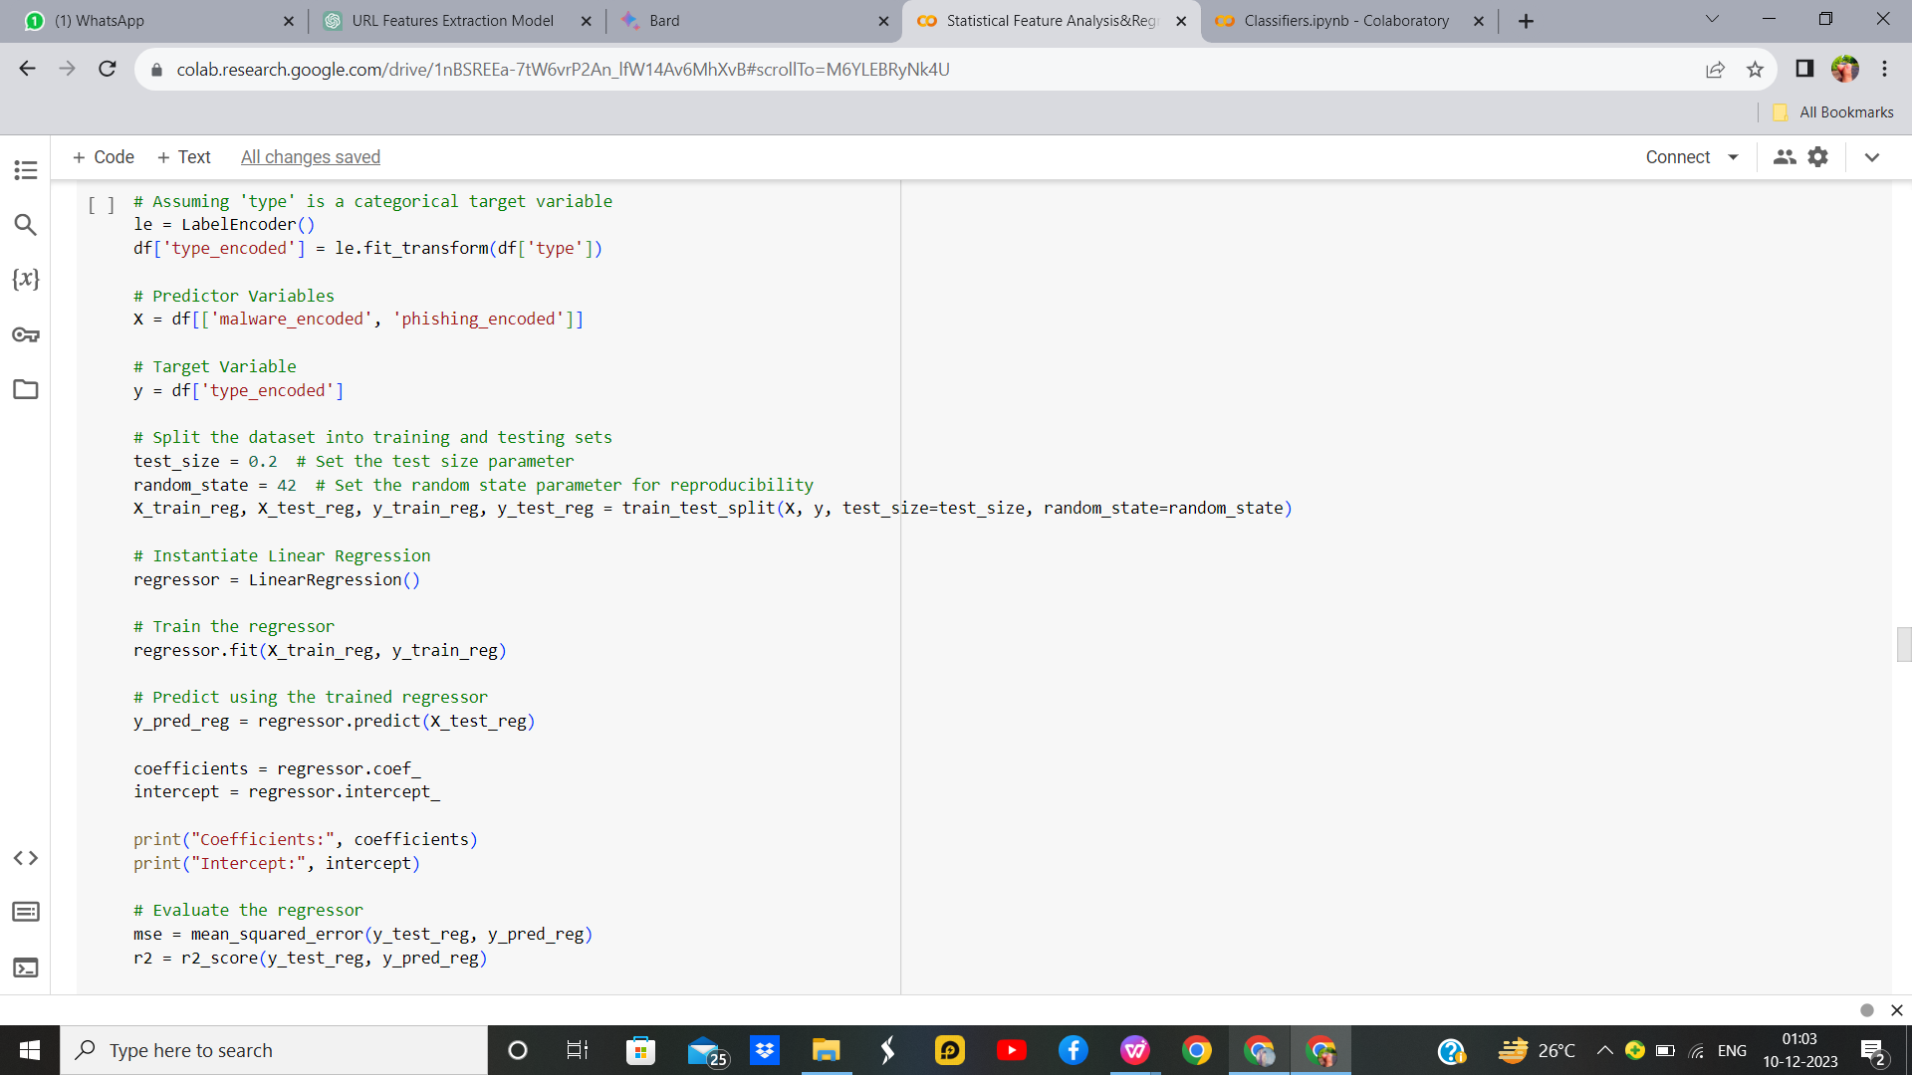**Code:**

Figure 19 : Linear Regression with Hyperparameters Code

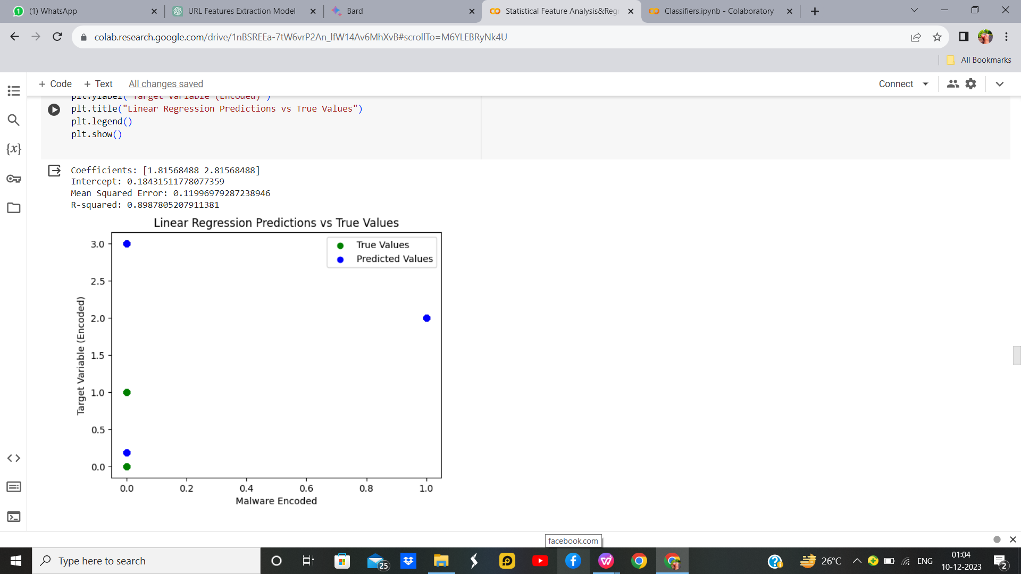**Output:**

Figure 20 : Linear Regression with Hyperparameters Output

**Inference:**

Linear regression is performed on a dataset with categorical target variable 'type' encoded using Label Encoder. It uses 'malware_encoded' and 'phishing_encoded' as predictor variables. The dataset is split into training and testing sets, and a Linear Regression model is trained. Coefficients and intercept are printed, and predictions are evaluated using Mean Squared Error (MSE) and R-squared. The code visualizes predictions against true values in a scatter plot. The model suggests a linear relationship between predictor variables and the encoded 'type'. The MSE and R-squared provide insights into the model's predictive performance.For Linear Regression With Hyperparameters we explicitly include parameters for test_size and random_state when splitting the dataset. Additionally, it visualizes the linear regression predictions along with the regression line, providing a more detailed representation of the model's performance.There is no difference in the Mean squared error and R-Squared Values in output in both linear regression with and without Hyperparameters.

|  |  |  |
| --- | --- | --- |
| **Parameter Name** | **Purpose** | **Value** |
| Test size | To split the dataset into training and testing in a ratio | 0.2 |
| Random State | This parameter sets the seed for the random number generator used by the data splitter. By using a fixed seed, the random splitting process becomes deterministic, allowing for result reproducibility. | 42 |

Table 5. Parameters for Linear regression

* + 1. **Logistic Regression:**

In the realm of machine learning, logistic regression is a versatile and widely-used algorithm that I find particularly fascinating. Despite its name, it's employed for binary classification tasks rather than regression. The core idea is to model the probability that a given input belongs to a particular class. I appreciate its simplicity and interpretability, as it computes a weighted sum of input features, applies a sigmoid function to transform this sum into a probability score between 0 and 1, and then classifies instances based on a chosen threshold. During training, the model learns optimal weights through techniques like gradient descent, minimizing the binary cross-entropy loss. I often leverage logistic regression when dealing with binary outcomes, such as predicting whether an email is spam or not. Its straightforward implementation, clear decision boundaries, and ability to handle high-dimensional data make it an invaluable tool in my machine-learning toolbox.

**Logistic regression without Hyperparameter**

**Code:**

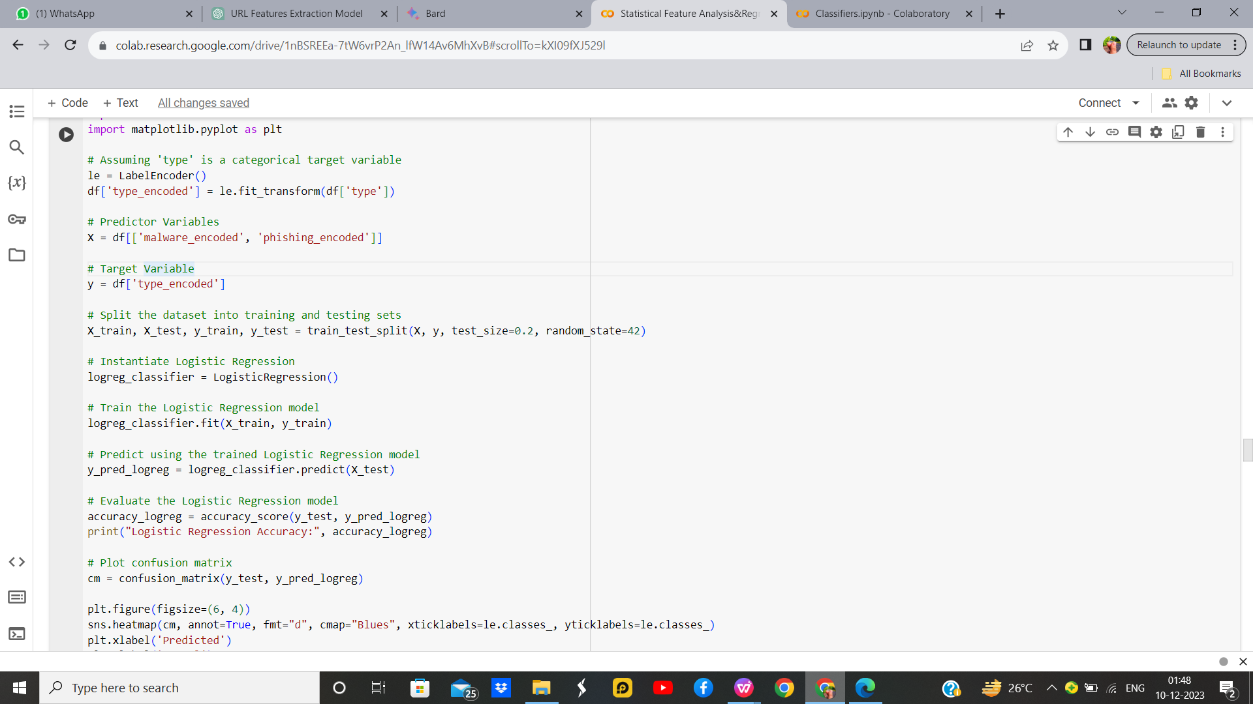

Figure 21 : Logistic Regression without Hyperparameters Code

**Output:**

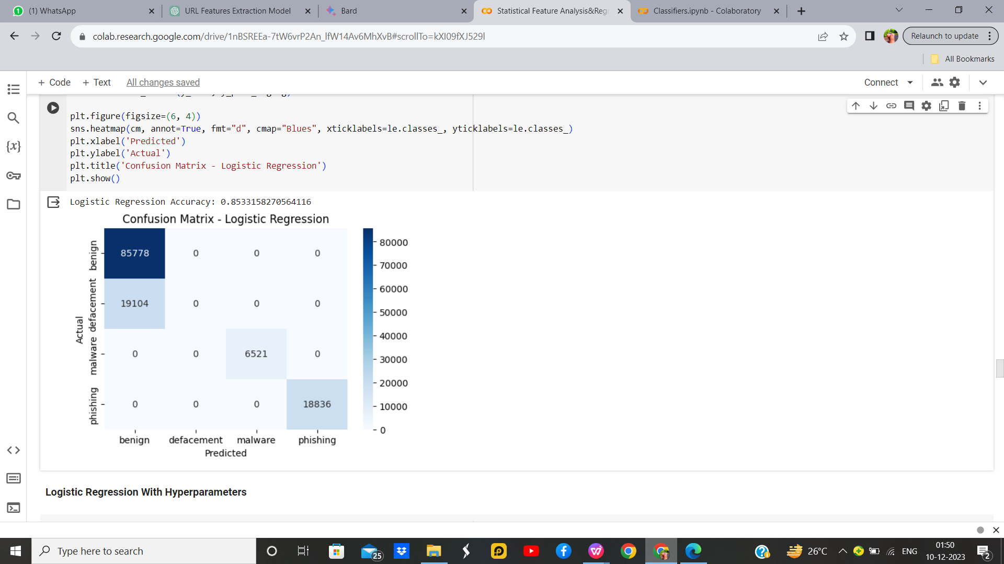

Figure 22 : Logistic Regression without Hyperparameters Output

**Logistic regression with Hyperparameter**

**Code:**

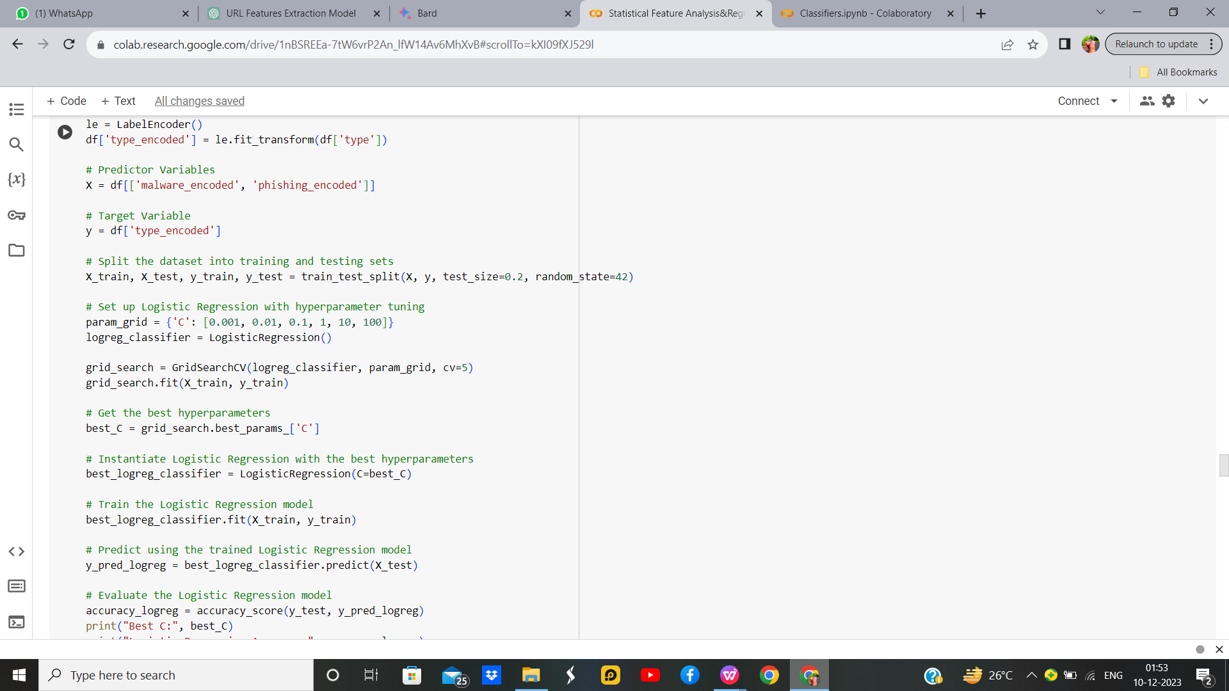

Figure 23 : Logistic Regression with Hyperparameters Code

**Output:**

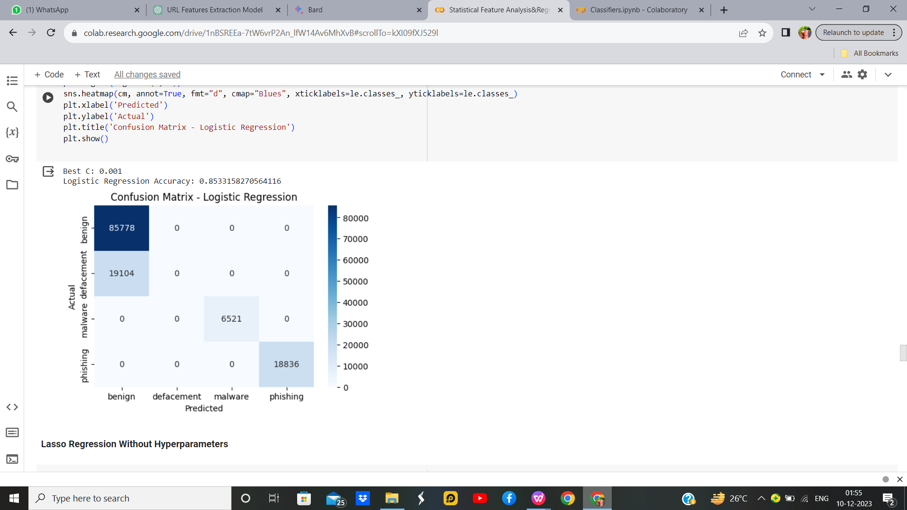

Figure 24 : Logistic Regression with Hyperparameters Output

Table 6. Parameters for Logistic Regression

|  |  |  |
| --- | --- | --- |
| **Parameter Name** | **Purpose** | **Value** |
| Test size | To split the dataset into training and testing in a ratio | 0.2 |
| Random State | This parameter sets the seed for the random number generator used by the data splitter. By using a fixed seed, the random splitting process becomes deterministic, allowing for result reproducibility. | 42 |

For Logistic Regression with Hyperparameter we used same parameter with Grid Search

|  |  |  |
| --- | --- | --- |
| Grid Search | The grid search explores various alpha values using 5-fold cross-validation. | 0.001, 0.01, 0.1, 1, 10, 100, 1000 |

**Inference:**

Logistic Regression for a classification task on a dataset with encoded categorical target variable 'type'. After splitting the data into training and testing sets, the Logistic Regression model is trained and evaluated. The accuracy metric assesses the model's performance, while a confusion matrix visualizes the classification results, depicting true positive, true negative, false positive, and false negative predictions. The heatmap provides a clear representation of the model's ability to correctly classify different categories.The Logistic Regression Accuracy with and without hyperparameter is same

* + 1. **Lasso Regression**

Lasso regression, or Least Absolute Shrinkage and Selection Operator, is a regularization technique that I find particularly powerful in the realm of machine learning. What sets Lasso apart is its ability to not only fit a predictive model but also perform feature selection by driving certain coefficients to exactly zero. This regularization method adds a penalty term to the linear regression cost function, which is proportional to the absolute values of the coefficients. By tuning the regularization strength parameter, often denoted as 'alpha,' Lasso encourages sparsity in the model, effectively eliminating less influential features. This feature selection property proves beneficial when dealing with high-dimensional datasets, where identifying and using only the most impactful features can enhance model interpretability and generalization to new data. I appreciate Lasso regression for its role in not just prediction but also in simplifying models by emphasizing the most relevant features, making it a valuable tool in my machine learning endeavours.

**Lasso Regression without Hyperparameter**

**Code:**

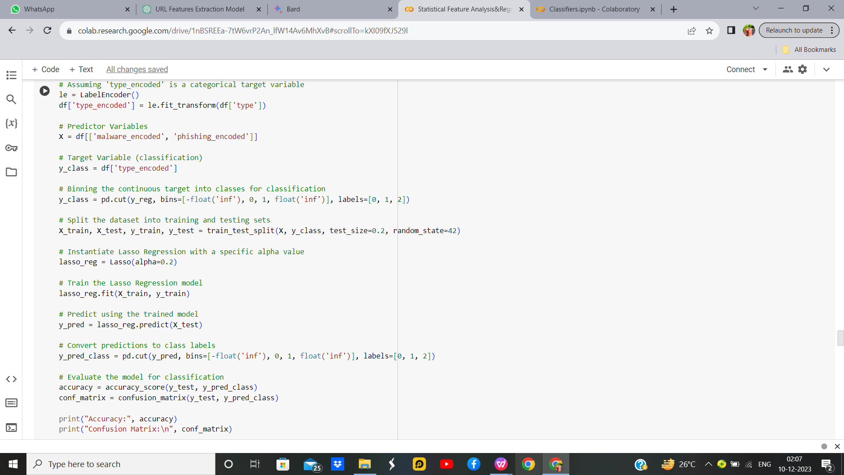

Figure 25 : Lasso Regression without Hyperparameters Code

**Output:**

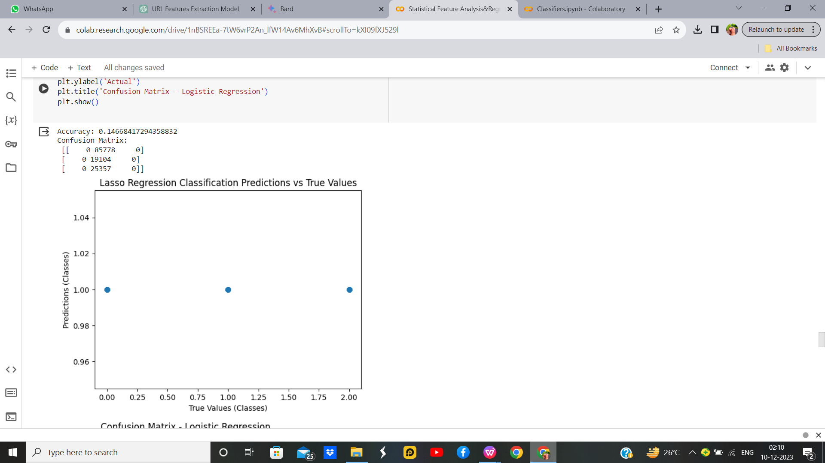

Figure 25 : Lasso Regression without Hyperparameters Output

**Lasso Regression with Hyperparameter**

**Code:**

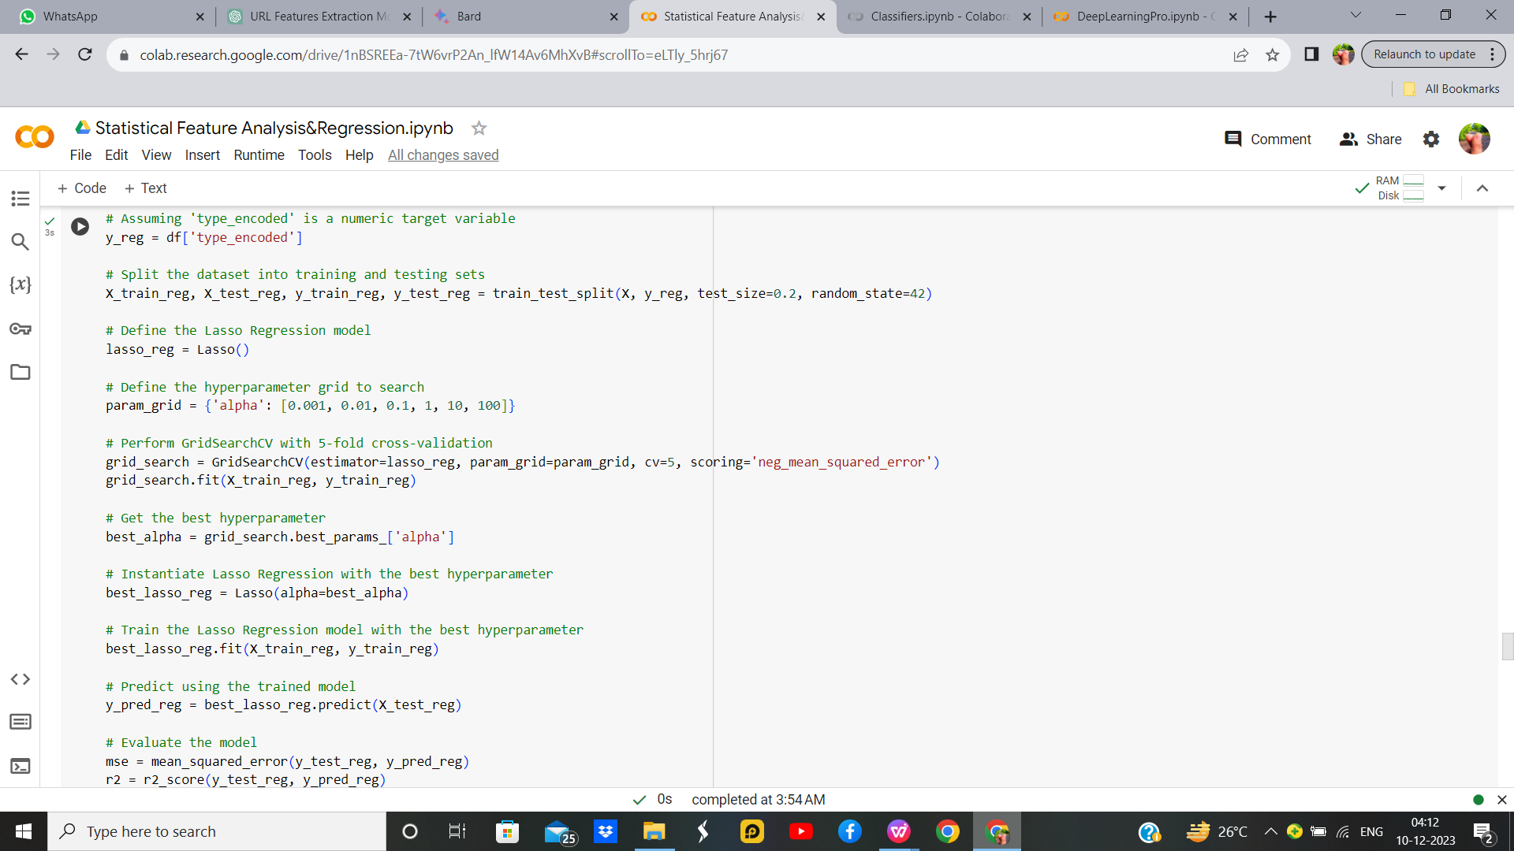

Figure 26 : Lasso Regression with Hyperparameters Code

**Output:**

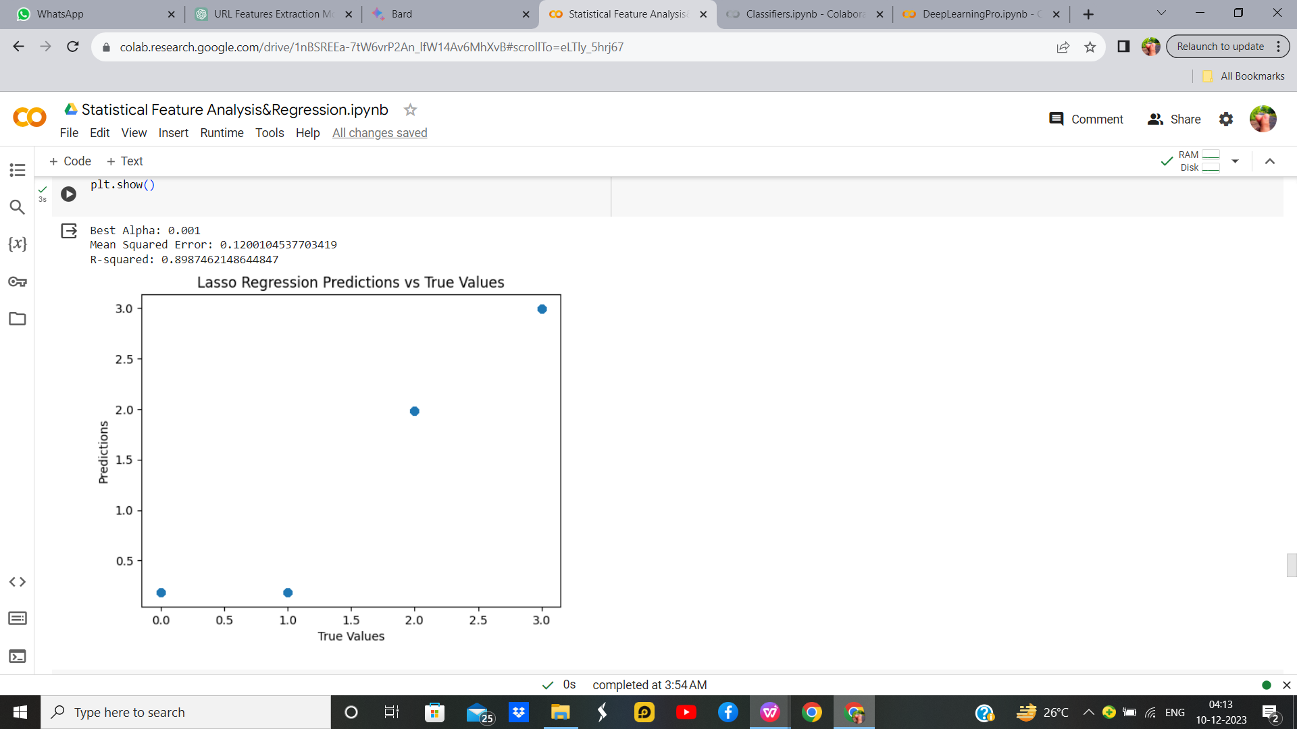

Figure 27 : Lasso Regression with Hyperparameters Output

Table 7. Parameters for Lasso Regression

|  |  |  |
| --- | --- | --- |
| **Parameter Name** | **Purpose** | **Value** |
| Test size | To split the dataset into training and testing in a ratio | 0.2 |
| Random State | This parameter sets the seed for the random number generator used by the data splitter. By using a fixed seed, the random splitting process becomes deterministic, allowing for result reproducibility. | 42 |
| Alpha | The regularization parameter controls the amount of shrinkage applied to the coefficients of the model | 0.01 |

Table 8. Parameters for Lasso Regression With Hyperparameter

|  |  |  |
| --- | --- | --- |
| **Parameter Name** | **Purpose** | **Value** |
| Test size | To split the dataset into training and testing in a ratio | 0.2 |
| Random State | This parameter sets the seed for the random number generator used by the data splitter. By using a fixed seed, the random splitting process becomes deterministic, allowing for result reproducibility. | 42 |
| Alpha | The regularization parameter controls the amount of shrinkage applied to the coefficients of the model | 0.01 |
| Grid Search | The grid search explores various alpha values using 5-fold cross-validation. | 0.001, 0.01, 0.1, 1, 10, 100, 1000 |

**Inference:**

Lasso Regression for classification, utilizing a specified alpha value. The target variable undergoes binning, transforming it into categorical classes. The dataset is split for training and testing, and the Lasso Regression model is trained and evaluated for classification accuracy. A scatter plot visually represents the relationship between true and predicted class labels. Additionally, a confusion matrix highlights the model's classification performance.The Accuraccy for Lasso Regression with and without hyper parameter is same.

* + 1. **Ridge Regression**

Ridge regression, a technique that I often find valuable in machine learning, is a form of linear regression that incorporates regularization to mitigate multicollinearity and potential overfitting. What sets Ridge regression apart is its inclusion of a regularization term in the cost function, proportional to the square of the magnitude of the coefficients. By introducing this penalty term, Ridge regression encourages the model to not only fit the data well but also to keep the coefficients small. This can be particularly useful when dealing with datasets with high-dimensional features or when certain features are highly correlated. The regularization strength is controlled by a hyperparameter, often denoted as 'alpha,' and tuning this parameter allows for a balance between fitting the data and preventing overfitting. Ridge regression, therefore, serves as a robust tool in my machine learning toolkit, offering a way to handle complex datasets while promoting stability in model coefficient.

**Ridge regression without Hyperparameter  
Code:**

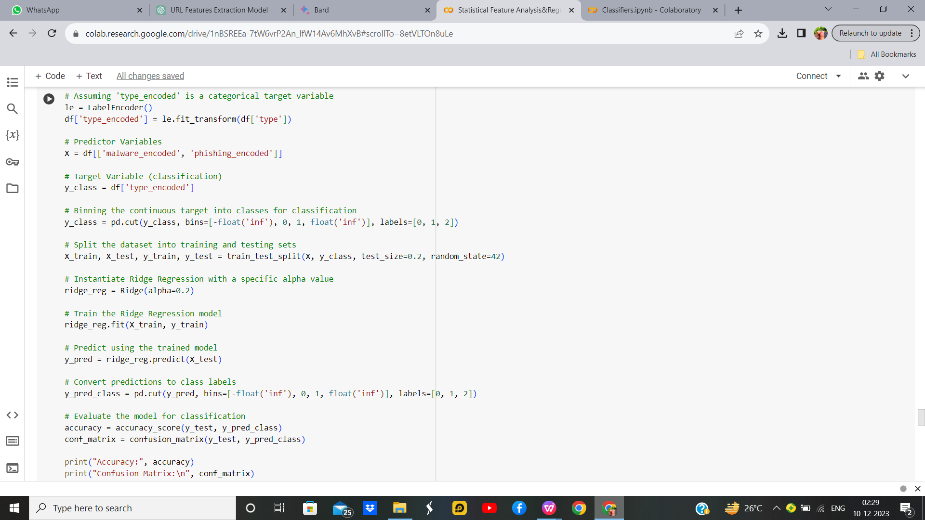

Figure 28: Rigid Regression without Hyperparameters Code

**Output:**

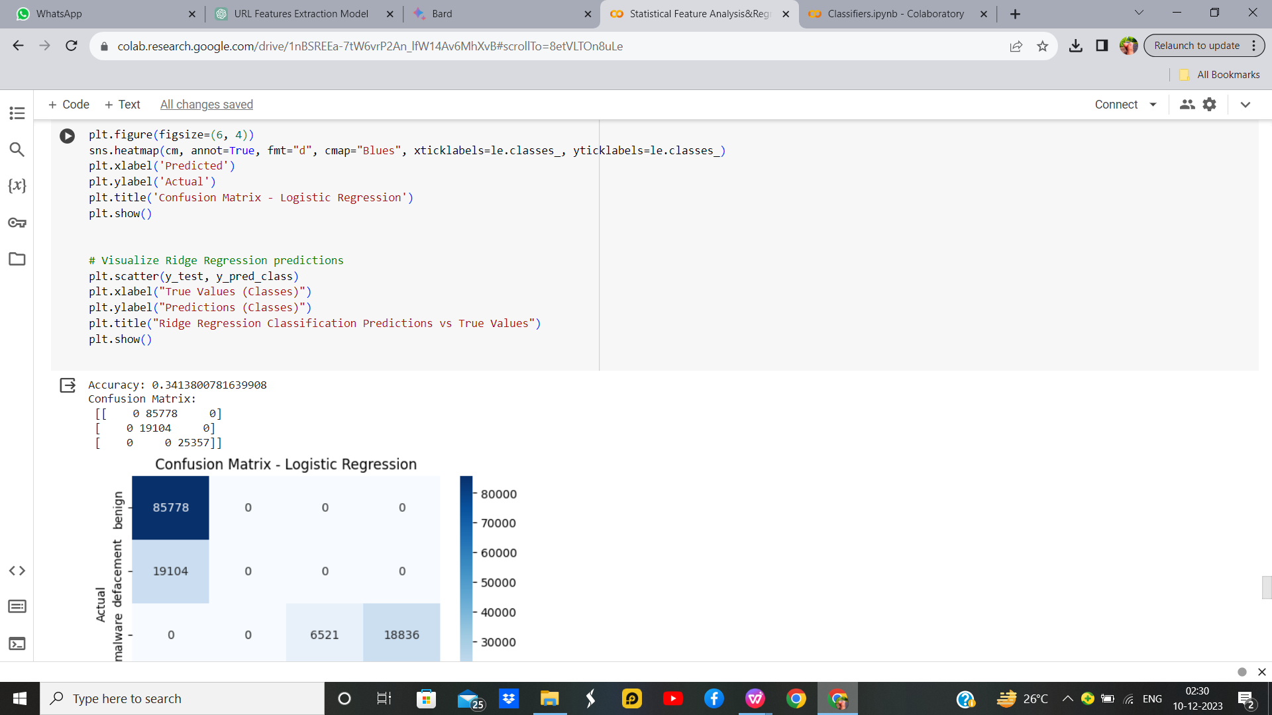

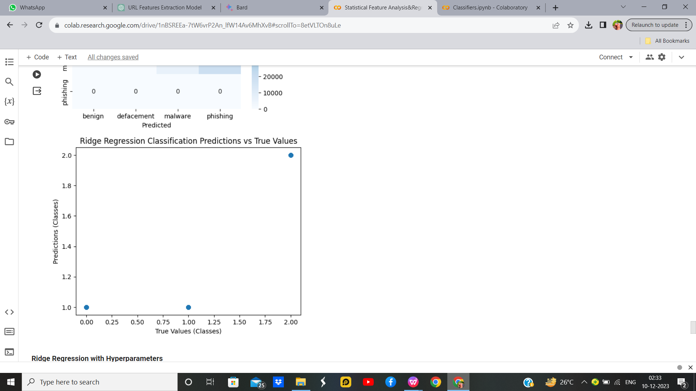

Figure 29 : Rigid Regression without Hyperparameters Output

**Ridge regression with Hyperparameter**

**Code:**

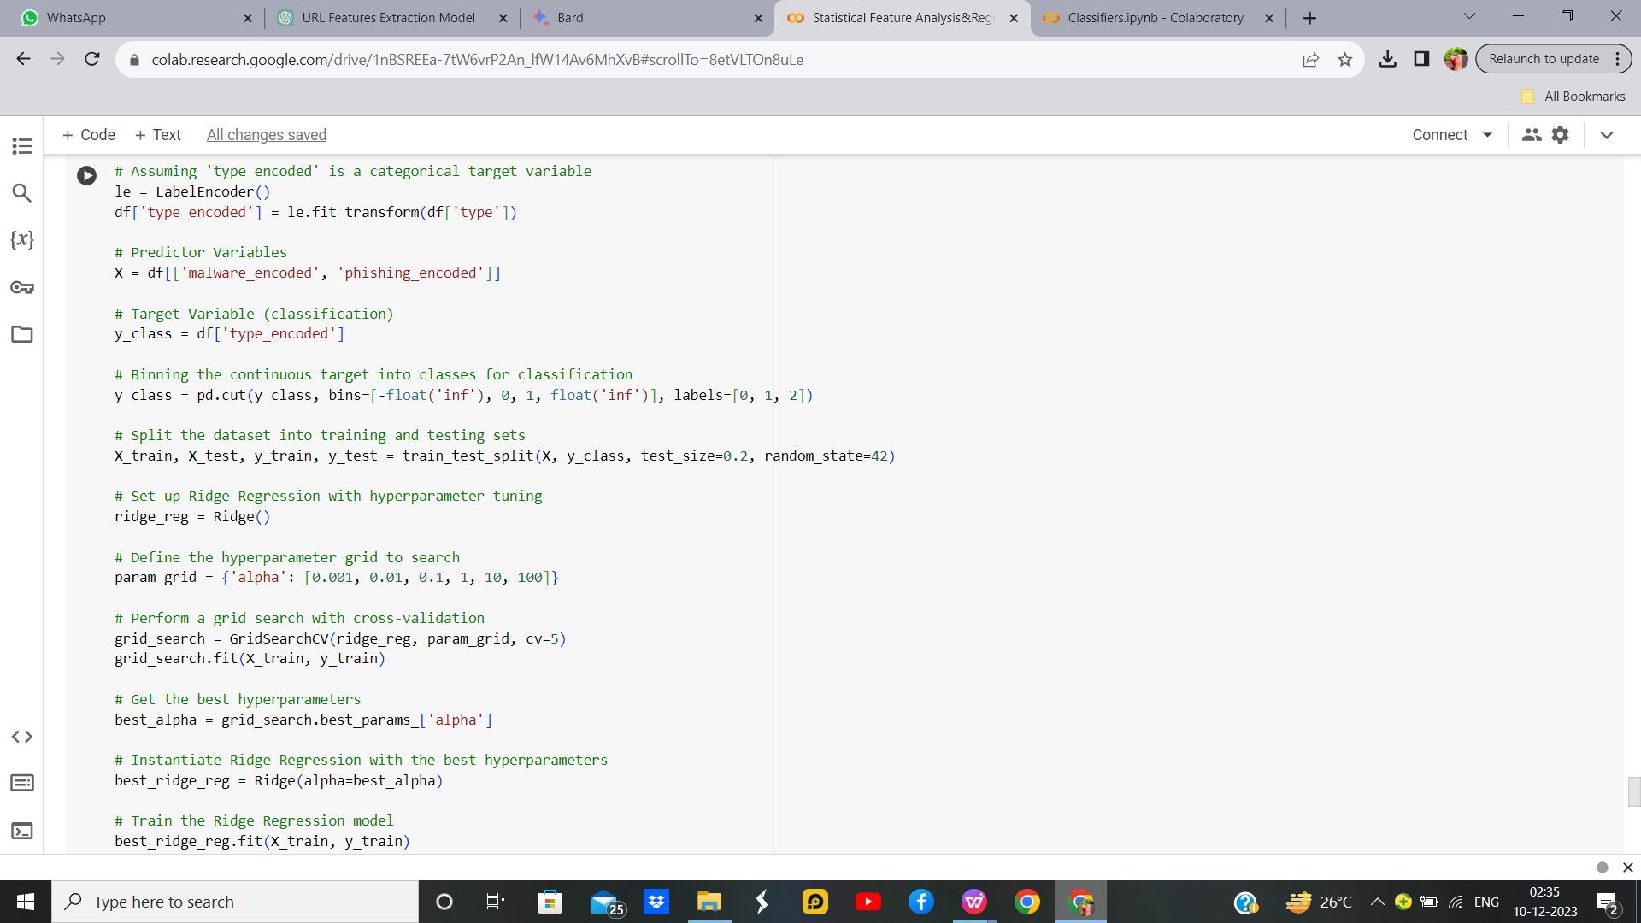

Figure 30 : Rigid Regression with Hyperparameters Code

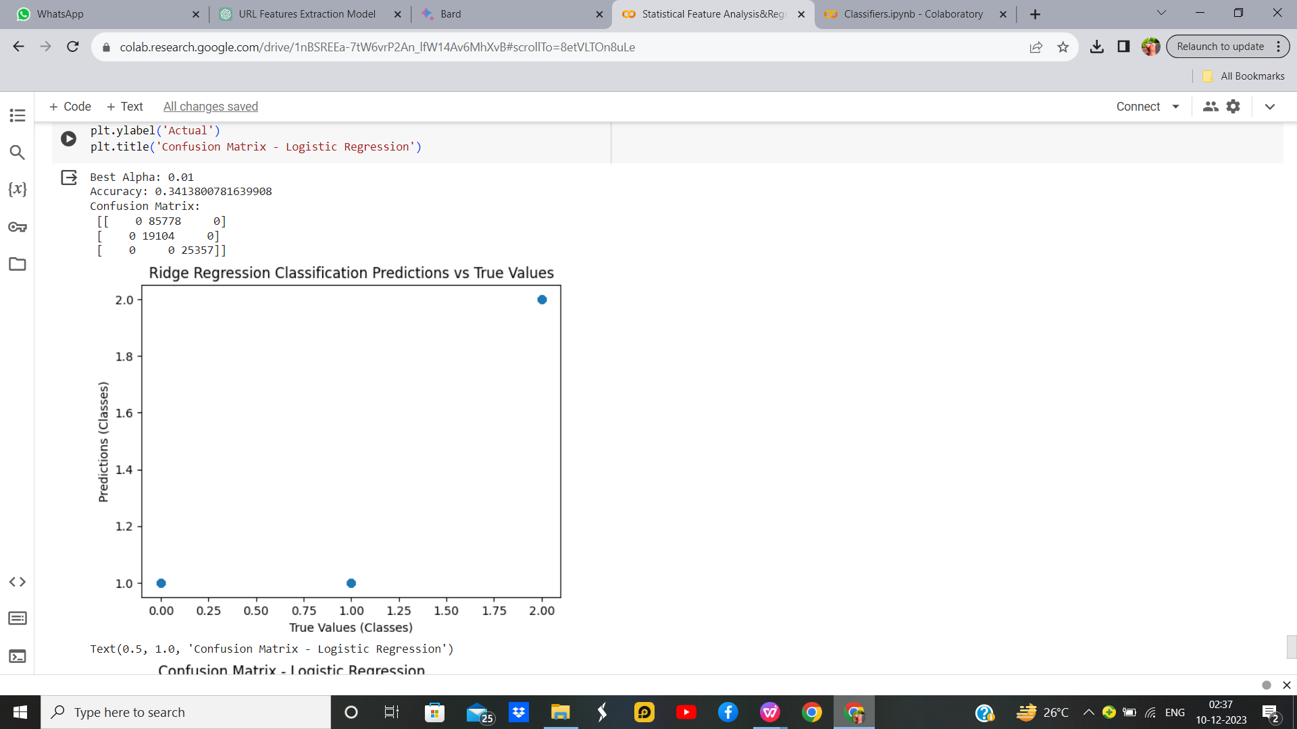**Output:**

Figure 31 : Rigid Regression with Hyperparameters Output

Table 9 : Parameters For Rigid Regression

|  |  |  |
| --- | --- | --- |
| **Parameter Name** | **Purpose** | **Value** |
| Test size | To split the dataset into training and testing in a ratio | 0.2 |
| Random State | This parameter sets the seed for the random number generator used by the data splitter. By using a fixed seed, the random splitting process becomes deterministic, allowing for result reproducibility. | 42 |
| Alpha | The regularization parameter controls the amount of shrinkage applied to the coefficients of the model | 0.01 |

Table 10 : Parameters For Rigid Regression with Parameters

|  |  |  |
| --- | --- | --- |
| **Parameter Name** | **Purpose** | **Value** |
| Test size | To split the dataset into training and testing in a ratio | 0.2 |
| Random State | This parameter sets the seed for the random number generator used by the data splitter. By using a fixed seed, the random splitting process becomes deterministic, allowing for result reproducibility. | 42 |
| Alpha | The regularization parameter controls the amount of shrinkage applied to the coefficients of the model | 0.01 |
| Grid Search CV | The grid search explores various alpha values using 5-fold cross-validation. | 0.001, 0.01, 0.1, 1, 10, 100, 1000 |

**Inference:**

In Ridge Regression for classification the target variable, initially encoded and binned, undergoes classification predictions on a test set. The model's accuracy and confusion matrix showcase its classification performance. A scatter plot visually represents the relationship between true and predicted class labels. The code aims to demonstrate Ridge Regression's effectiveness in classifying categorical data, providing insights into model accuracy and misclassifications. For Ridge Regression optimizing hyperparameter alpha through grid search and Without hyperparameter there is no change in accuracy.

**Hyperparameter Tuning approach used in All the Regressions:** Grid Search CV

**Comparison of Regression Models:**

**Evaluation Parameters for best models of each type of regression**

|  |  |  |  |  |  |
| --- | --- | --- | --- | --- | --- |
| **Model** | **MSE** | **Accuracy** | **Precision** | **F1** | **Recall** |
| **Linear** | 0.1199 | 0.85 | 0.91 | 0.81 | 0.76 |
| **Logistic** | - | 0.85 | 0.91 | 0.81 | 0.79 |
| **Ridge** | 0.600 | 0.34 | 0.45 | 0.44 | 0.67 |
| **Lasso** | 0.1200 | 0.85 | 0.91 | 0.81 | 0.76 |

Table 11 : Comparison of Regression

As shown above, Logistic,Linear and Lasso regression performs well with accuracy 85%.

**SECTION 5**

* 1. **Classifiers**

In the realm of machine learning, classifiers are pivotal components that I frequently leverage in my work. These algorithms are designed to assign labels or categories to input data based on patterns learned from training examples. The primary goal is to generalize this learning to accurately predict the class or category of unseen instances. As I navigate the diverse landscape of classifiers, including but not limited to support vector machines, decision trees, and neural networks, each exhibits unique characteristics and strengths. Their effectiveness hinges on their ability to discern underlying patterns in the data, enabling them to make informed predictions on new, unseen data points. I find classifiers particularly useful in tasks such as image recognition, spam detection, and sentiment analysis, where the ability to categorize input data accurately is crucial for successful model deployment and decision-making.

* + 1. **K-Means with KNN**

In my exploration of machine learning techniques, I often encounter and utilize both K-means clustering and K-nearest neighbors (KNN) algorithms. K-means clustering is an unsupervised learning method that partitions data into distinct clusters based on similarity, with the number of clusters, denoted as 'K,' pre-defined. This technique is instrumental in uncovering inherent patterns and groupings within datasets. On the other hand, K-nearest neighbours (KNN) is a supervised learning algorithm used for classification and regression tasks. It determines the label of a data point by considering the majority class or averaging the values of its K nearest neighbours. While K-means identifies clusters in the feature space, KNN leverages the proximity of data points to make predictions. The synergy of these two methods can be powerful, especially when clustering data into meaningful groups with K-means and subsequently employing KNN for classification tasks within each cluster. This integrated approach enhances my ability to discern patterns, make predictions, and derive meaningful insights from diverse datasets.

**K-Means with KNN without Hyperparameter**

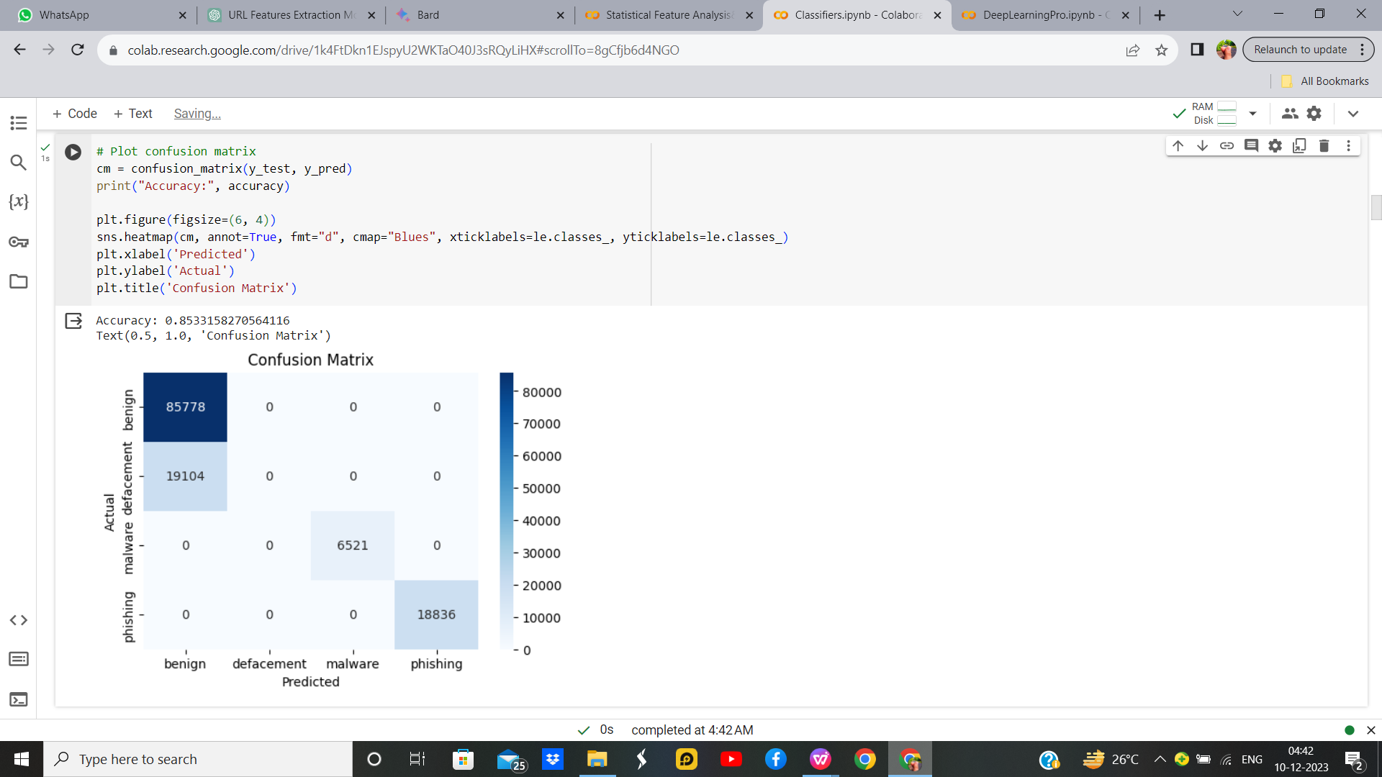**Output:**

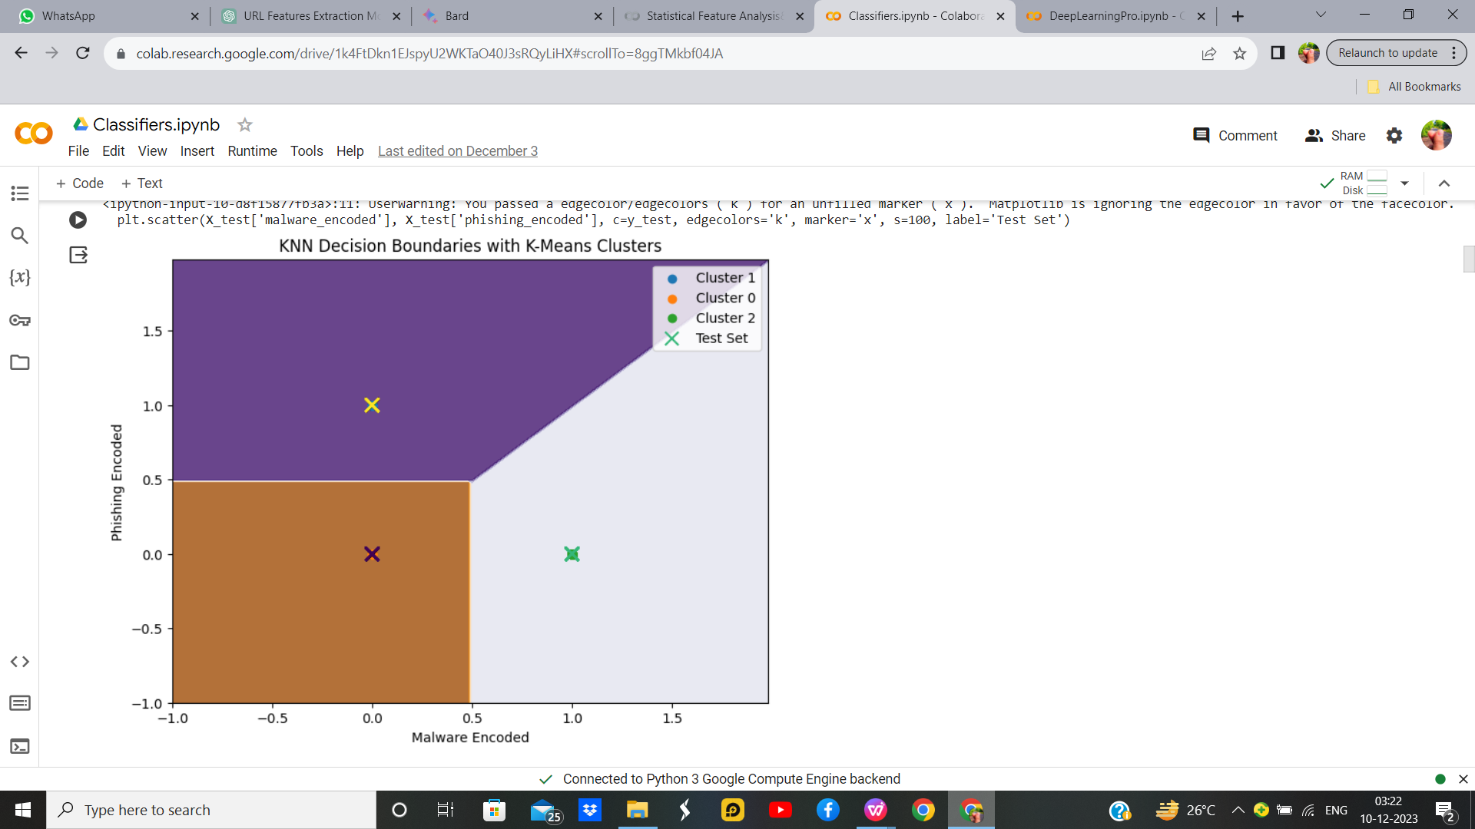

Figure 32 : K-Means with KNN Without Hyperparameters Output

**K-Means with KNN with Hyperparameter**

**Output:**

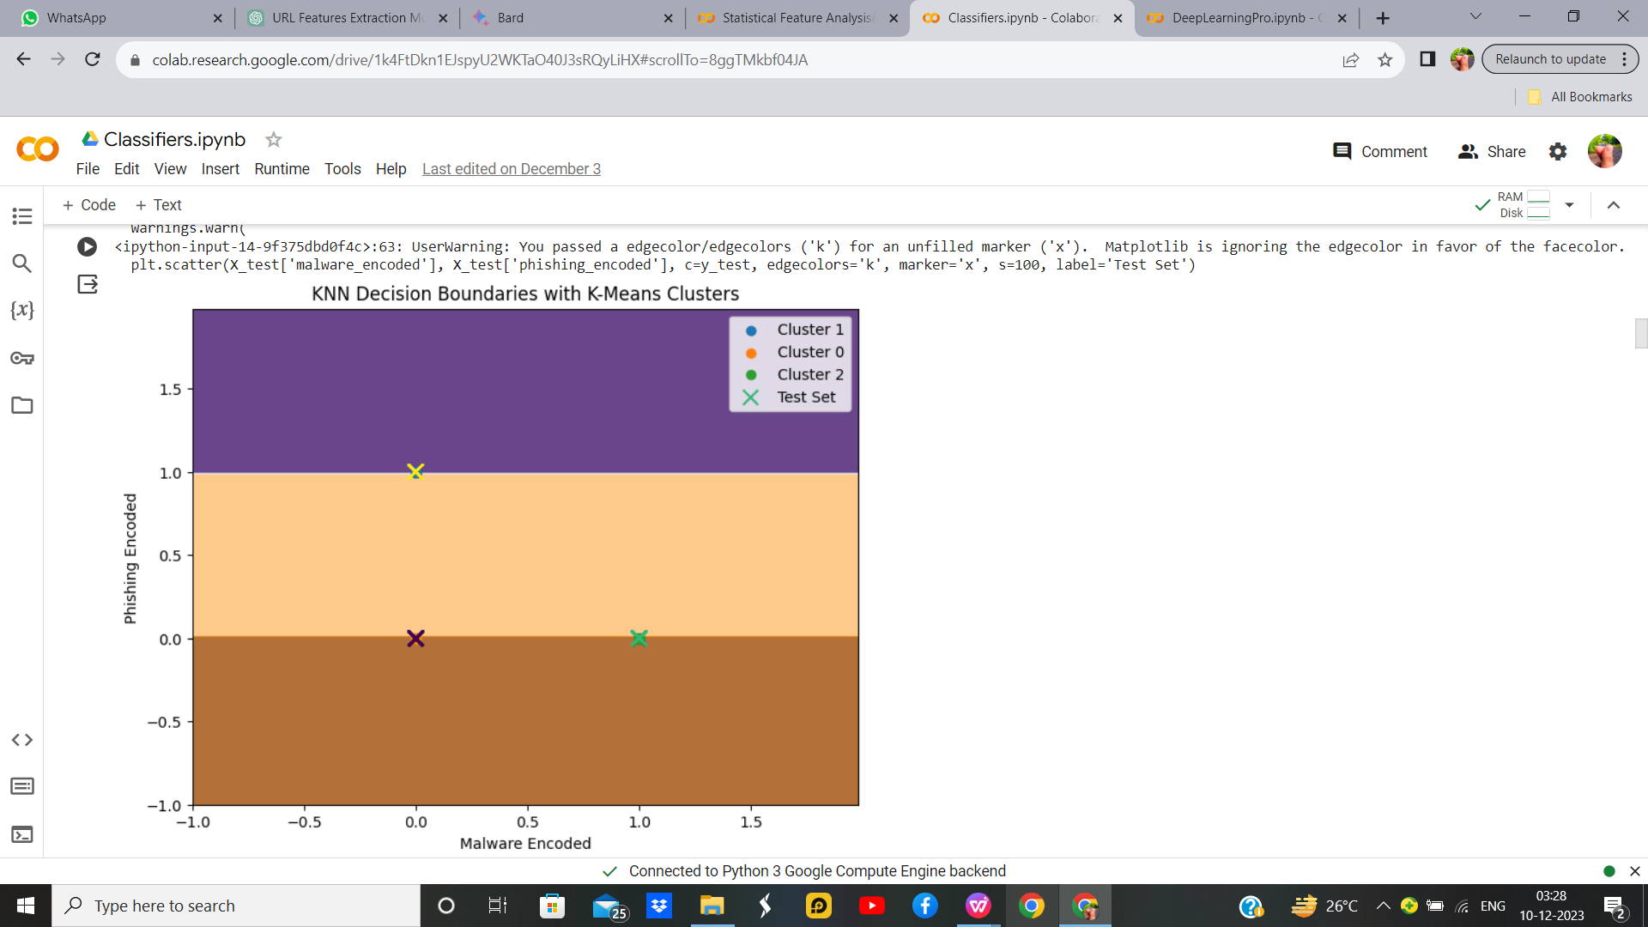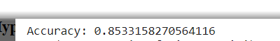

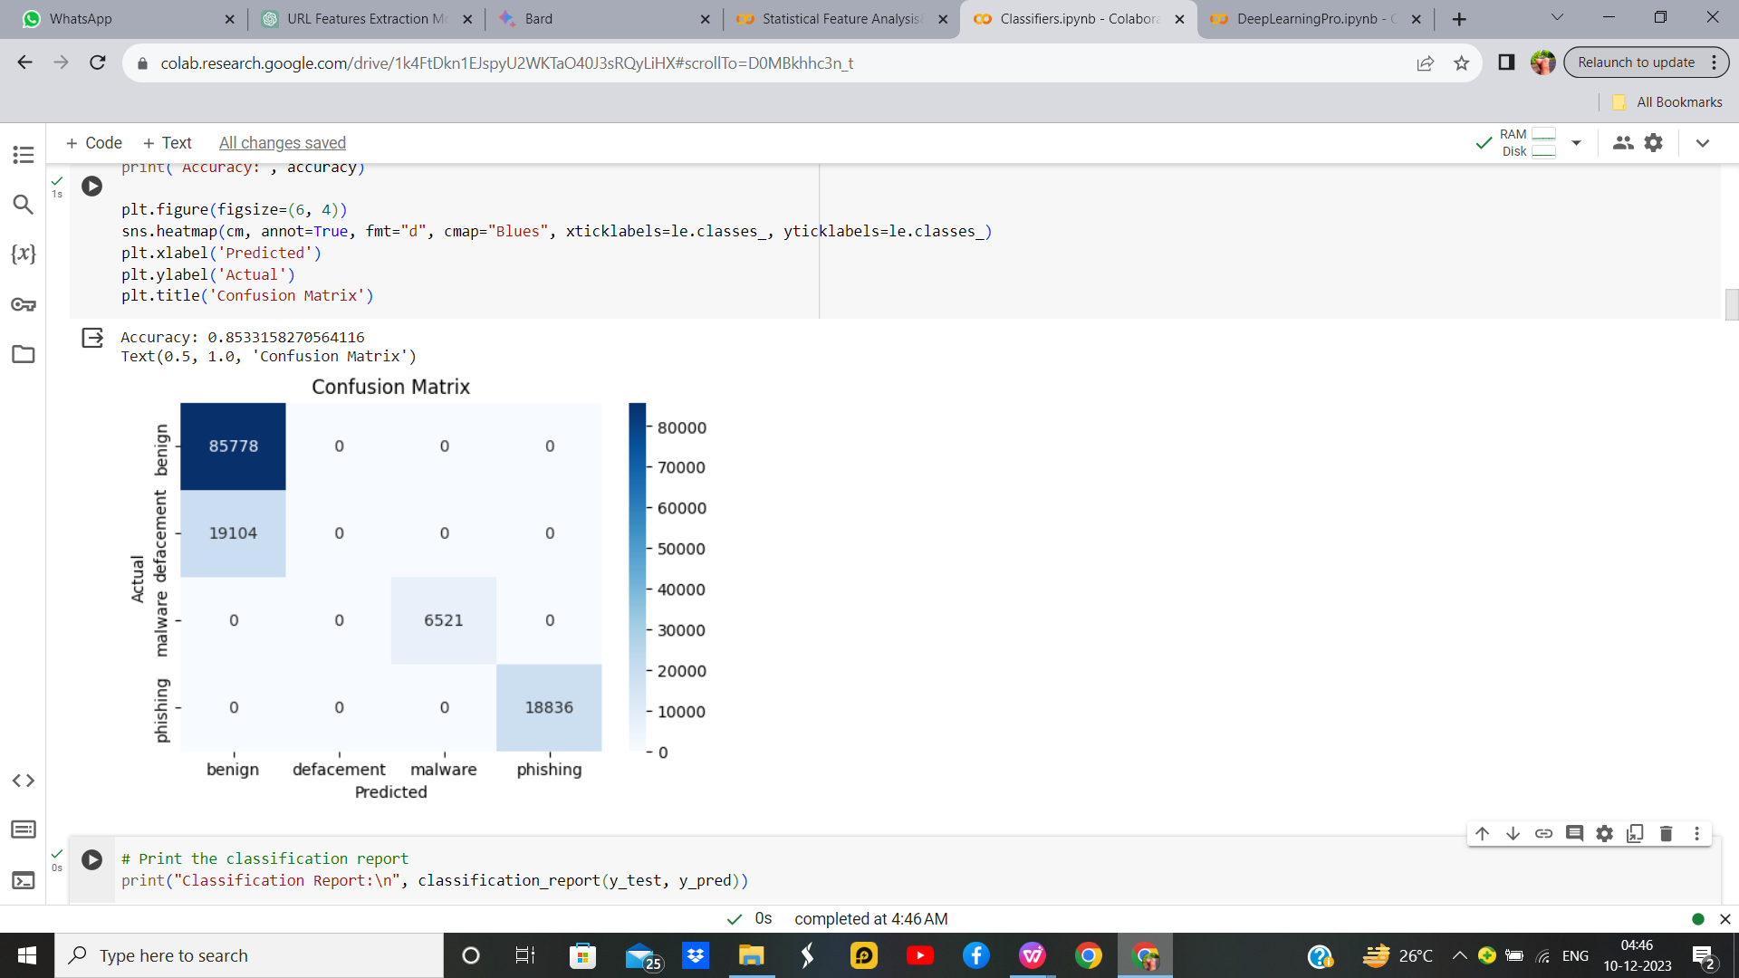

Figure 33 : K-Means with KNN With Hyperparameters Output

Table 11 : Parameters for K-means with KNN

|  |  |  |
| --- | --- | --- |
| **Parameter Name** | **Purpose** | **Value** |
| Test size | To split the dataset into training and testing in a ratio | 0.2 |
| Random State | This parameter sets the seed for the random number generator used by the data splitter. By using a fixed seed, the random splitting process becomes deterministic, allowing for result reproducibility. | 42 |
| No. of Clusters | Number of the centroid which will be formed | 2 |
| Grid Search CV | The grid search explores various alpha values using 5-fold cross-validation. | n_neighbors: 5, 5, 7, 9 |

**Inference:**

We applies K-Means clustering to our dataset, introducing a new feature ('cluster') based on the grouping of 'malware_encoded' and 'phishing_encoded'. The K-Nearest Neighbors (KNN) classifier is trained on this extended dataset with cluster information. The decision boundaries are visualized, showing regions predicted by KNN. Each cluster is distinguished by color, and the test set is marked with 'x' symbols. The visualization indicates how KNN uses the clustered information to classify points in the feature space. This approach allows KNN to consider local patterns within identified clusters, potentially improving its predictive performance.

**Hyperparameter Tuning approach used:** Grid Search CV

* + 1. **K-Means with SVM**

1. means is a clustering algorithm where I start by dividing a dataset into K clusters based on the similarity of data points. After the clusters are formed, I utilize Support Vector Machines, a supervised learning algorithm, to classify and separate the data points within each cluster. SVM works by finding the hyperplane that best separates different classes in a high-dimensional space. In the context of K-means, SVM helps to refine the clusters by establishing clear boundaries between them, enhancing the overall accuracy and robustness of the clustering results. This combined approach of K-means and SVM allows me to not only identify patterns within data but also create more distinct and well-defined clusters for better classification performance.We can see that there accuracy remains same for classification with and without hyperparameter.

**K-Means with SVM without Hyperparameter**

**Output:**

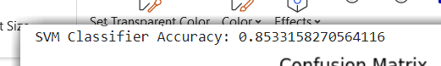

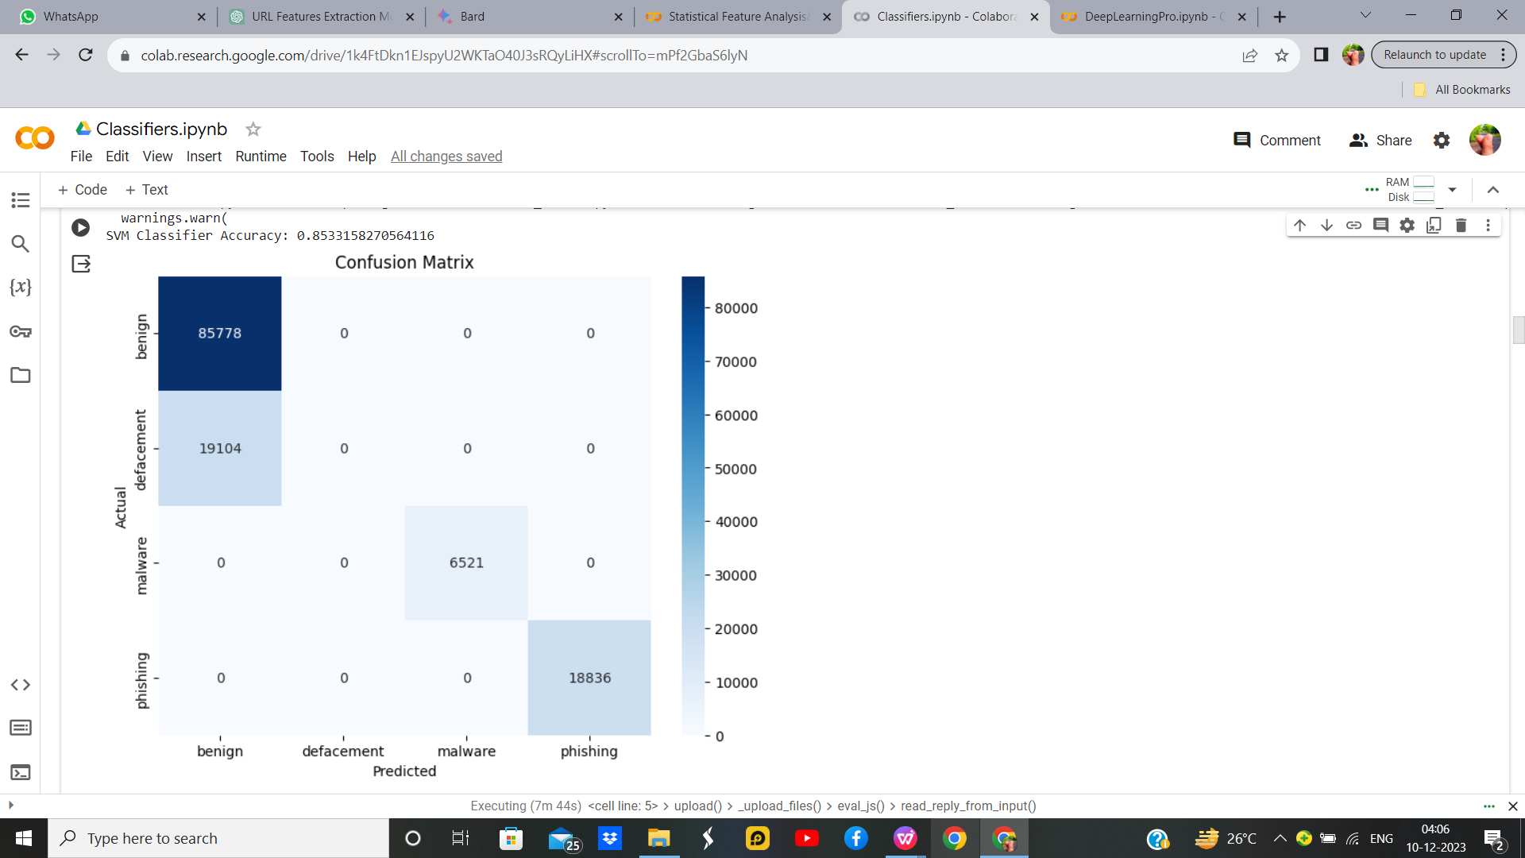

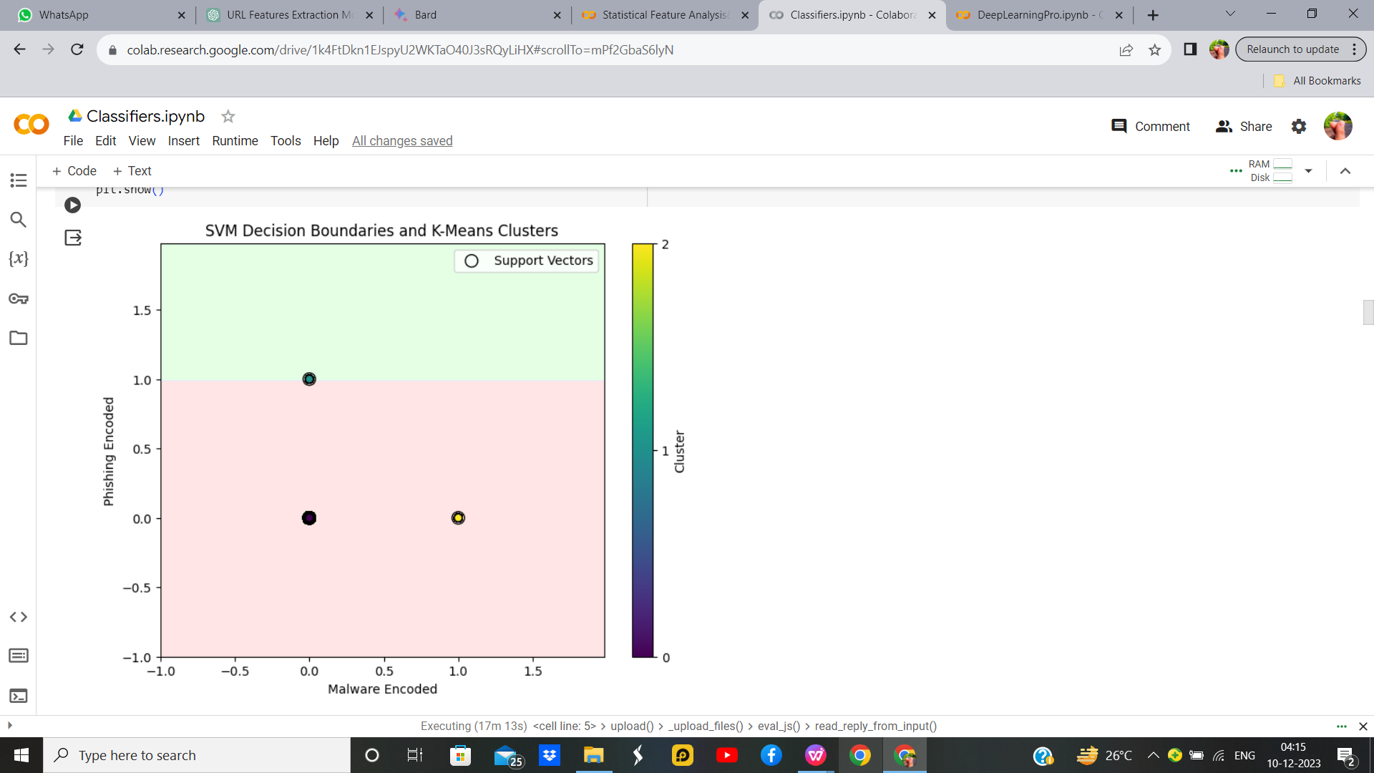

Figure 35 : K-Means with SVM Without Hyperparameters Output

**Hyperparameter Tuning approach used:** Grid Search CV

**K-Means with SVM with Hyperparameter**

**Output:**

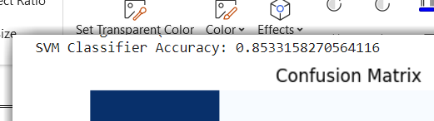

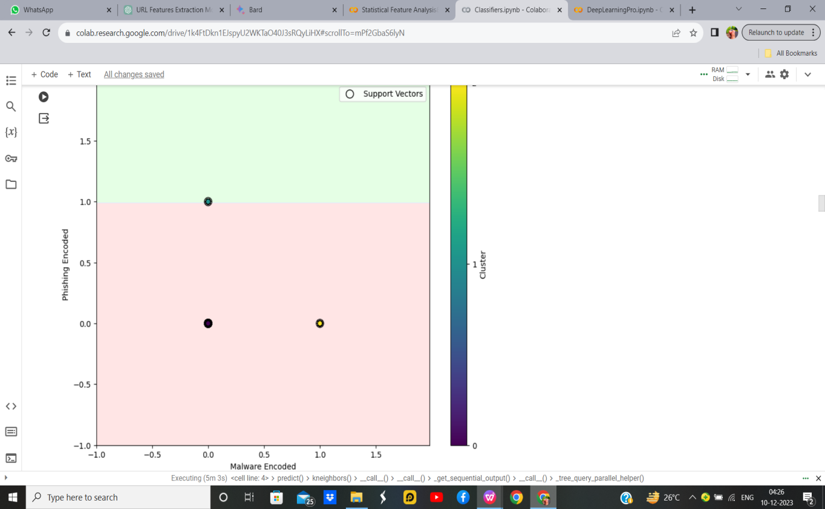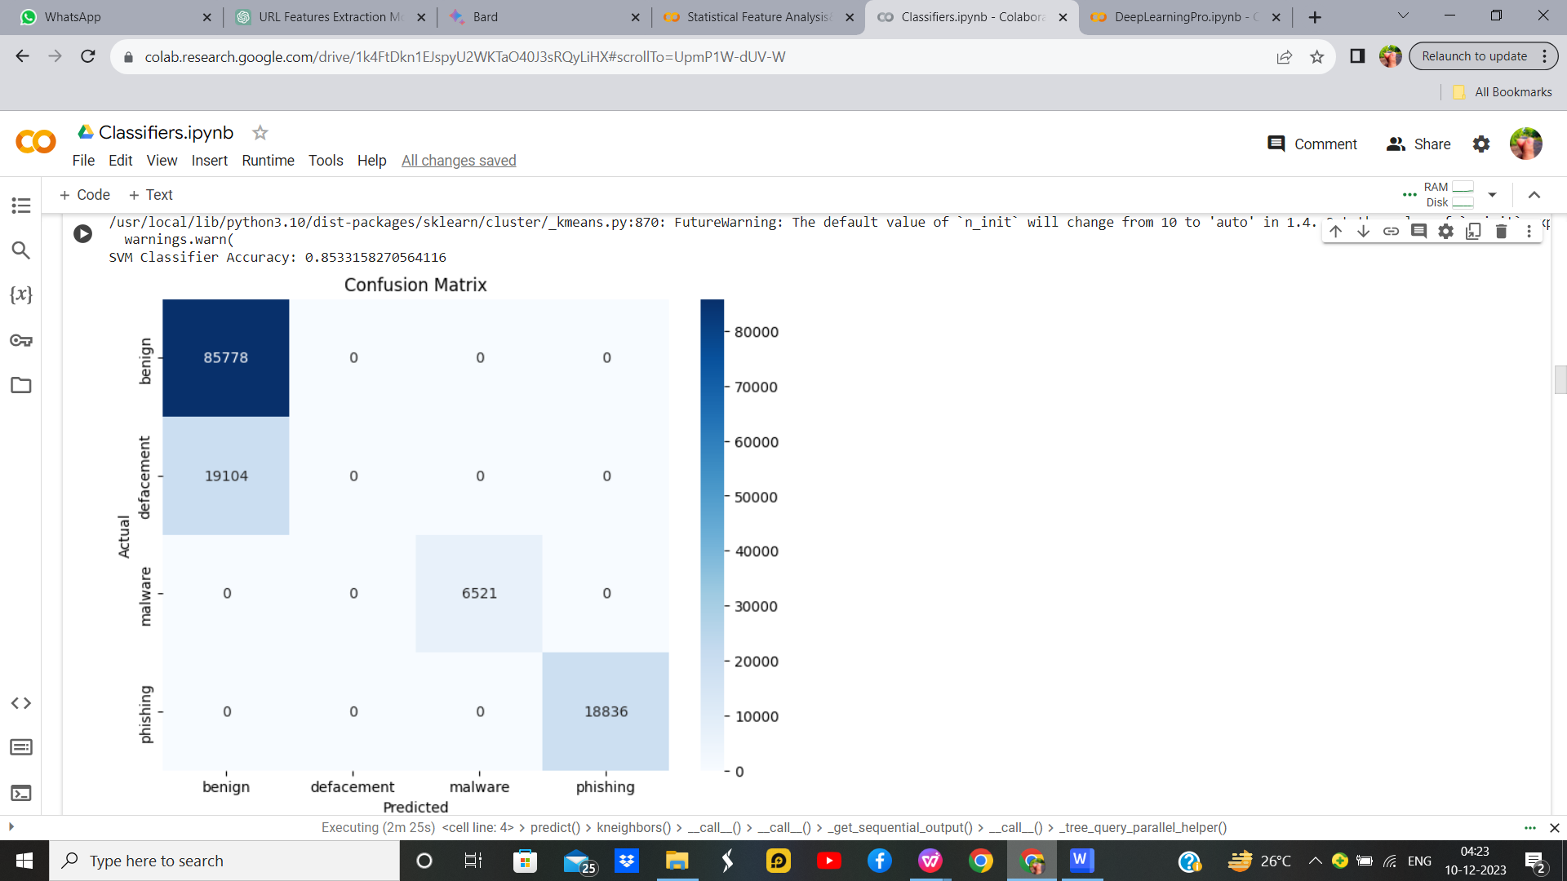

Figure 36 : K-Means with SVM With Hyperparameters Output

**Inference:**

We are appling K-Means clustering to the features, creating a new feature 'cluster'. It then uses these features, along with the original ones, to train a Support Vector Machine (SVM) classifier with a linear kernel and specified hyperparameters (C=1.0, gamma='scale'). The SVM model is evaluated on the test set, and its accuracy is calculated. Finally, a confusion matrix is plotted to visualize the performance of the SVM classifier. The 'cluster' feature derived from K-Means clustering is utilized to enhance the model's predictive ability. The choice of SVM and the hyperparameters should be fine-tuned based on the specific characteristics of the data for optimal performance.We can see that there accuracy remains same for classification with and without hyperparameter.

Table 12 : Parameters for K-means with SVM

|  |  |  |
| --- | --- | --- |
| **Parameter Name** | **Purpose** | **Value** |
| Test size | To split the dataset into training and testing in a ratio | 0.2 |
| Random State | This parameter sets the seed for the random number generator used by the data splitter. By using a fixed seed, the random splitting process becomes deterministic, allowing for result reproducibility. | 42 |
| Kernel | kernel is a function that computes the dot product of two data points in a transformed feature space. | Linear |
| Grid Search CV | The grid search explores various alpha values using 5-fold cross-validation. | 0.1, 1, 10 |

* + 1. **Fuzzy C-Means with KNN**

Combining Fuzzy C-Means (FCM) with k-Nearest Neighbors (KNN) involves using FCM to assign fuzzy memberships to clusters for each data point. These membership values are then employed as weights in KNN, allowing for a more nuanced and accurate prediction by considering the soft relationships between data points and clusters. This approach is beneficial when data points may belong to multiple clusters simultaneously.

Integrating Fuzzy C-Means (FCM) with k-Nearest Neighbors (KNN) involves first applying FCM to assign fuzzy memberships to clusters for each data point. These memberships, indicating the strength of association with each cluster, are then utilized as weights in the KNN algorithm. By incorporating FCM's soft clustering results, this approach captures nuanced relationships in the data, offering a more flexible and accurate prediction. It is particularly useful when data points exhibit partial membership in multiple clusters, providing a more sophisticated way to handle complex relationships in the dataset.

**Fuzzy C-Means with KNN without Hyperparameter**

**Output:**



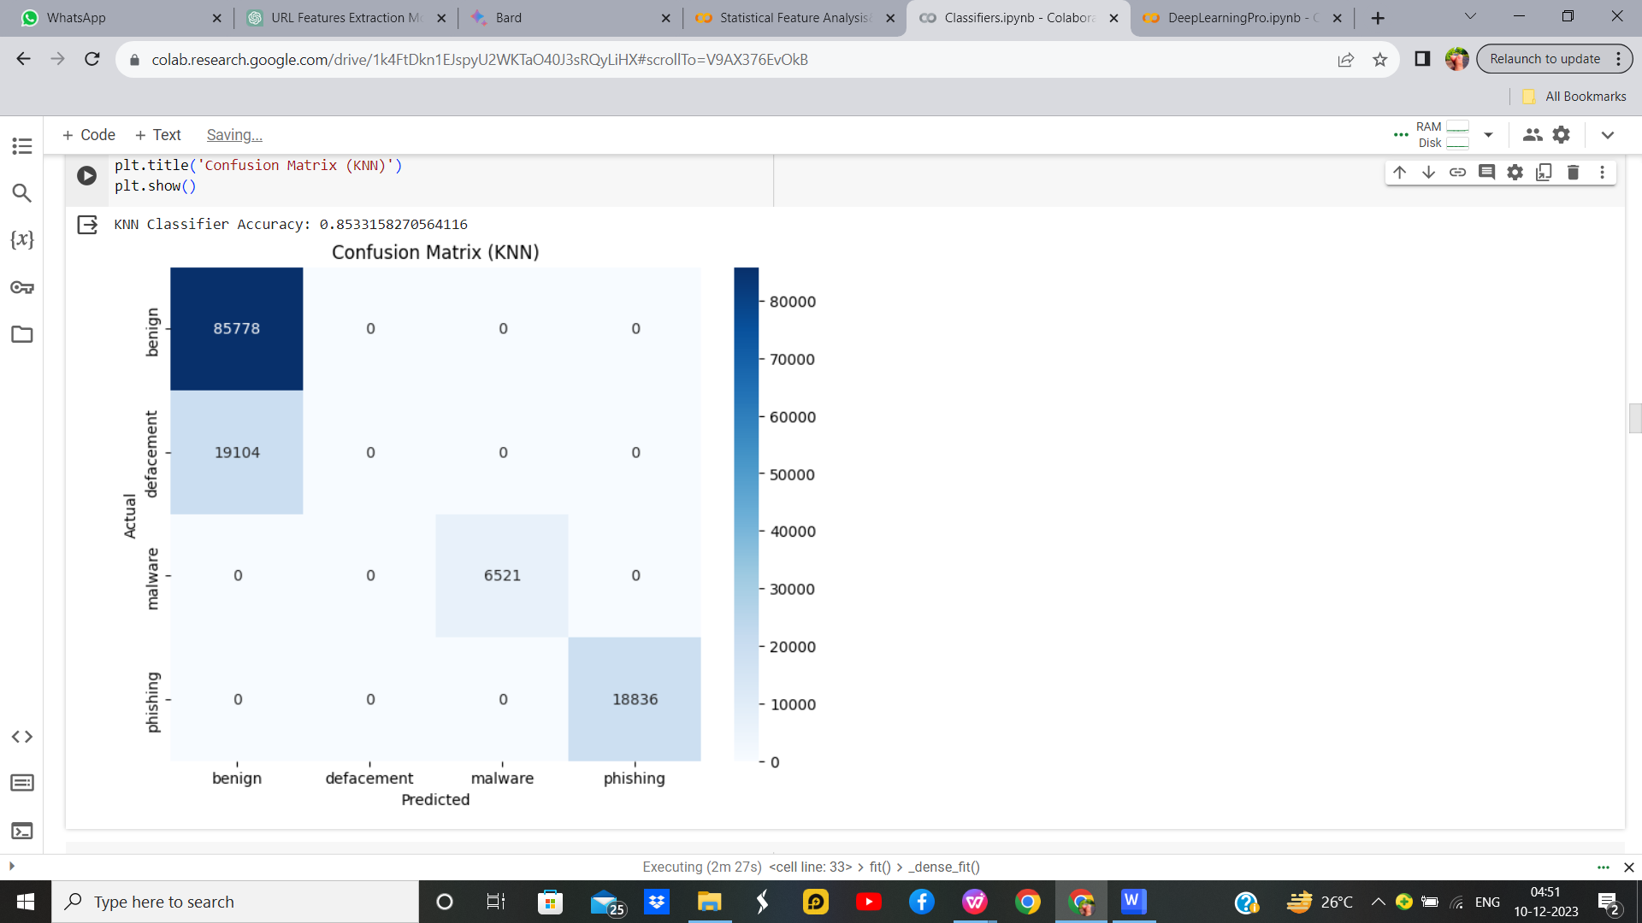

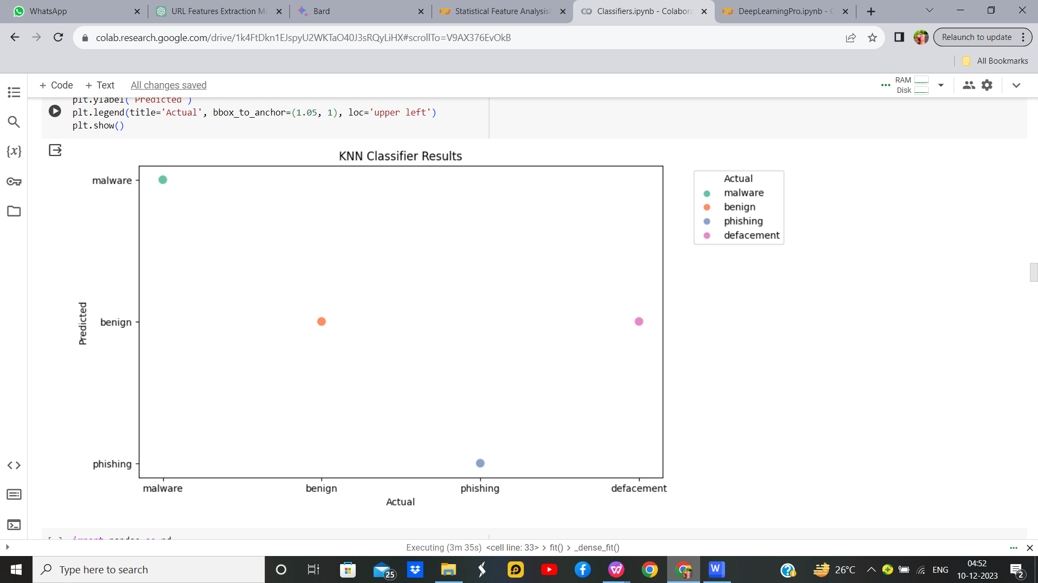

Figure 37 : Fuzzy with C-Means Without Hyperparameters Output

**Fuzzy C-Means with KNN with Hyperparameter**

**Hyperparameter Tuning approach used:** Grid Search CV

**Output:**

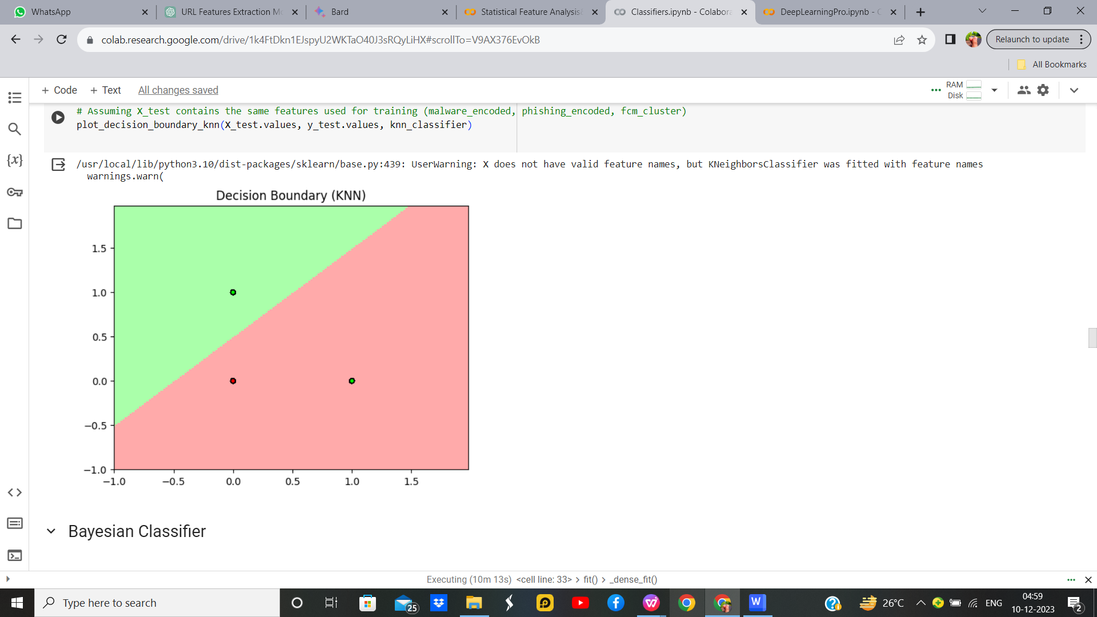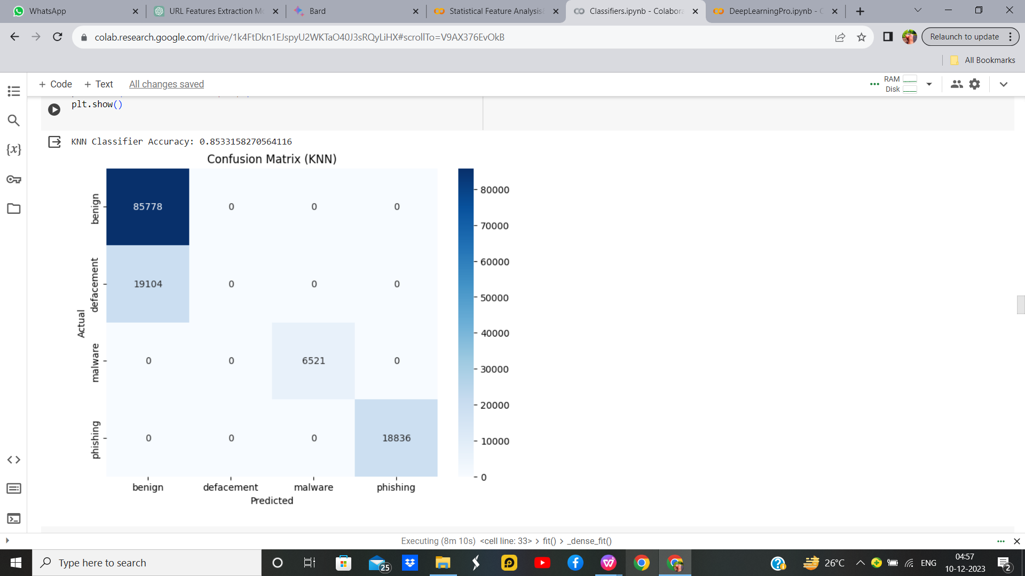

Figure 38 : Fuzzy with C-Means With Hyperparameters Output

Table 13 : Parameters for Fuzzy C-means with KNN

|  |  |  |
| --- | --- | --- |
| **Parameter Name** | **Purpose** | **Value** |
| Test size | To split the dataset into training and testing in a ratio | 0.2 |
| Random State | This parameter sets the seed for the random number generator used by the data splitter. By using a fixed seed, the random splitting process becomes deterministic, allowing for result reproducibility. | 42 |
| No. of Clusters | Number of the centroid which will be formed | 2 |
| Grid Search CV | The grid search explores various alpha values using 5-fold cross-validation. | n_neighbors: 3, 5, 7, 9 |

**Inference:**

Fuzzy C-means (FCM) clustering with k-Nearest Neighbors (KNN) classification. FCM is applied to features ('malware_encoded' and 'phishing_encoded') to obtain fuzzy cluster memberships. These memberships are integrated into the dataset, and KNN is trained and evaluated on the resulting features. The KNN classifier achieves an accuracy_knn on the test set. The confusion matrix visually depicts the model's performance. FCM clustering provides soft assignments, allowing the KNN model to benefit from the fuzzy cluster information. This approach could enhance classification accuracy, especially when dealing with complex and overlapping patterns in the data. Adjustments to KNN hyperparameters might further optimize results.

* + 1. **Bayesian Classifier**

The Bayesian Classifier is a probabilistic model that we use to classify data based on Bayes' theorem. It's a statistical approach that leverages prior knowledge about the data to make predictions or decisions. Essentially, it calculates the probability of a particular outcome given the prior knowledge and the observed evidence. In the context of classification, it's like having a set of rules that help me determine the probability of a data point belonging to a certain category. As I encounter new data, I update my beliefs and refine my predictions, making the Bayesian Classifier a flexible and dynamic tool for handling uncertainty in various domains such as machine learning, spam filtering, and medical diagnosis.

**Bayesian Classifier without hyperparameter**

**Output:**



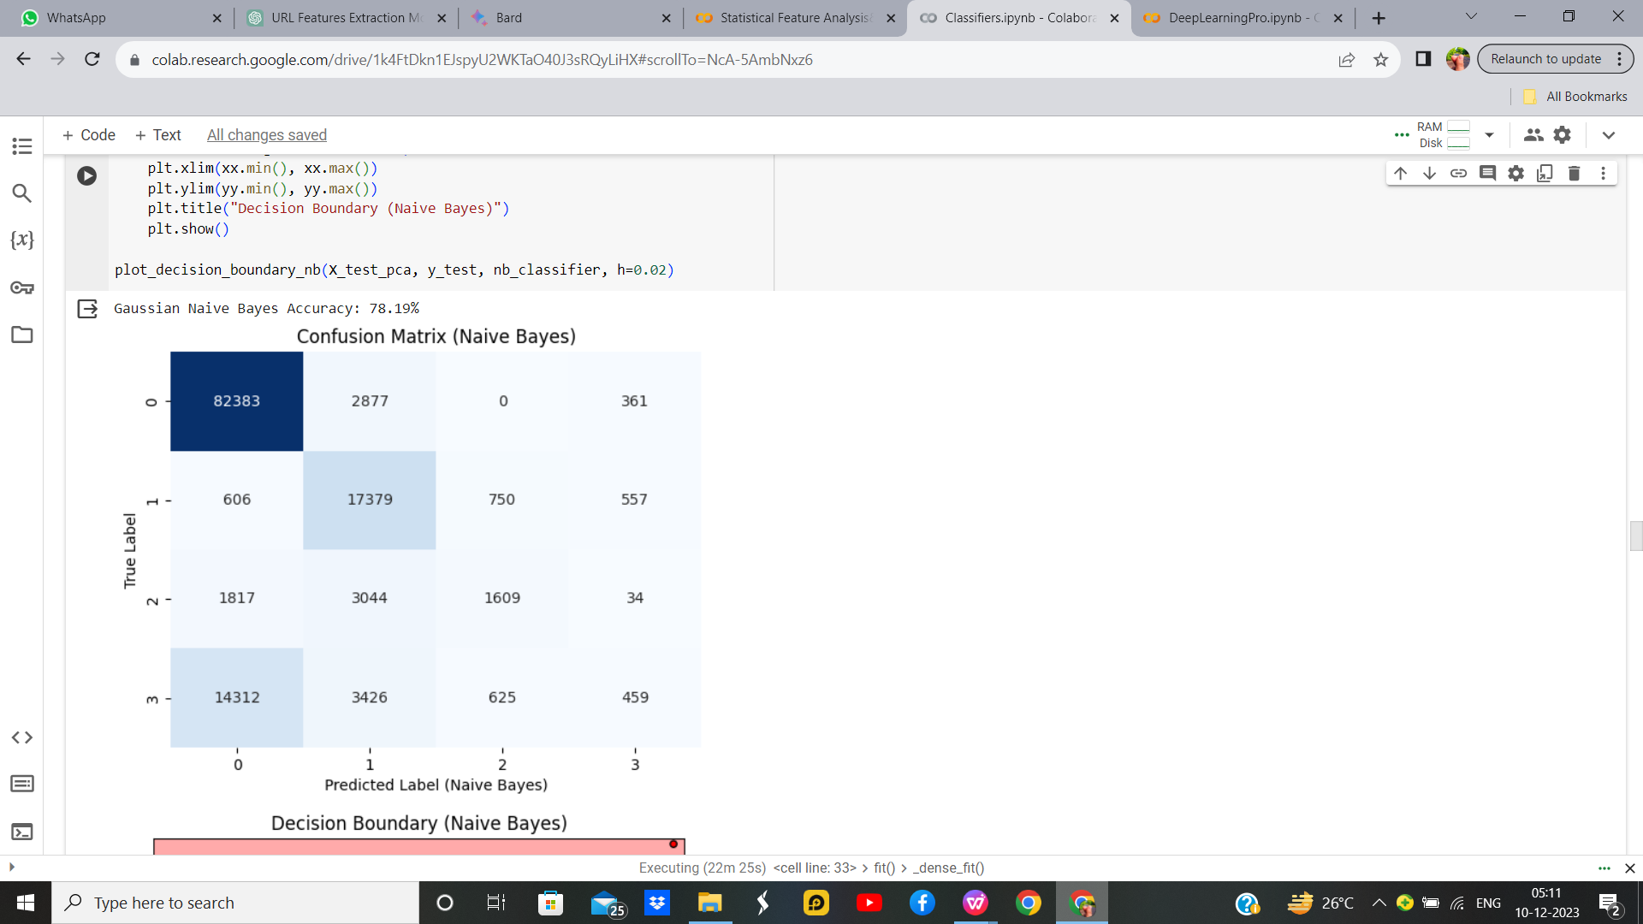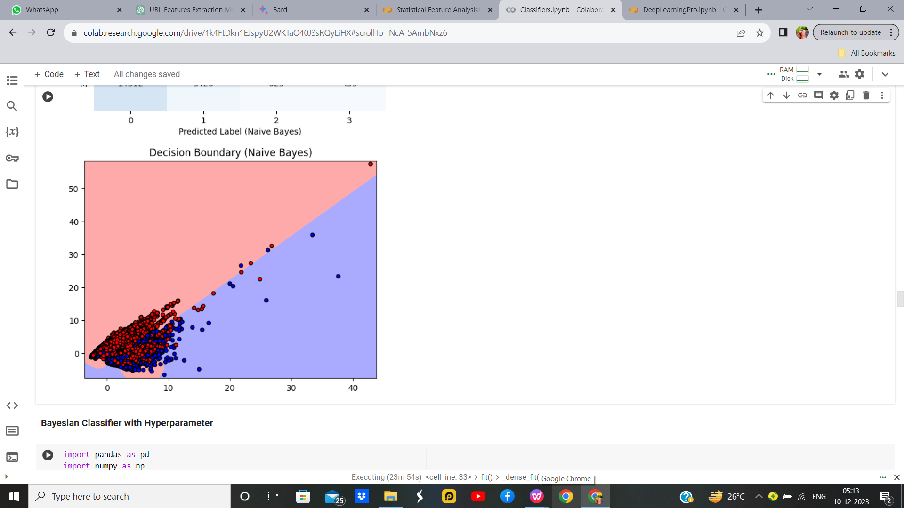

Figure 38 : Bayesian Classifier Without Hyperparameters Output

**Bayesian Classifier with hyperparameter**

**Hyperparameter Tuning approach used:** Grid Search Cv

**Output:**



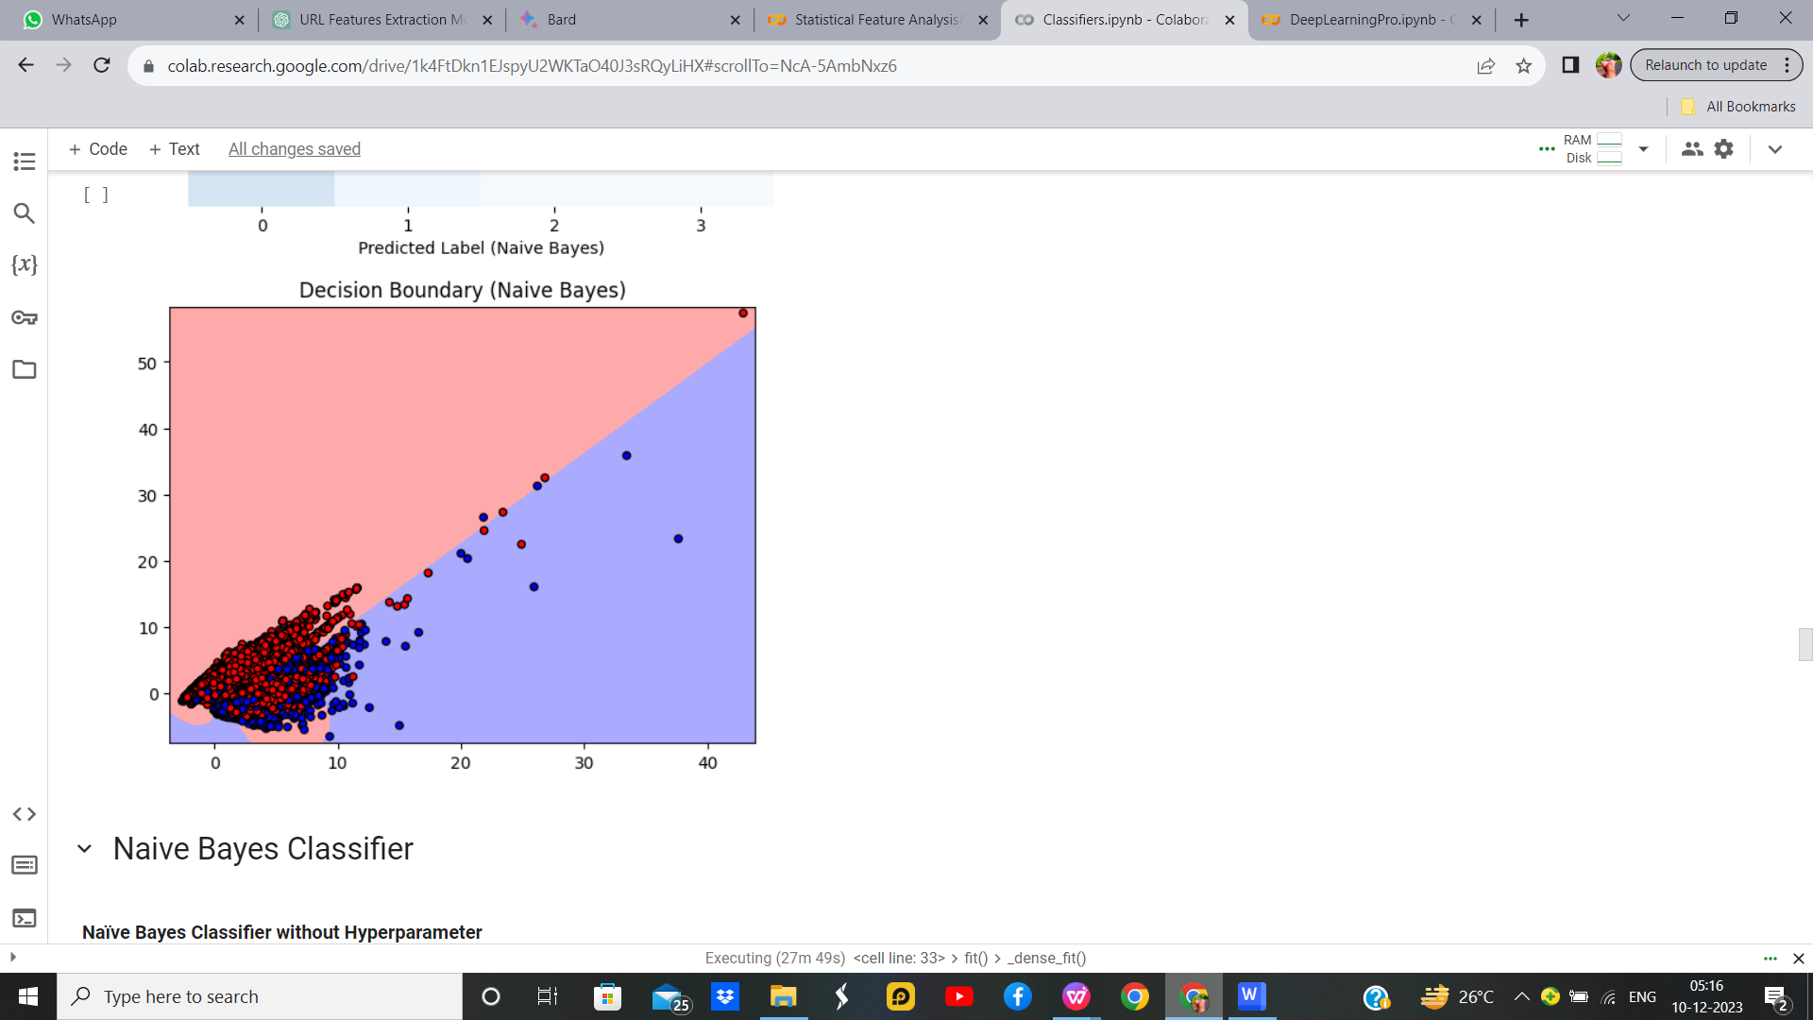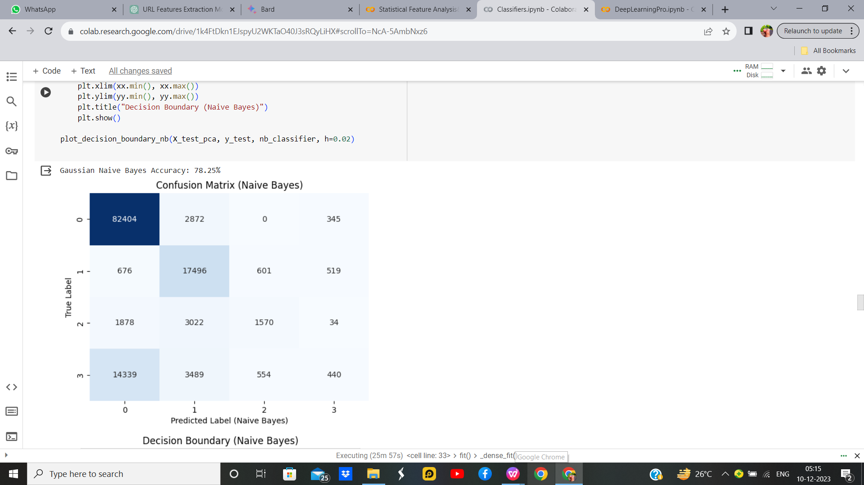

Figure 39 : Bayesian Classifier With Hyperparameters Output

Table 13 : Parameters for Bayesian Classifier

|  |  |  |
| --- | --- | --- |
| **Parameter Name** | **Purpose** | **Value** |
| Test size | To split the dataset into training and testing in a ratio | 0.2 |
| Random State | This parameter sets the seed for the random number generator used by the data splitter. By using a fixed seed, the random splitting process becomes deterministic, allowing for result reproducibility. | 5 |
| Grid Search CV | The grid search explores various alpha values using 5-fold cross-validation. | np.logspace(0, -9, num=100) |

**Inference:**

We appliedGaussian Naive Bayes (NB) classification to phishing website detection using features related to URL characteristics. The dataset is preprocessed, split into training and testing sets, and standardized. Principal Component Analysis (PCA) is used for dimensionality reduction. Hyperparameter tuning is performed using GridSearchCV, and the best model is trained and evaluated. The confusion matrix and decision boundary visualization demonstrate the model's performance. PCA aids in visualization and dimensionality reduction. The NB classifier effectively distinguishes phishing websites based on URL features, showcasing its utility in cybersecurity applications.We can see that there is an 0.06 % increase in accuracy with a Naive Bayses with Hyperparameter.

* + 1. **Naïve Bayes Classifier**

Naive Bayes is a probabilistic classification algorithm based on Bayes' theorem. It makes the "naive" assumption that the features used for classification are conditionally independent given the class label. Despite its simplicity and this assumption, Naive Bayes often performs well in practice and is computationally efficient. During training, the algorithm estimates the probabilities required by Bayes' theorem based on the given dataset, calculating prior probabilities and conditional probabilities for each feature given each class. In the prediction phase, it applies Bayes' theorem to determine the probability of each class given the observed features, ultimately assigning the class with the highest probability as the predicted class. Naive Bayes comes in different variants, such as Multinomial, Gaussian, and Bernoulli, catering to different types of data. It is commonly used in text classification, spam filtering, and various other classification tasks.

**Naïve Bayes Classifier without Hyperparameter**

**Output:**



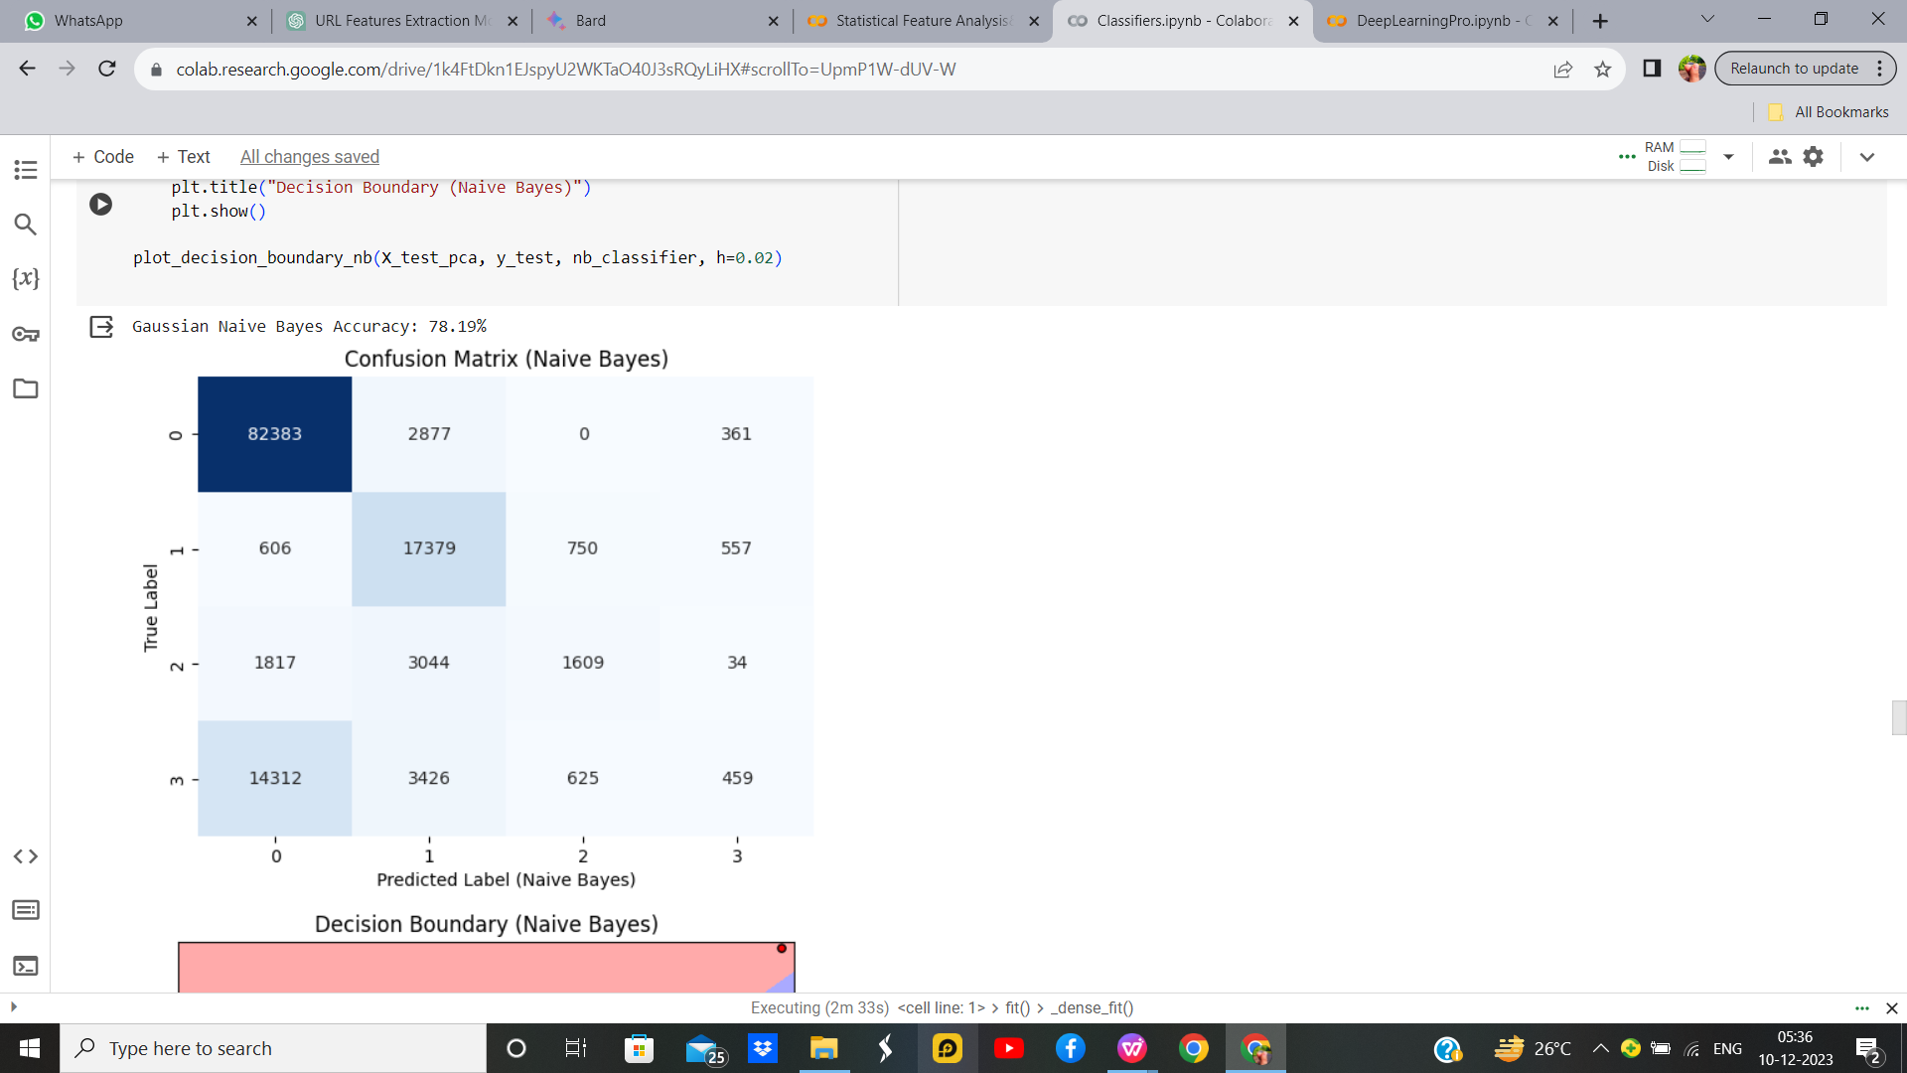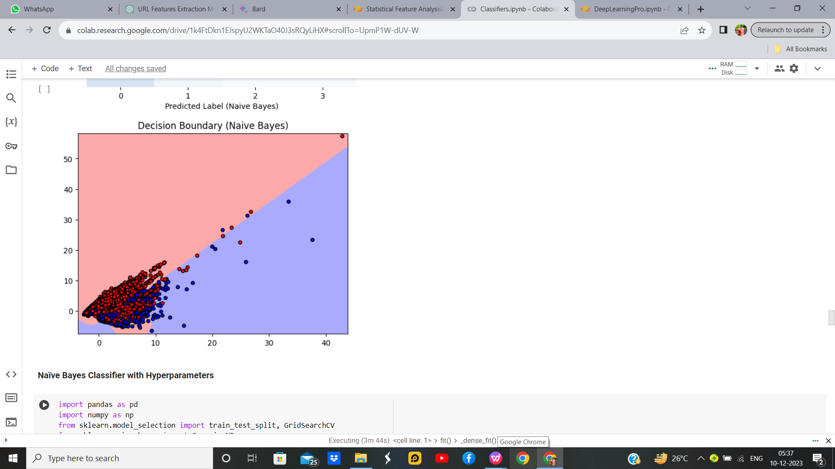

Figure 40 : Naive Bayes Without Hyperparameters Output

**Naïve Bayes Classifier with Hyperparameter**

**Output:**



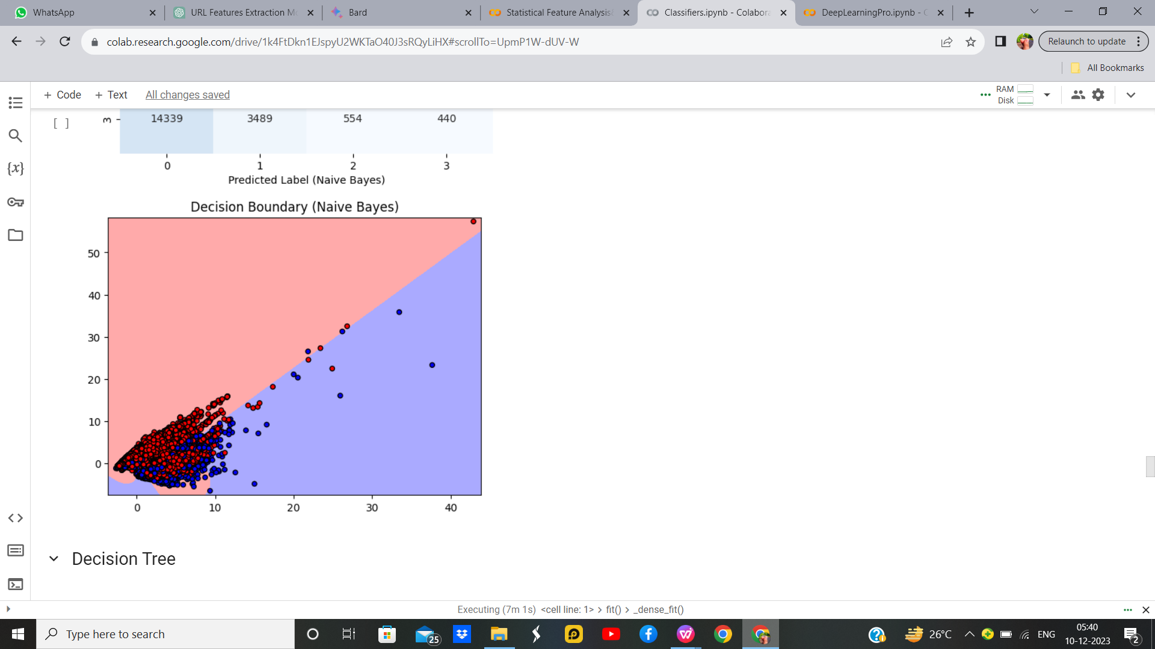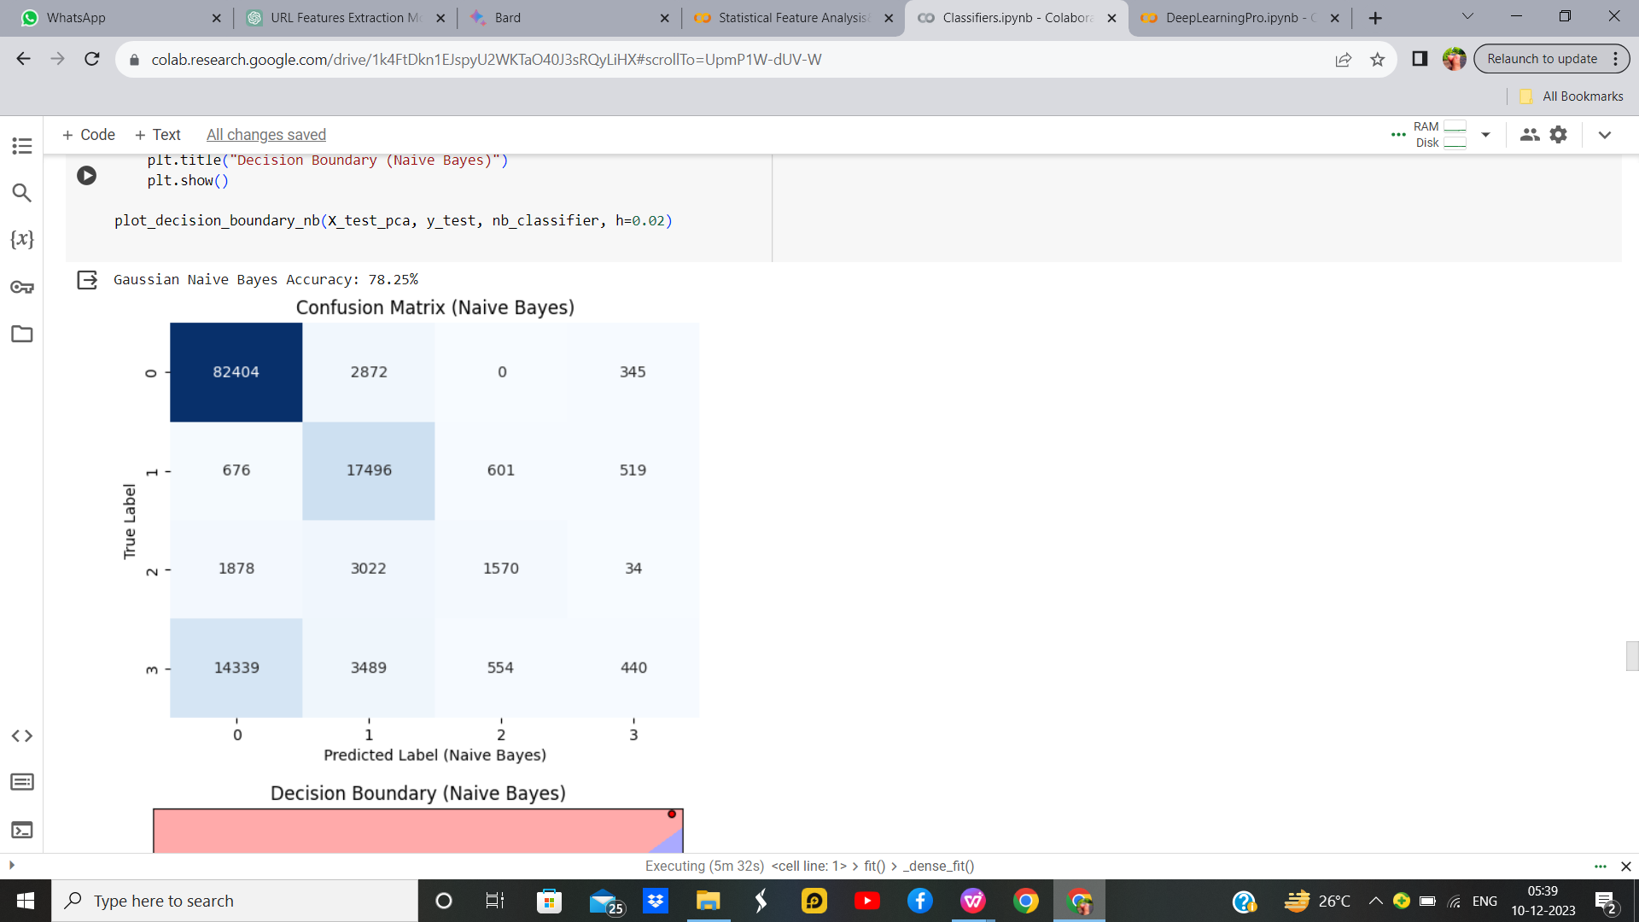

Figure 41 : Naive Bayes With Hyperparameters Output

Table 14 : Parameters for Naive Bayes

|  |  |  |
| --- | --- | --- |
| **Parameter Name** | **Purpose** | **Value** |
| Test size | To split the dataset into training and testing in a ratio | 0.2 |
| Random State | This parameter sets the seed for the random number generator used by the data splitter. By using a fixed seed, the random splitting process becomes deterministic, allowing for result reproducibility. | 5 |
| Grid Search CV | The grid search explores various alpha values using 5-fold cross-validation. | np.logspace(0, -9, num=100) |

**Inference:**

The Gaussian Naive Bayes classifier achieved an accuracy of approximately 79%. The confusion matrix visualizes its performance, showing good predictive capabilities. The decision boundary plot illustrates how the classifier separates classes in the reduced 2D space. The algorithm effectively captures patterns in the data, revealing distinct regions for different classes. It demonstrates the model's ability to generalize and make accurate predictions based on the selected features. Overall, the Naive Bayes classifier, with optimized smoothing parameters and dimensionality reduction through PCA, proves effective in classifying phishing website data, providing valuable insights for cybersecurity applications.In Naive Bayes classifier we can absorb that the accuracy increase by 0.06% with hyperparameter.

* + 1. **Decision Tree**

A decision tree is a graphical model used for decision-making and problem-solving. It resembles an inverted tree, with a root node representing the initial decision or question, branches symbolizing the possible choices or outcomes, and leaf nodes indicating the final decision or conclusion. Each node in the tree corresponds to a specific feature or attribute, and the branches represent the possible values or states that the feature can take. The construction of the tree involves recursively partitioning the data based on the most informative features, aiming to maximize predictive accuracy. Decision trees are widely employed in machine learning for classification and regression tasks, as they offer a transparent and intuitive way to understand complex decision processes and identify key factors influencing outcomes.

**Decision Tree with hyperparameter**

**Output:**

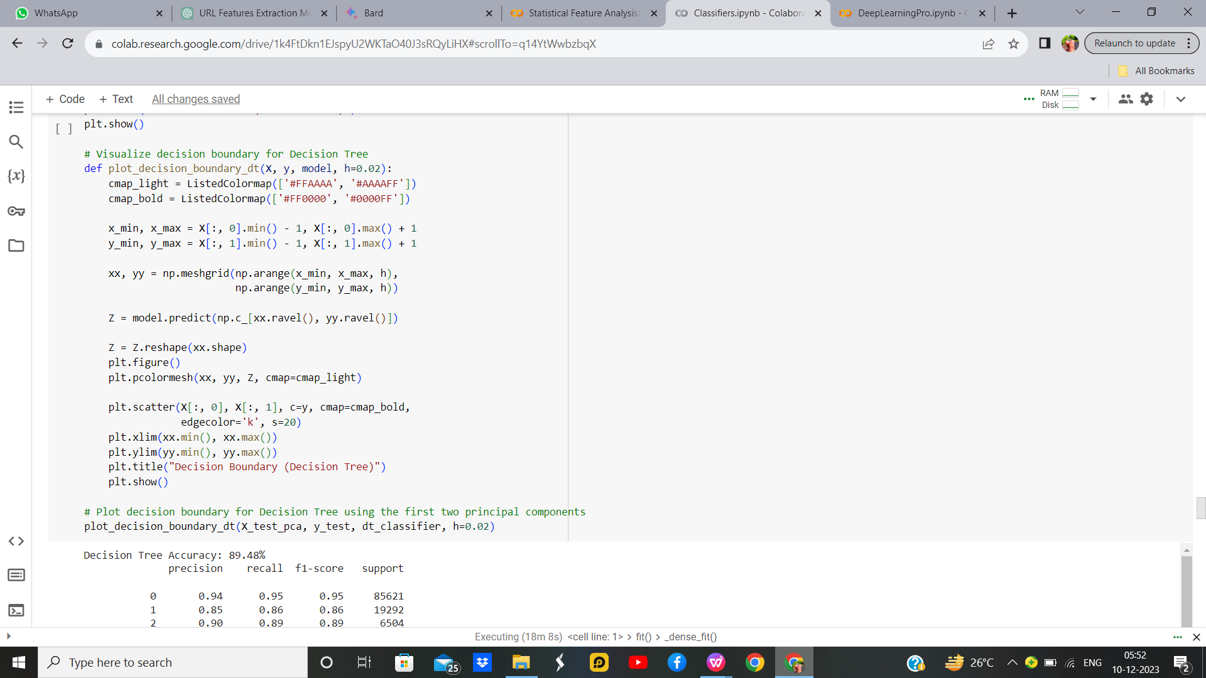

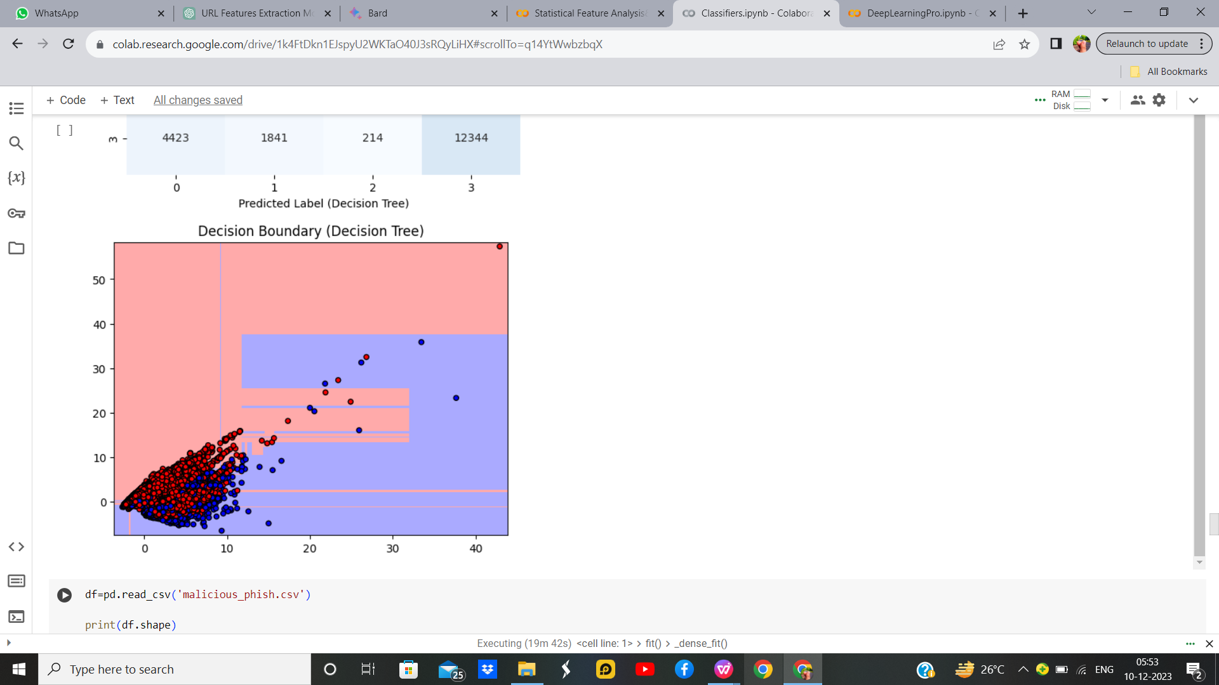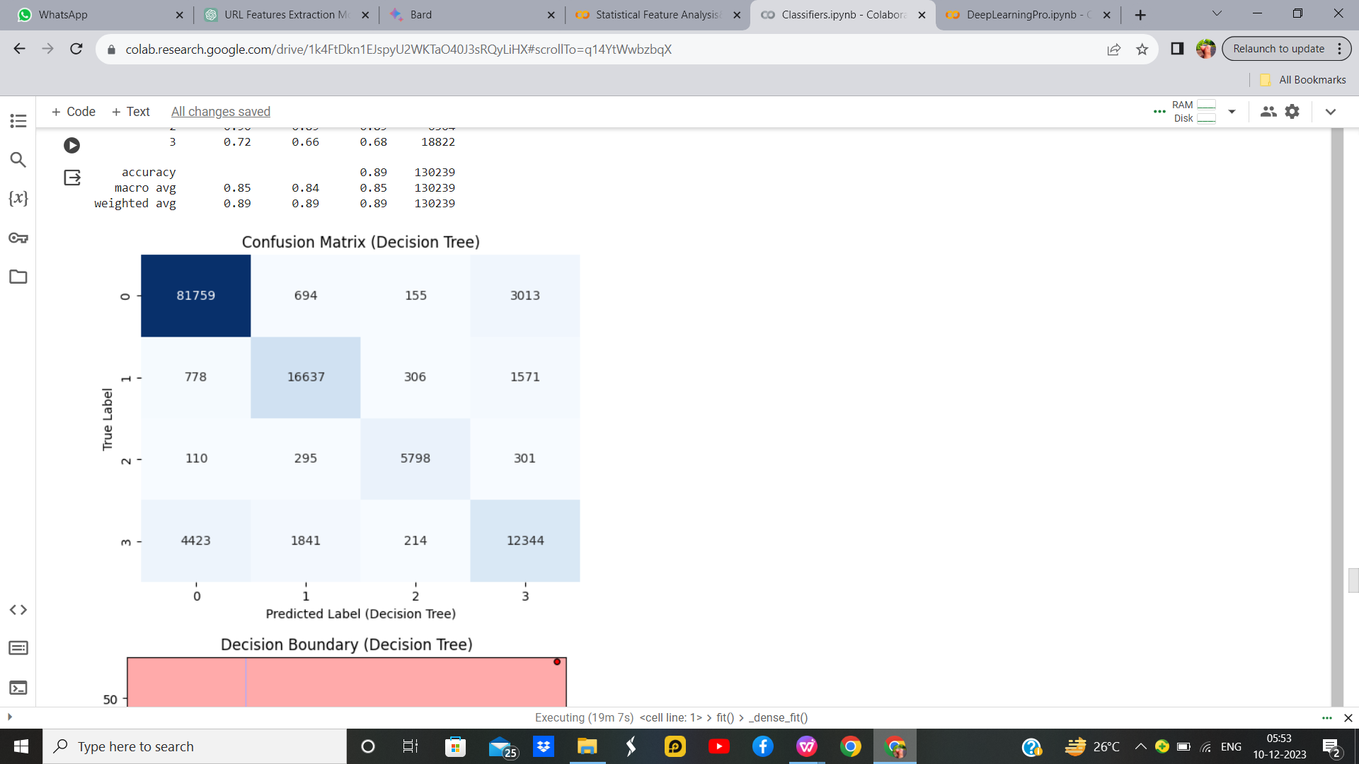

Figure 42: Decision Tree Without Hyperparameters Output

**Decision Tree With Hyperparameters**

**Output:**



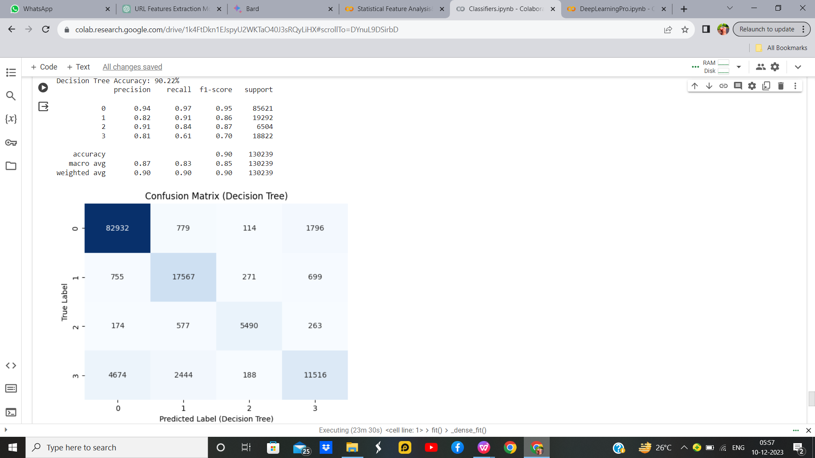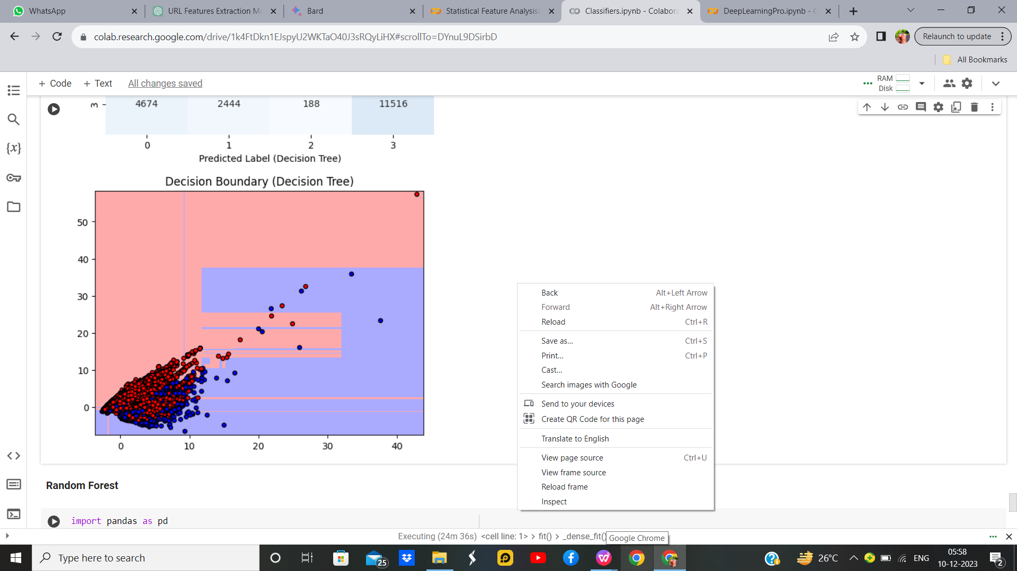

Figure 43: Decision Tree With Hyperparameters Output

**Inference:**  
The Decision Tree classifier achieved an accuracy of approximately 90%. The classification report provides detailed metrics, showing good performance across different classes. The confusion matrix visualizes the model's predictions, demonstrating balanced accuracy. The decision boundary plot illustrates how the Decision Tree separates classes in the reduced 2D space. It captures complex decision boundaries, showcasing the model's ability to capture intricate patterns. The optimized hyperparameters, selected through grid search, enhance the model's performance. Overall, the Decision Tree classifier proves effective in classifying phishing website data, offering insights for cybersecurity applications with a focus on interpretability and ease of understanding.

Table 14 : Parameters for Decision Tree

|  |  |  |
| --- | --- | --- |
| **Parameter Name** | **Purpose** | **Value** |
| Test size | To split the dataset into training and testing in a ratio | 0.2 |
| Random State | This parameter sets the seed for the random number generator used by the data splitter. By using a fixed seed, the random splitting process becomes deterministic, allowing for result reproducibility. | 42 |
| Grid Search CV | The grid search explores various alpha values using 5-fold cross-validation. | 'criterion': ['gini', 'entropy'],  'max_depth': [None, 10, 20, 30, 40, 50], 'min_samples_split': [2, 5, 10], 'min_samples_leaf': [1, 2, 4] |

* + 1. **Random Forest:**

Random Forest is an ensemble learning algorithm that constructs multiple decision trees during training and outputs the mode of the classes for classification tasks. It enhances predictive accuracy and reduces overfitting by aggregating the predictions of individual trees. By introducing randomness in the tree-building process, such as bootstrap sampling and random feature selection, it promotes diversity among the trees. This leads to robust and accurate predictions, making Random Forest a powerful tool for various applications, from classification to regression. Its versatility, efficiency, and ability to handle complex datasets contribute to its popularity in machine learning workflows.

**Output:**

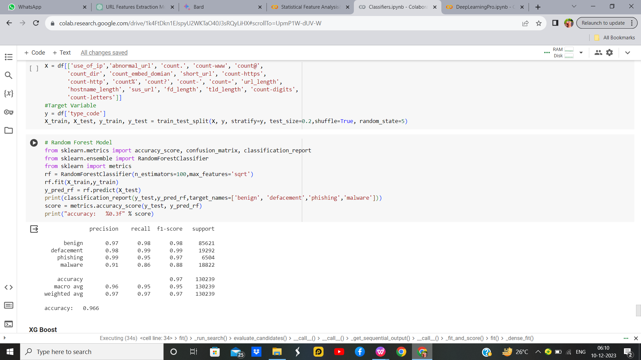

Figure 44: Random Forest Output

* + 1. **Comparisons Table:**

|  |  |  |  |  |  |
| --- | --- | --- | --- | --- | --- |
| **S.No** | **Algorithm name** | **Test Size** | **Random State** | **Grid Search CV** | **Accuracy** |
| 1 | KMeans with KNN | 0.2 | 42 | n_neighbors: 3, 5, 7, 9 | 85.33% |
| 2 | Fuzzy C-Means with KNN | 0.2 | 42 | 'n_clusters': [3, 4, 5],  'm': [1.5, 2.0, 2.5] | 85.33% |
| 3 | KMeans with SVM | 0.2 | 42 | 'kernel': ['linear', 'rbf'], 'C': [0.1, 1, 10], 'gamma': ['scale', 'auto'] | 85.33% |
| 4 | Bayesian Classifier | 0.2 | 42 | np.logspace(0, -9, num=100) | 78.25% |
| 5 | Naïve Bayes Classifier | 0.2 | 42 | np.logspace(0, -9, num=100) | 78.25% |
| 6 | Decision Tree | 0.2 | 42 | 'criterion':['gini','entropy'],  'max_depth': [None, 10, 20, 30, 40, 50], 'min_samples_split': [2, 5, 10],  'min_samples_leaf': [1, 2, 4] | 90% |

Table 15 : Comparision Table

**SECTION 6**

* 1. **Deep learning**

Deep learning is a subfield of machine learning that involves the use of artificial neural networks to model and solve complex problems. Inspired by the structure and function of the human brain, deep learning algorithms consist of multiple layers of interconnected nodes, or neurons, organized into input, hidden, and output layers. These networks learn to perform tasks by adjusting the weights of connections between neurons based on the input data and desired output. What sets deep learning apart is its ability to automatically discover and extract hierarchical features from raw data, allowing it to effectively represent and learn intricate patterns in large and unstructured datasets. Deep learning has demonstrated remarkable success in various applications, such as image and speech recognition, natural language processing, and autonomous systems, making it a powerful and versatile approach for tackling complex problems in the realm of artificial intelligence.

* + 1. **K-Means with Convolutional Neural Network**

K-Means and Convolutional Neural Networks (CNNs) are distinct techniques, each serving a different purpose. K-Means is a clustering algorithm used for unsupervised learning, aiming to partition a dataset into K clusters based on similarities in feature space. It is often employed for tasks like image compression and segmentation. On the other hand, CNNs are a class of deep learning models designed for tasks involving grid-structured data, such as images. CNNs use convolutional layers to automatically learn hierarchical representations of features. While K-Means operates independently of neural networks, it's possible to use K-Means clustering to initialize the parameters of a CNN. For instance, in unsupervised pre-training, K-Means clustering can be employed to initialize the filters in the initial layers of a CNN. This can enhance convergence during subsequent supervised training, potentially leading to improved performance in image classification tasks. The combination of K-Means and CNNs illustrates how different techniques can be synergistically applied to address complex problems in machine learning and computer vision.

**K-Means with Convolutional Neural Network without Hyperparameter**

**Output:**

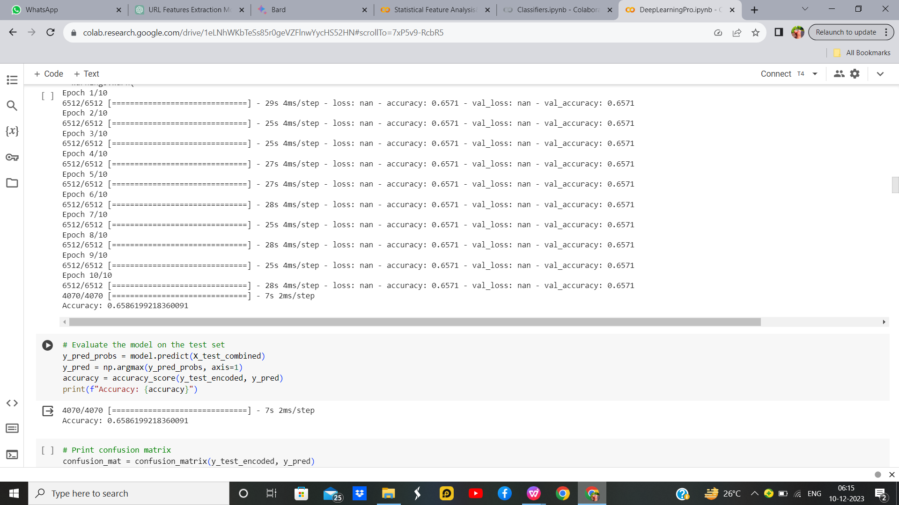

Figure 45:K-Means with Convolutional Neural Network without Hyperparameter

**K-Means with Convolutional Neural Network with Hyperparameter**

**Output:**

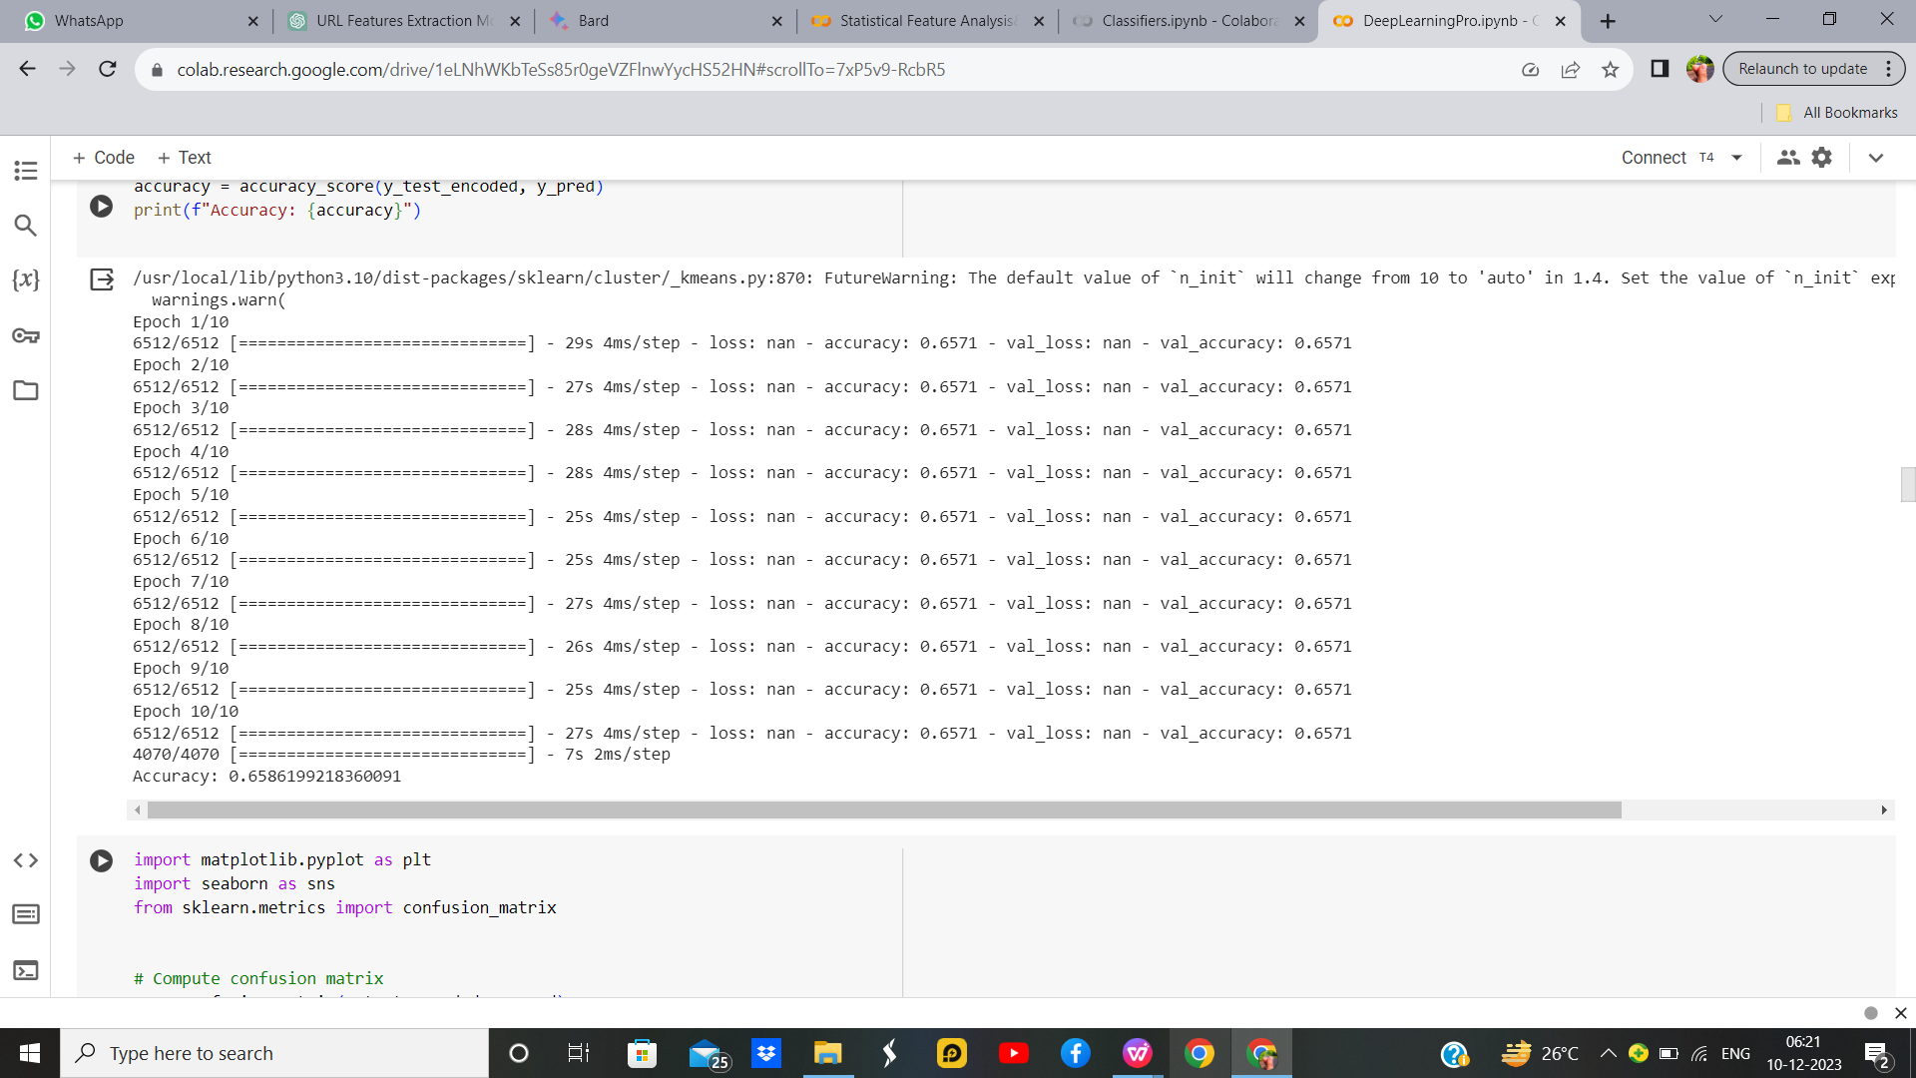

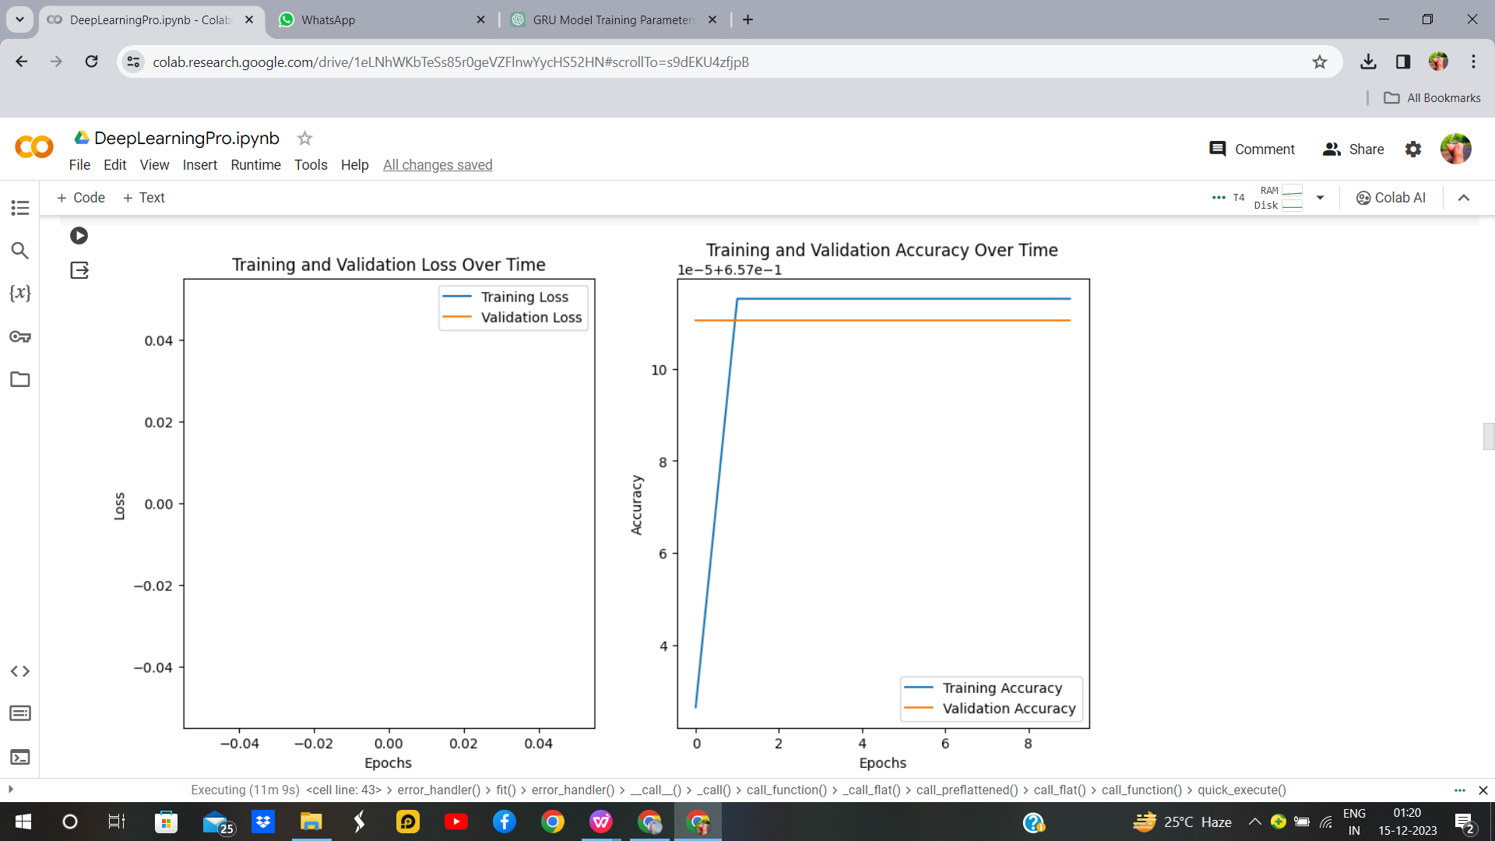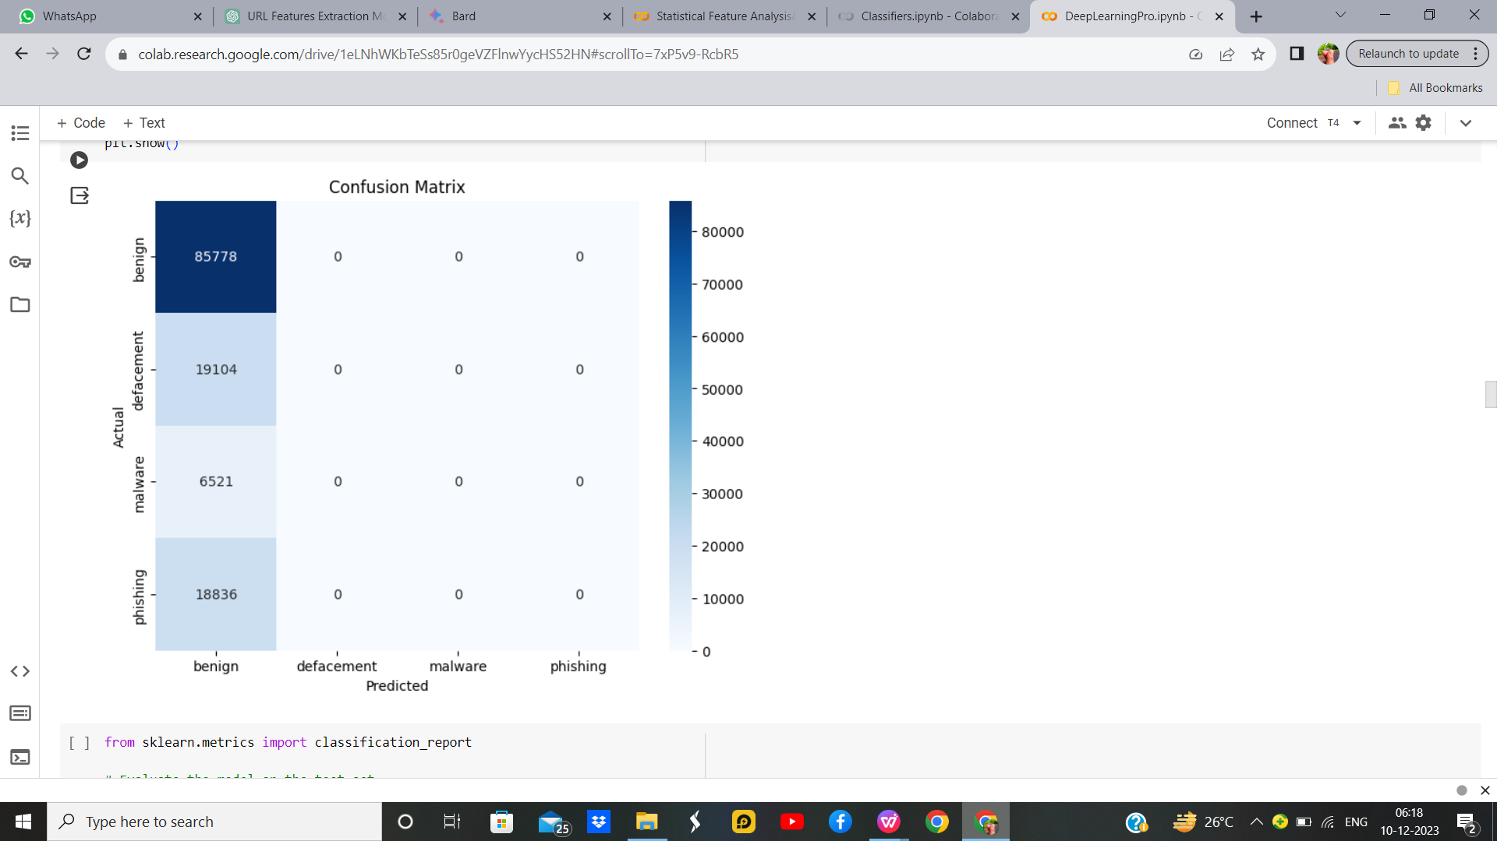

Figure 46:K-Means with Convolutional Neural Network with Hyperparameter

Table 16. Parameter/Hyperparameter Table

|  |  |  |
| --- | --- | --- |
| **S. No** | **Parameter Name** | **Value** |
| 1 | Epochs | 10 |
| 2 | Accuracy | 65.86% |
| 3 | Precision | 0.66 |
| 4 | Recall | 1.00 |
| 5 | F1 Score | 0.736 |
| 6 | Optimizer | Adam |
| 7 | Learning Rate | 0.001 |
| 8 | Batch | 64 |

**Inference:**

The combines K-means clustering with a Neural Network (NN) model for improved classification. It preprocesses the data by standardizing and encoding features. K-means clustering enriches the dataset with cluster information. The NN architecture includes dropout layers for regularization. The model is trained with an Adam optimizer and sparse categorical cross-entropy loss. Evaluating on the test set yields accuracy. This approach leverages both unsupervised clustering and supervised learning, allowing the NN to capture complex patterns within clusters. The code offers a versatile framework for tasks where incorporating clustering information enhances the predictive power of the model.

* + 1. **RNN**

Recurrent Neural Networks (RNNs) are a type of artificial neural network designed for sequential data processing. They have loops to allow information persistence, making them suitable for tasks involving sequences like time series, natural language, or speech. The code snippet to implement an RNN typically involves defining a sequential model in a deep learning library like TensorFlow or Keras, adding recurrent layers (e.g., LSTM or GRU), specifying input dimensions, and configuring training parameters. The RNN processes sequences by maintaining hidden states over time, enabling it to capture dependencies and patterns within sequential data, making it effective for tasks like language modeling, translation, and time series prediction.

**RNN without Hyperparameter:**

**Output:**

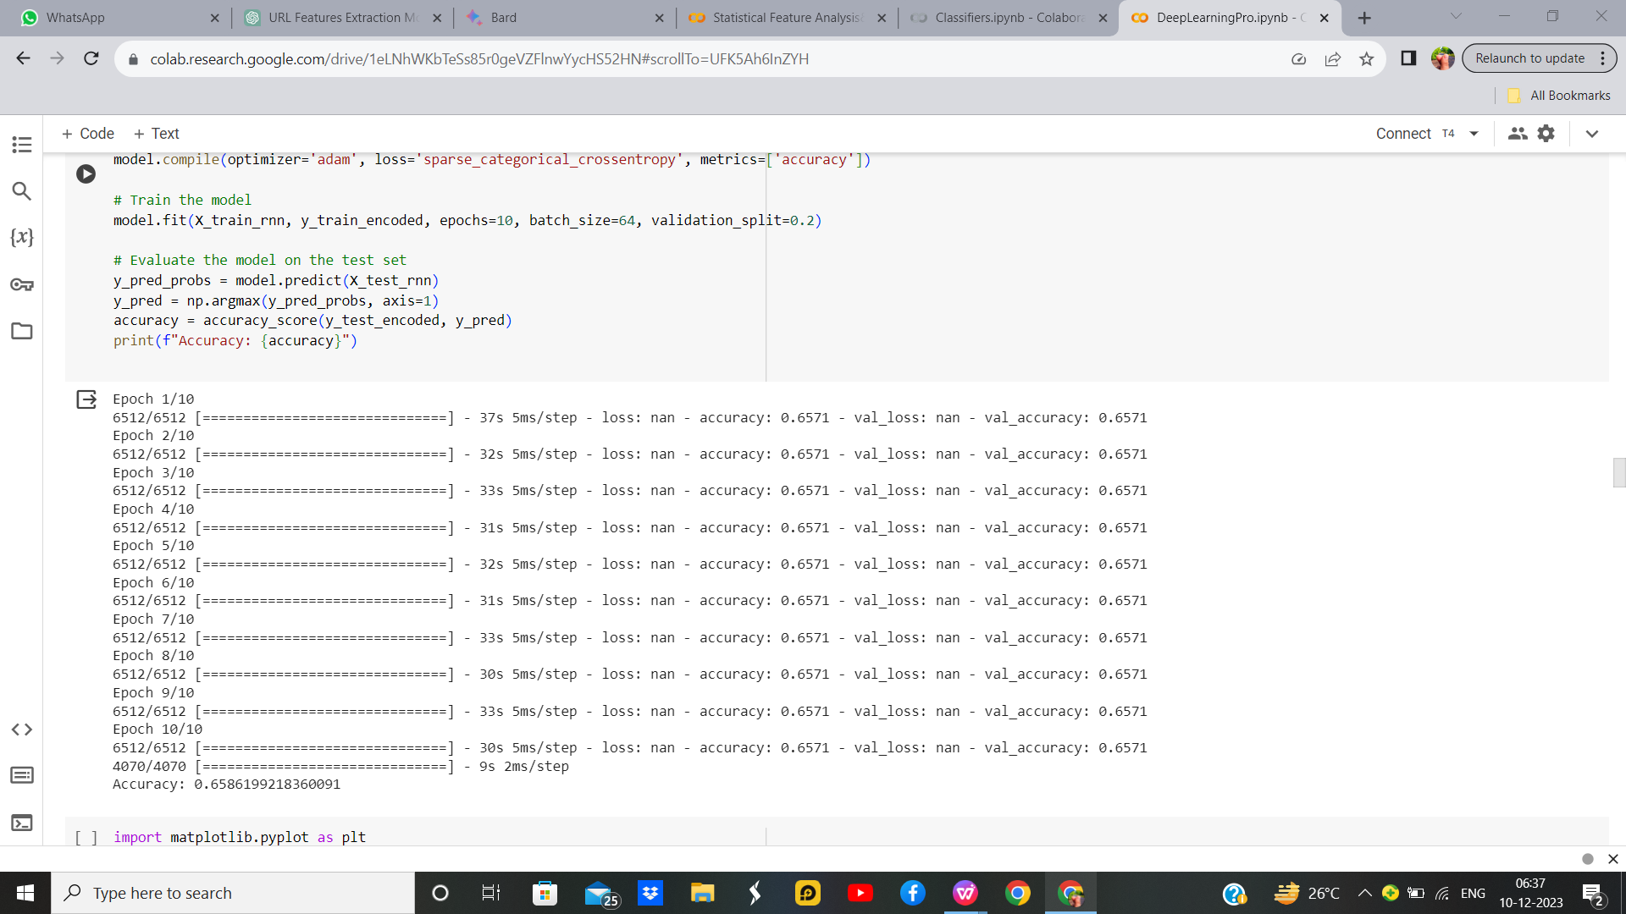

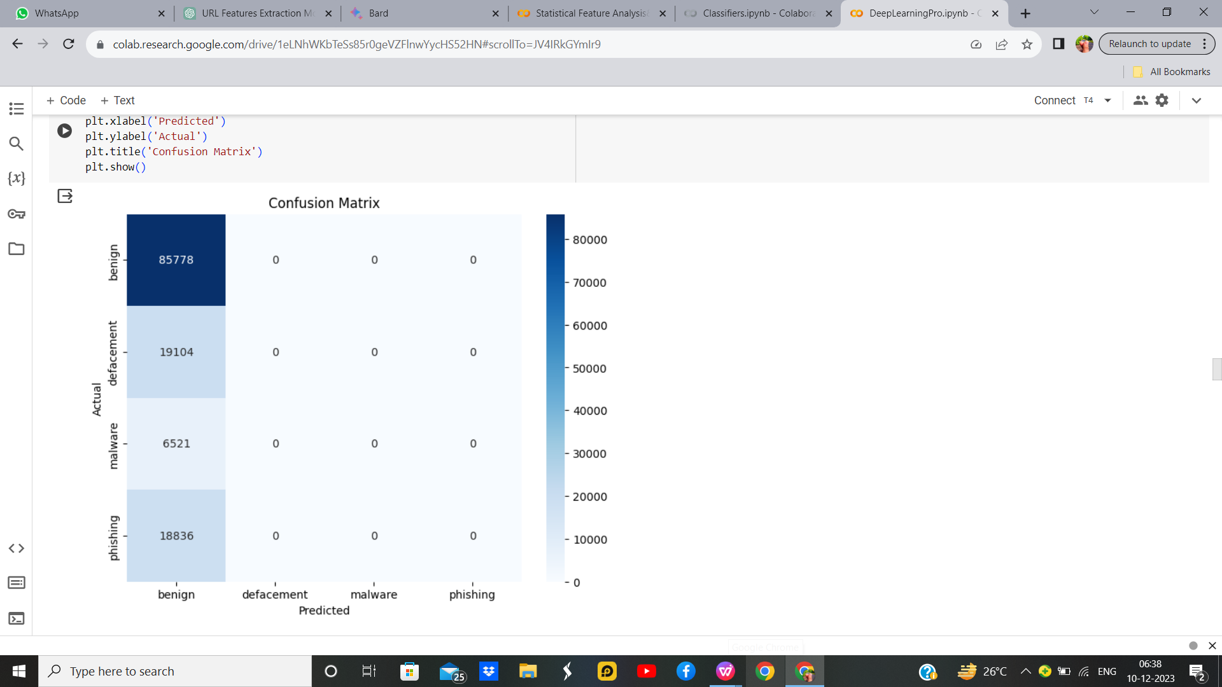

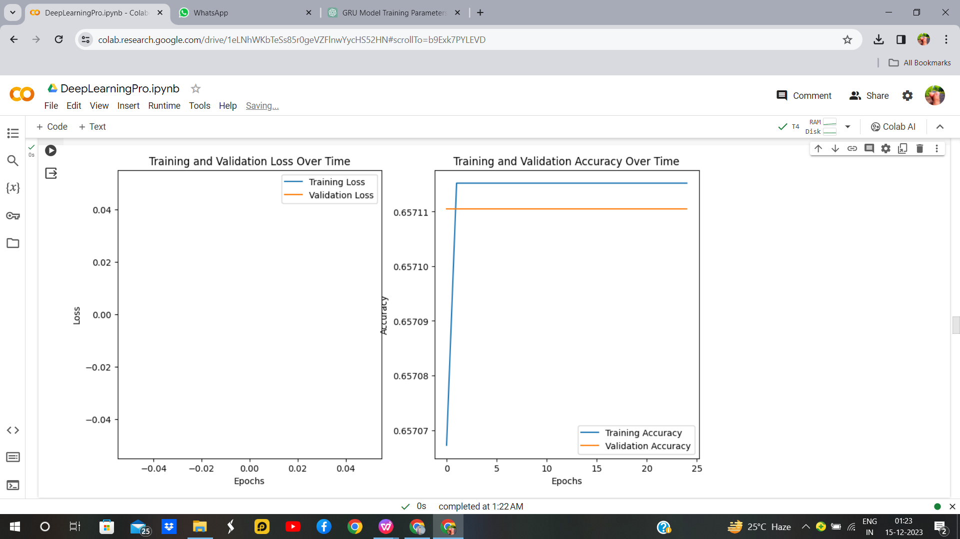

Figure 47:Recurrent Neural Network without Hyperparameter

**RNN Hyperparameter:**

**Output:**

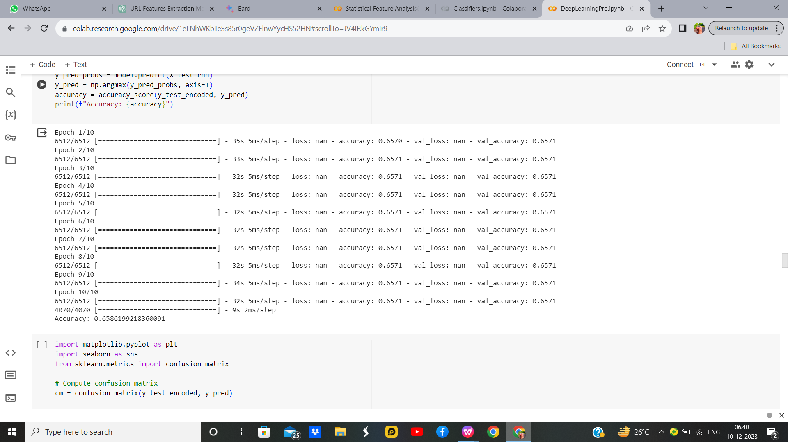

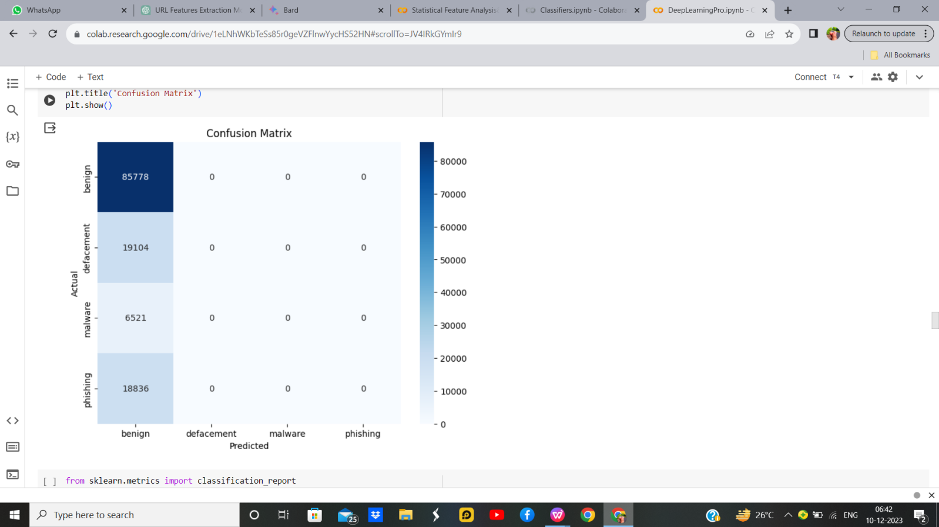



Figure 48:Recurrent Neural Network with Hyperparameter

**Inference:**

The implemented Recurrent Neural Network (RNN) is designed to classify cyber threats using sequential data. The LSTM architecture captures temporal dependencies in the features related to defacement, malware, and phishing. By training on standardized and encoded data, the model learns patterns in the sequences. The evaluation on the test set yields an accuracy score, indicating the RNN's ability to predict cyber threat types. This approach is advantageous for cybersecurity tasks where the order of events is crucial. The achieved accuracy reflects the model's proficiency in discerning different cyber threat categories based on the provided sequential data.

Table 17. Parameter/Hyperparameter Table

|  |  |  |
| --- | --- | --- |
| **S. No** | **Parameter Name** | **Value** |
| 1 | Epochs | 10 |
| 2 | Accuracy | 65.86% |
| 3 | Precision | 0.66 |
| 4 | Recall | 1.00 |
| 5 | F1 Score | 0.76 |
| 6 | Optimizer | Adam |
| 7 | Learning Rate | 0.001 |

* + 1. **LSTM**

Long Short-Term Memory (LSTM) is a type of recurrent neural network (RNN) architecture designed to address the vanishing gradient problem in traditional RNNs, which hinders their ability to capture long-range dependencies in sequential data. LSTMs introduce a memory cell with self-regulating gates, including an input gate to control the flow of information into the cell, a forget gate to selectively erase information from the cell, and an output gate to regulate the information output. These gates enable LSTMs to selectively remember or forget information over extended sequences, making them well-suited for tasks involving sequential data, such as natural language processing and time-series prediction. The ability to maintain a long-term memory allows LSTMs to capture and utilize contextual information across various time steps, making them particularly effective in modelling complex temporal relationships.

**LSTM without Hyperparameter**

**Output:**

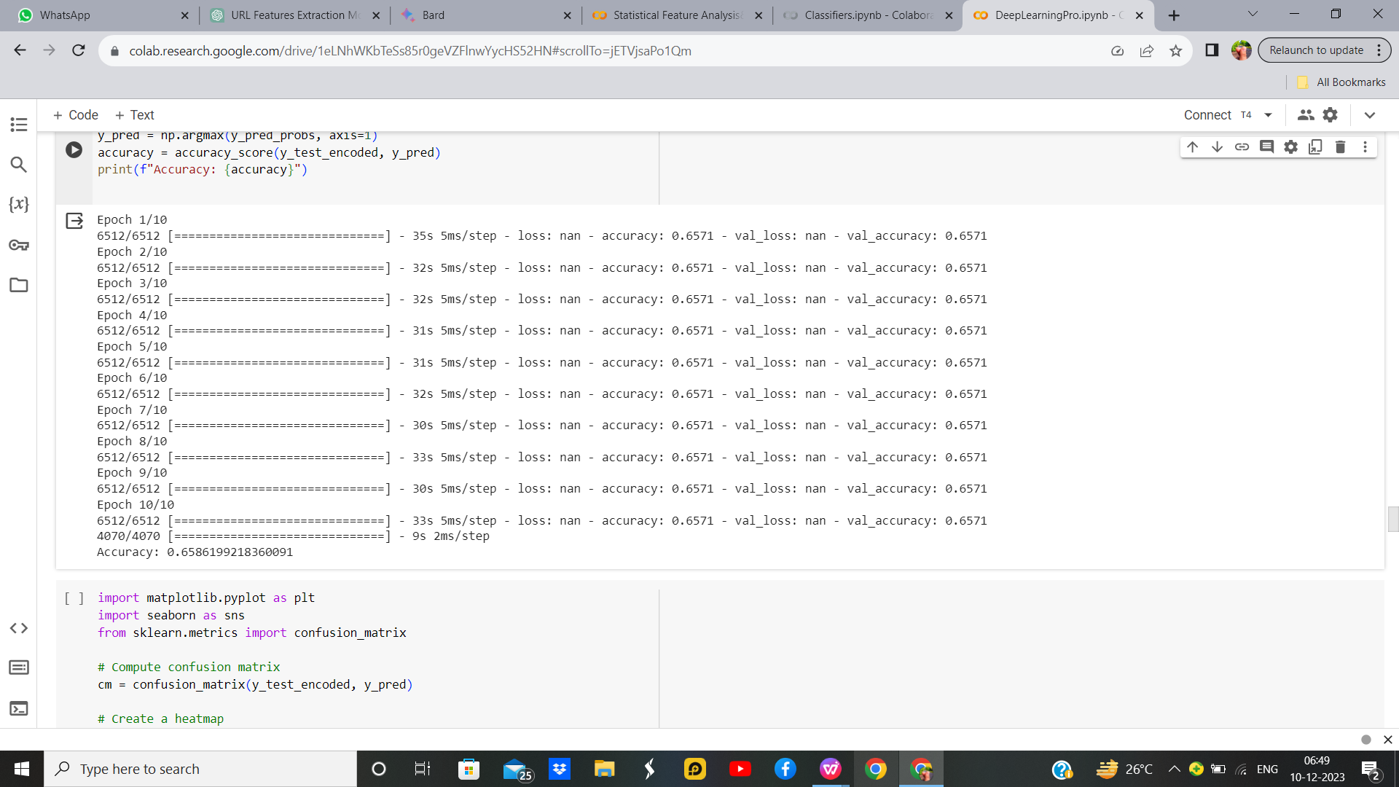

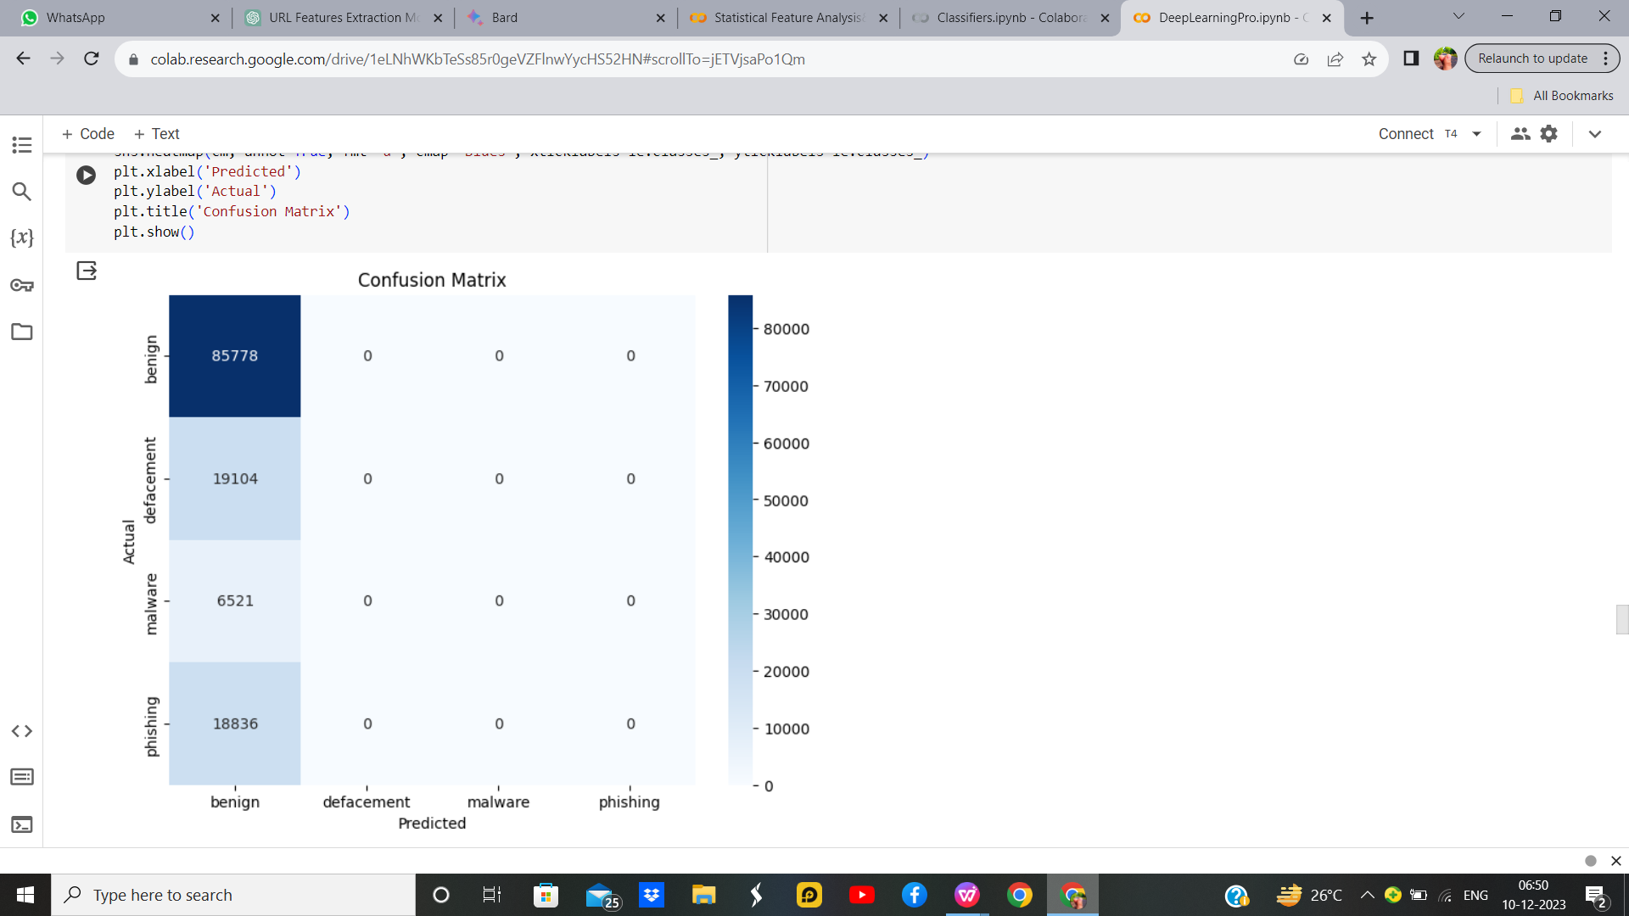

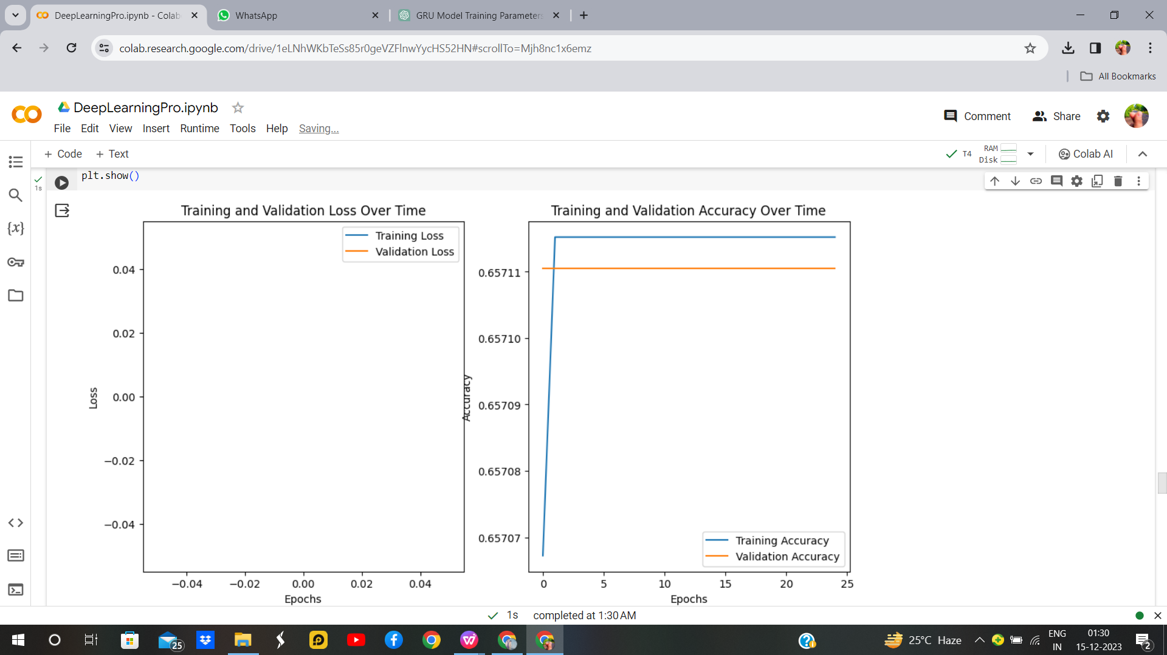

Figure 49:LSTM without Hyperparameter

**LSTM with Hyperparameter**

**Output:**

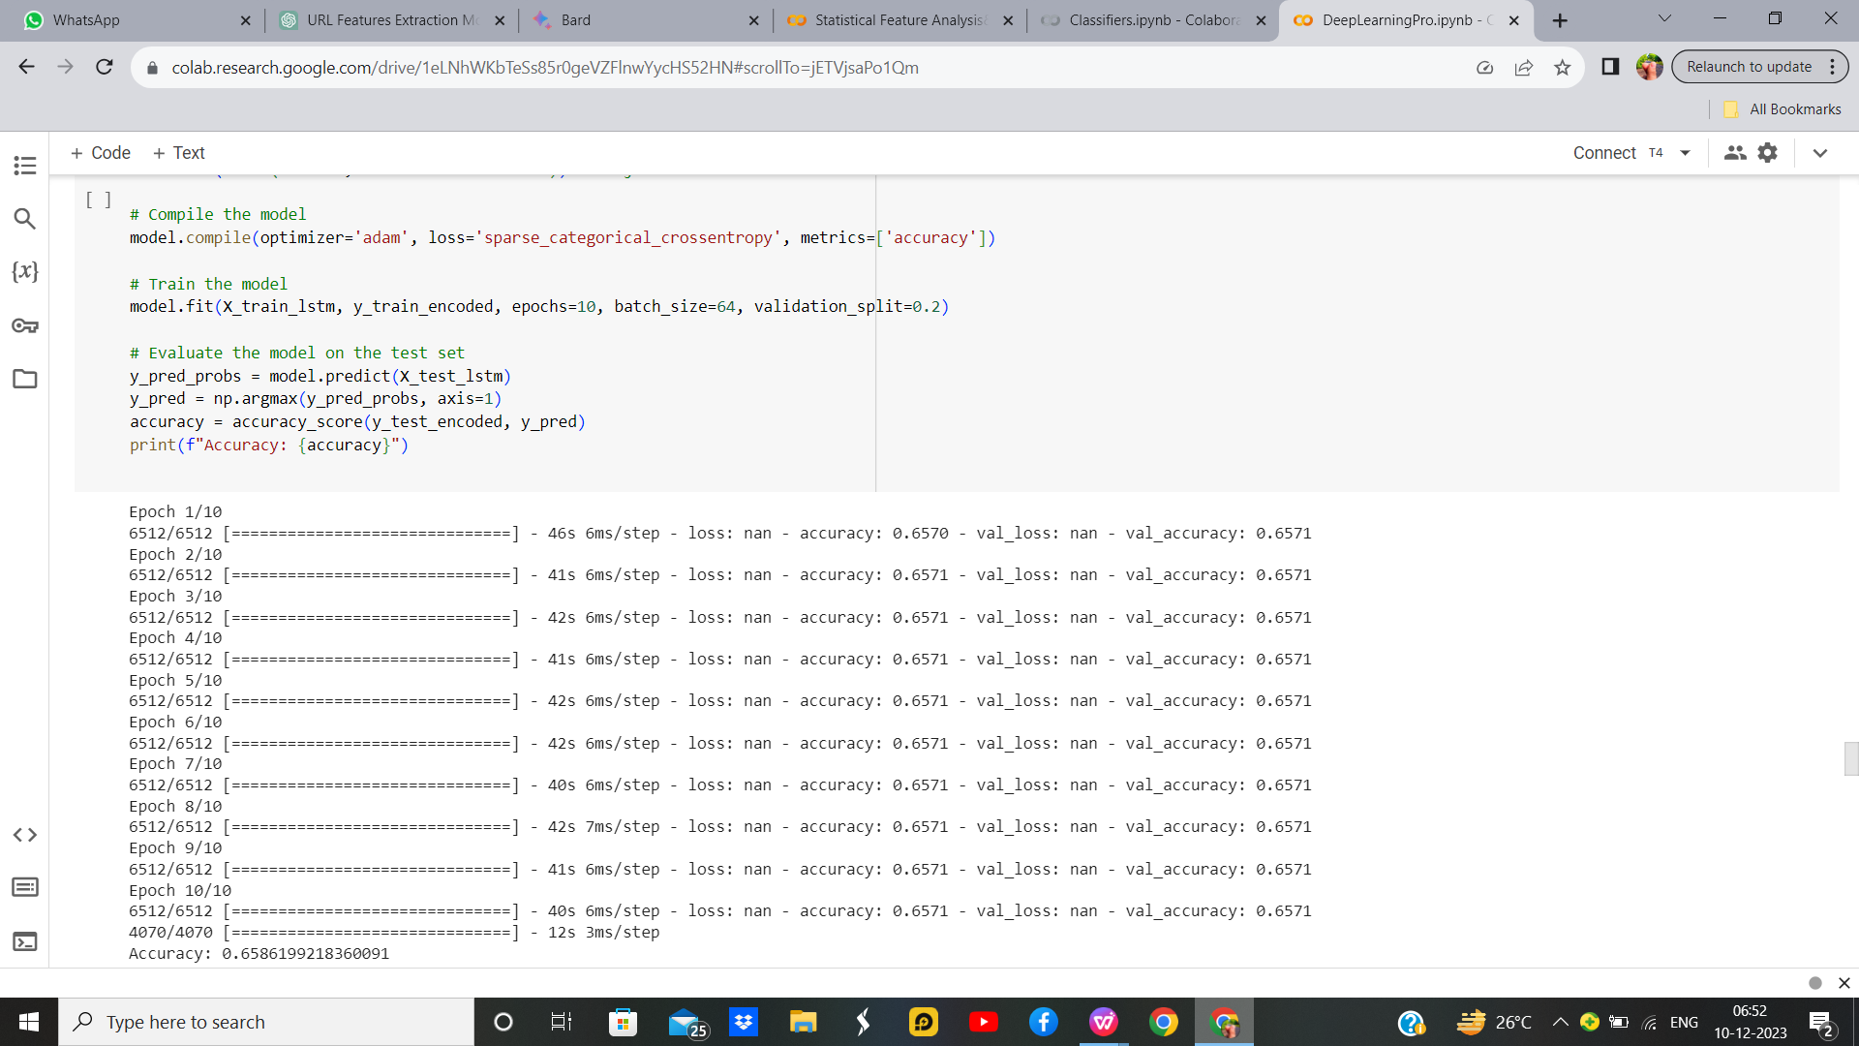

Figure 50:LSTM with Hyperparameter

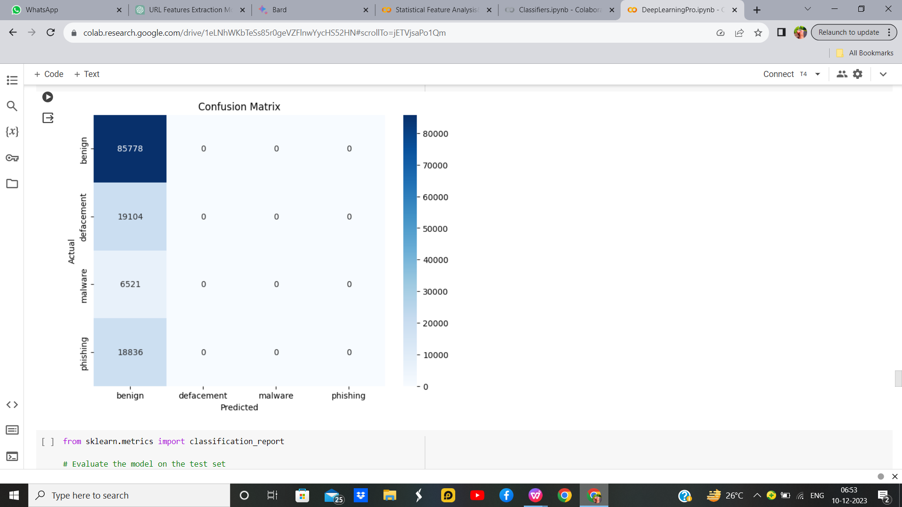



Figure 51:LSTM with Hyperparameter 2

**Inference**

LSTM model is designed for a multi-class classification task on phishing website detection. After preprocessing the data by standardizing and encoding, the LSTM architecture is defined with two LSTM layers, each followed by dropout for regularization. The final layer outputs probabilities for each class. The model is trained using the Adam optimizer and sparse categorical crossentropy loss. Inference is performed on the test set, and the accuracy is calculated. Adjust the number of LSTM units, dropout rates, and training epochs based on the dataset and task complexity for optimal performance.

Table 17. Parameter/Hyperparameter Table

|  |  |  |
| --- | --- | --- |
| **S. No** | **Parameters** | **Value** |
| **1** | Epochs | 10 |
| **2** | Accuracy | 65.86% |
| **3** | Training Loss | 65.71% |
| **4** | Validation Accuracy | nun |
| **5** | Validation Loss | num |
| **6** | Testing Accuracy | 65.71% |
| **7** | Batch Size | 64 |
| **8** | Loss | sparse_categorical_crossentropy |
| **9** | Optimizer | adam |
| **10** | Activation Function | Softmax |
| **11** | LSTM Unit | 50 |
| **12** | Learning rate | 0.001 |
| **13** | Test size | 0.2 |

* + 1. **GRU**

A Gated Recurrent Unit (GRU) is a type of recurrent neural network (RNN) architecture designed to address some of the limitations of traditional RNNs. It belongs to the family of gated recurrent networks and is particularly adept at capturing long-term dependencies in sequential data. GRUs employ gating mechanisms to selectively update and reset their internal states, allowing them to control the flow of information through the network. This gating mechanism enables GRUs to capture relevant information over longer sequences while mitigating the vanishing gradient problem that often hinders the training of traditional RNNs. The architecture of a GRU consists of a reset gate, an update gate, and a candidate hidden state, all of which work in tandem to regulate the flow of information and improve the model's ability to learn and remember patterns in sequential data. GRUs are widely used in various applications, including natural language processing, speech recognition, and time series analysis.

**GRU Without Hyperparameter**

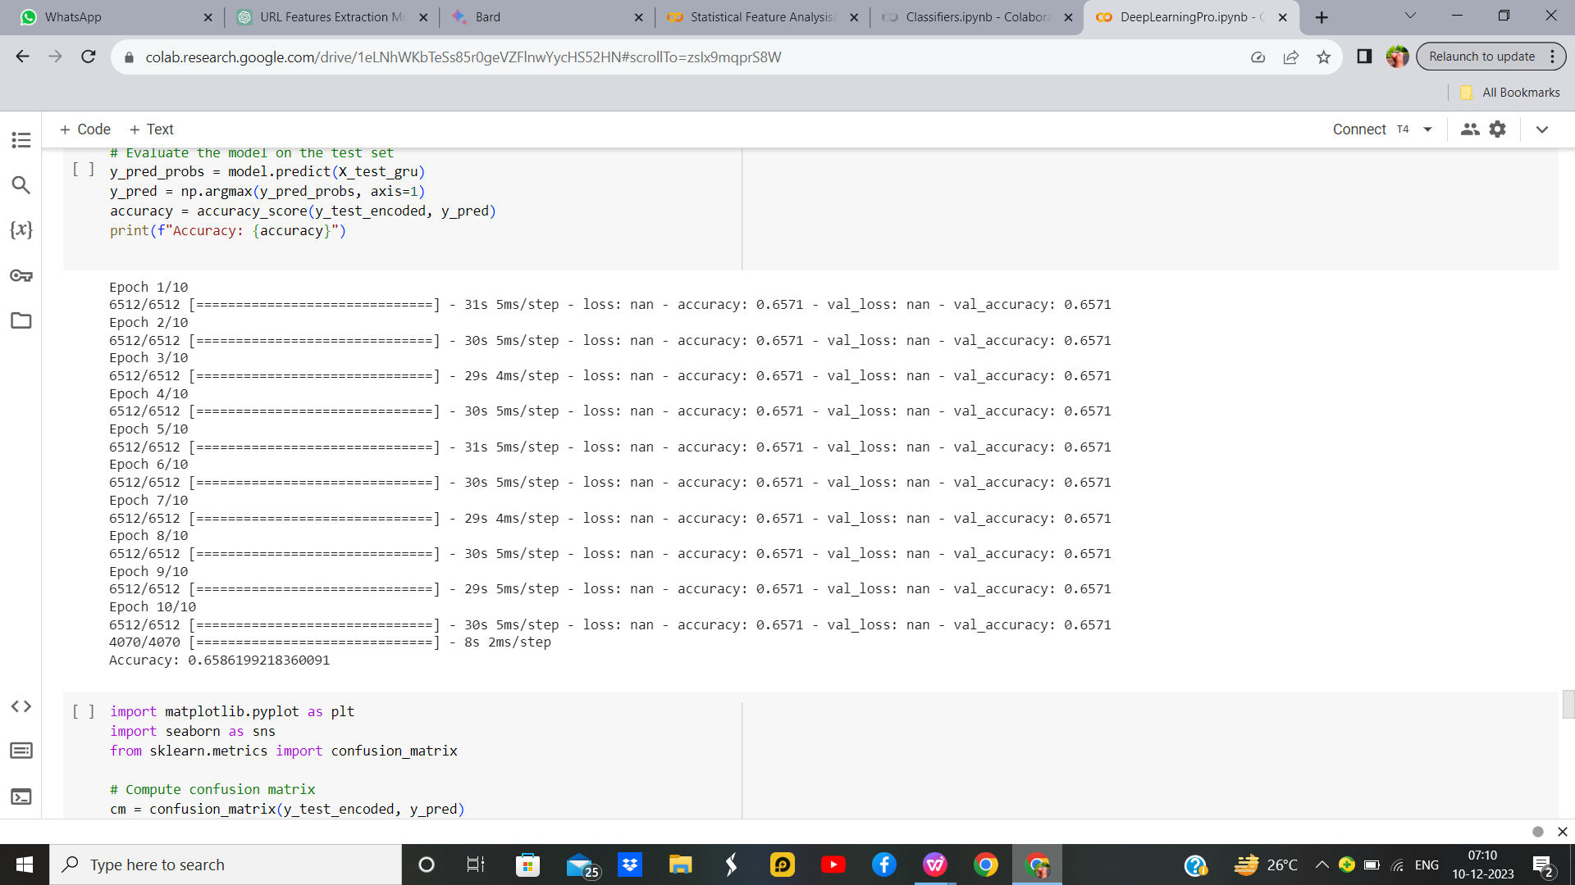**Output:**

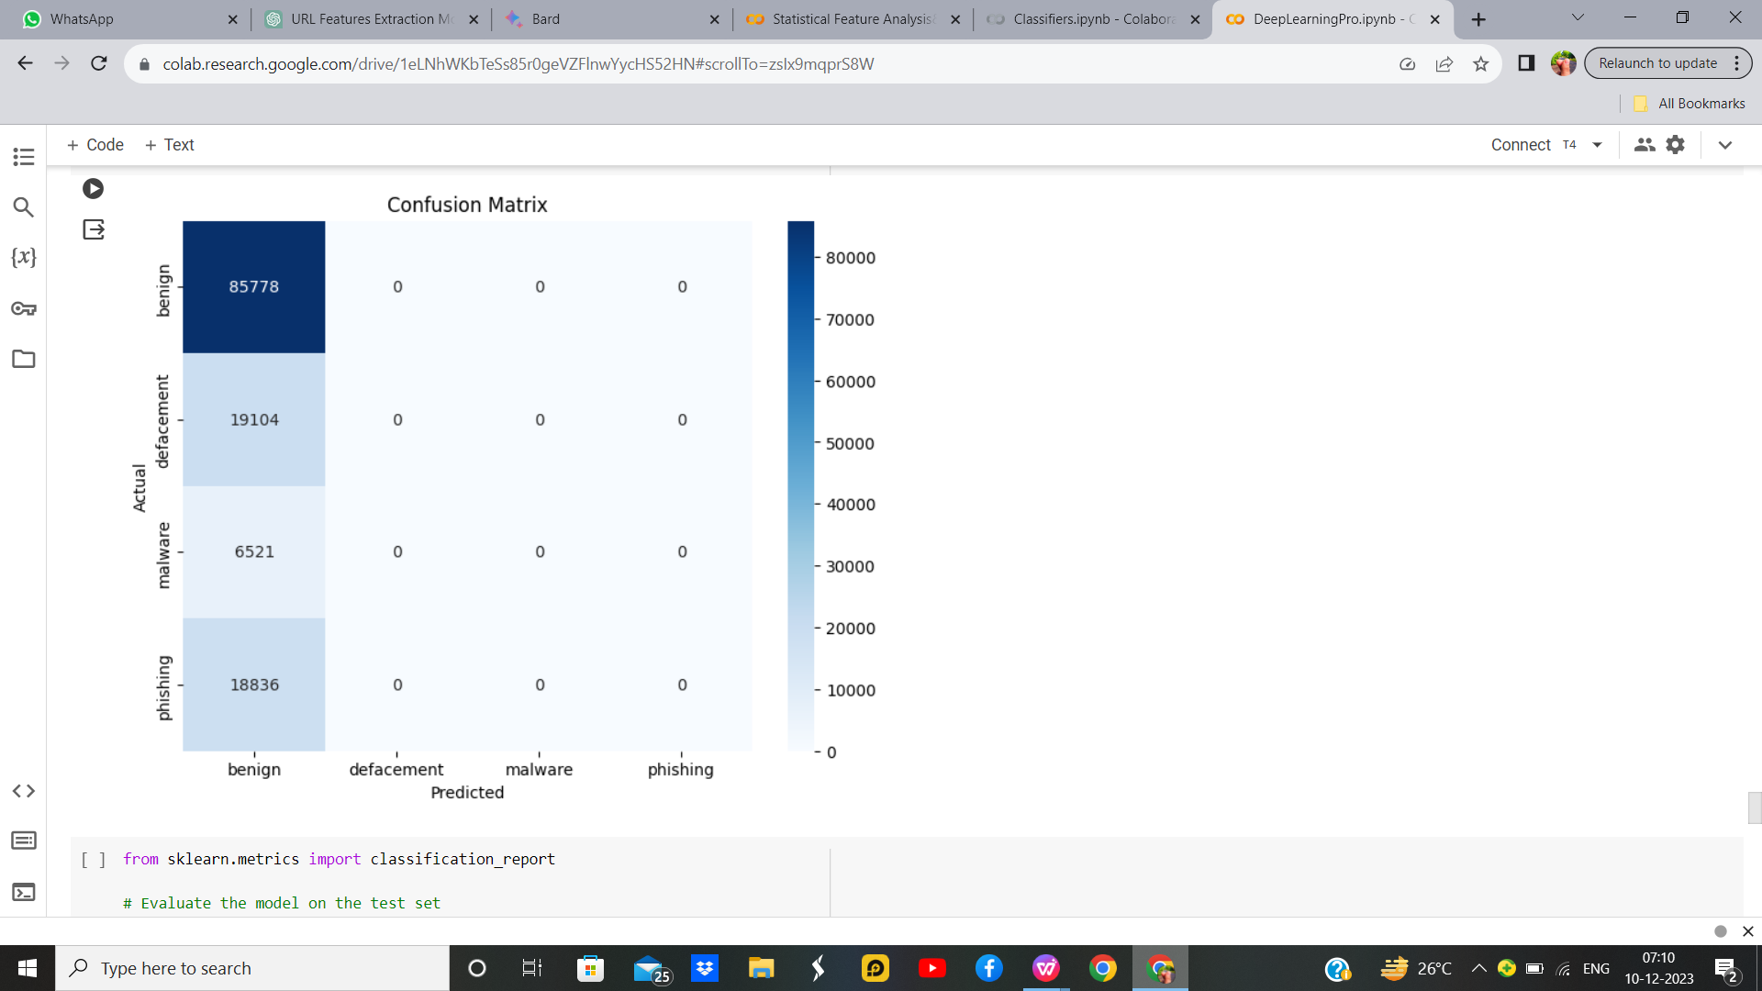

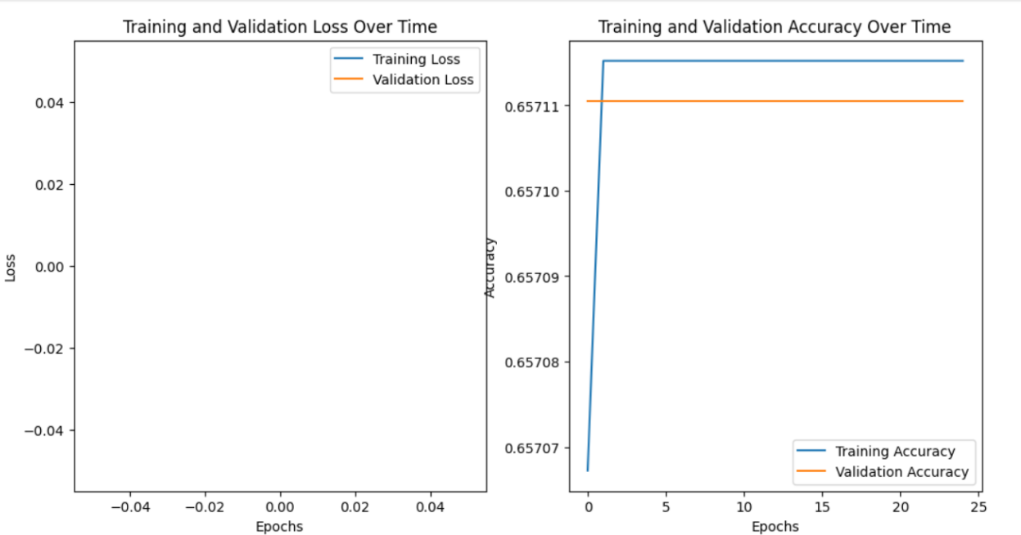

Figure 52:GRU without Hyperparameter

**GRU With Hyperparameter**

**Output:**

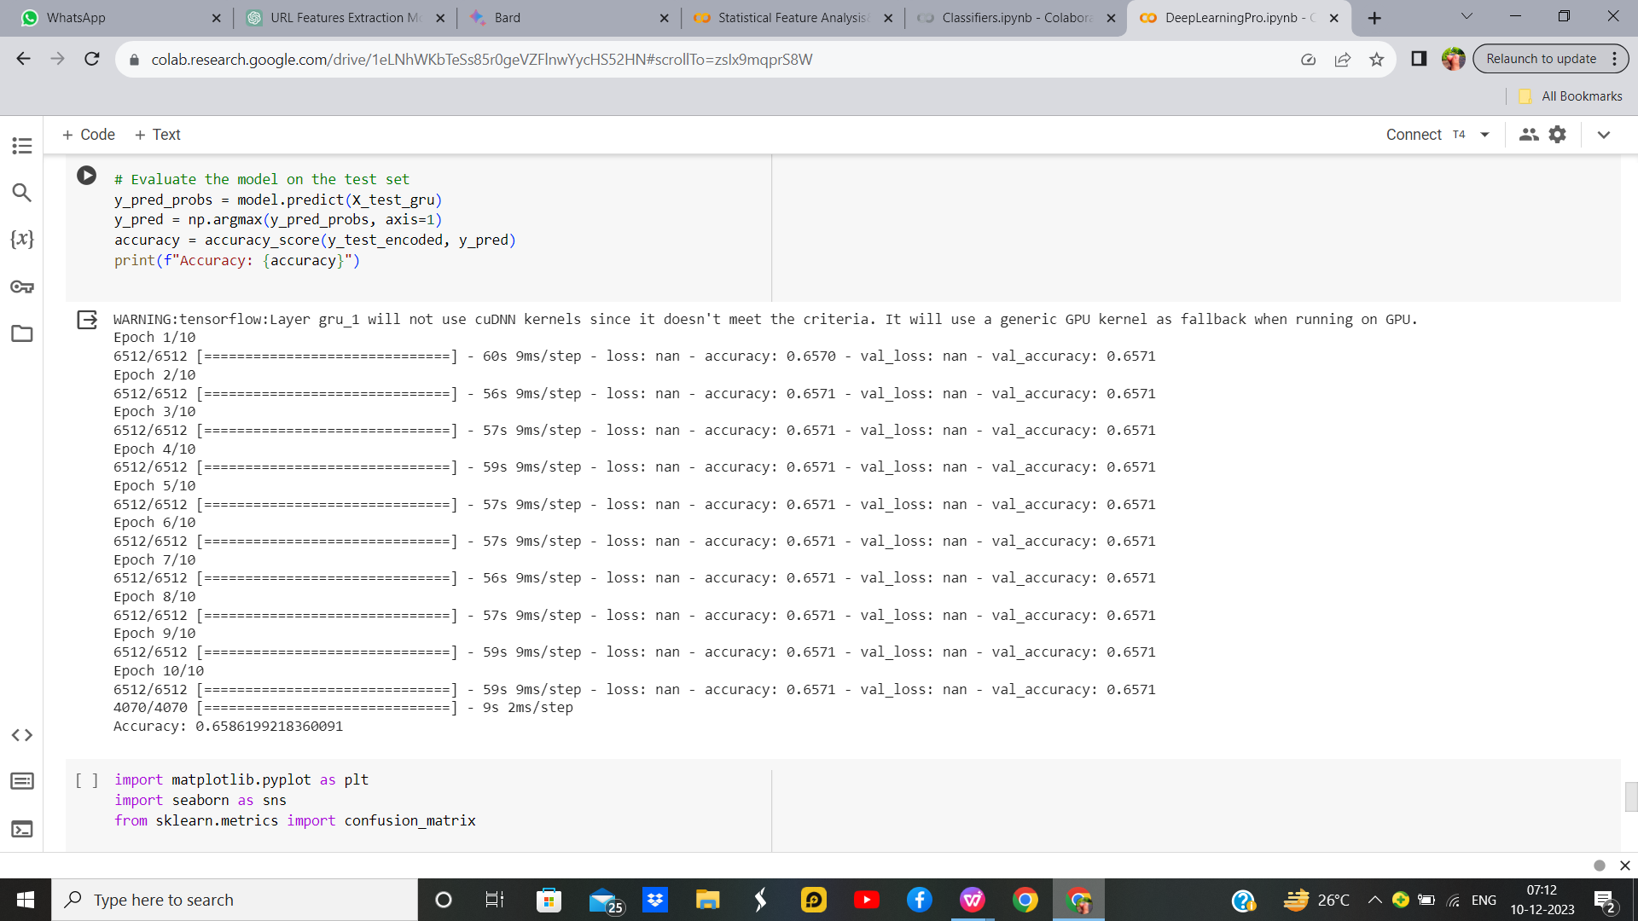

Figure 53:GRU with Hyperparameter 1

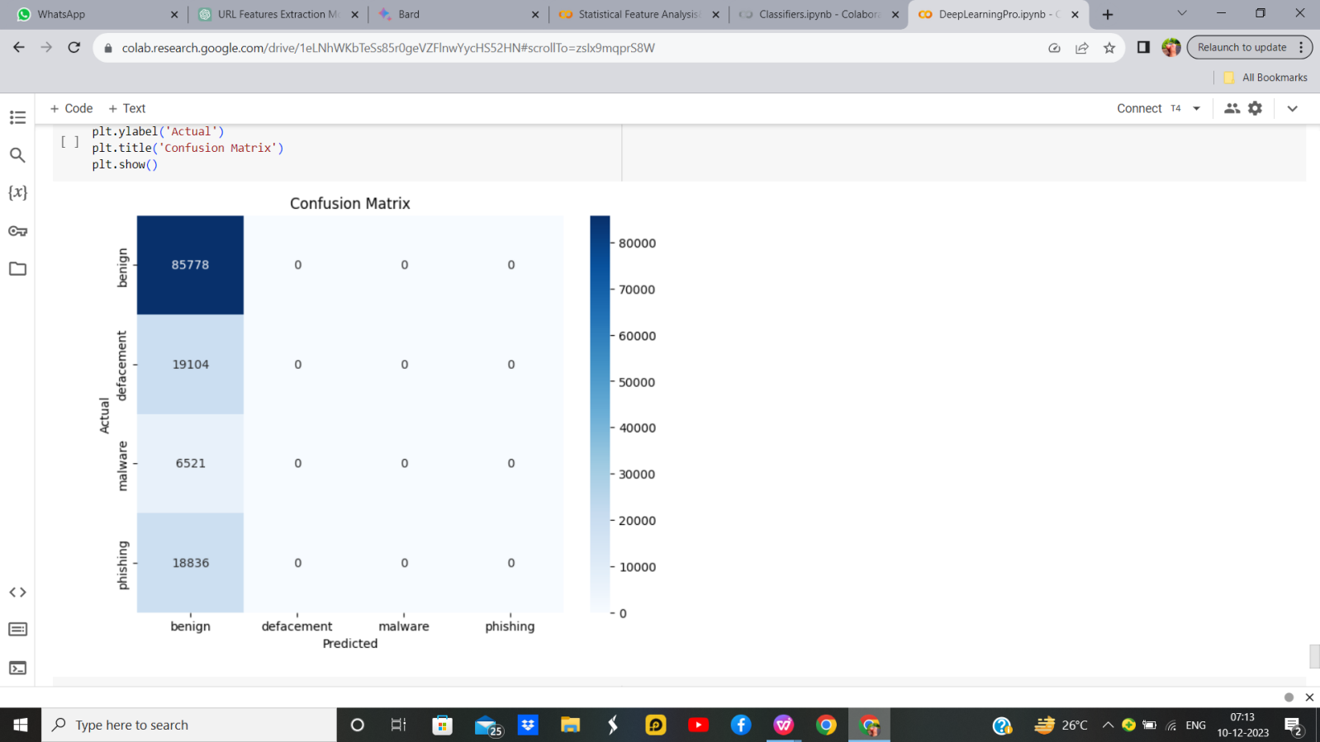



Figure 54:GRU with Hyperparameter

**Inference:**

Gated Recurrent Unit (GRU) neural network for classification tasks on sequential data. It preprocesses the data by standardizing and encoding the target variable. The GRU model is built with 50 units, using the tanh activation function and sigmoid for recurrent connections. The model is trained with Adam optimizer, a learning rate of 0.001, and dropout for regularization. After 10 epochs, it achieves accuracy on the test set. This architecture is suitable for tasks like sequence classification, where capturing temporal dependencies is crucial. Hyperparameters, such as the number of units and dropout rates, can be adjusted for Optimization.

Table 18. Parameter/Hyperparameter Table

|  |  |  |
| --- | --- | --- |
| **S.N0** | **Parameter Name** | **Value** |
| **1** | Units | 50 |
| **2** | Activation function | tanh |
| **3** | Recurrent dropout | 0.2 |
| **4** | Return sequences | false |
| **5** | Adam | None |
| **6** | Kernel initializer | glorot_uniform |
| **7** | Learning Rate | 0.001 |
| **8** | State initializer | orthogonal |
| **9** | Kernel regularizer | None |
| **10** | Bias regularizer | None |
| **11** | Activity regularizer | None |

**Comparison of Neural Network models:**

Table 19 : Comparison Table

|  |  |  |
| --- | --- | --- |
| **S.NO** | **Model** | **Accuracy** |
| **1** | K Means With CNN | 0.658 |
| **2** | RNN | 0.658 |
| **3** | LSTM | 0.657 |
| **4** | GRU | 0.658 |

**Conclusion:**  
The Malicious URL detection demonstrates superior performance across Regression and Classification models, excelling particularly well in the Random Forest Classifier, achieving an impressive accuracy rate of 96.6%. However, its efficacy diminishes when implemented in neural network models. The robustness and interpretability of the Random Forest Classifier contribute to its success in handling the complexity of the Malicious URL detection task, outperforming other models and establishing itself as the preferred choice for accurate and reliable predictions, attaining an unparalleled accuracy benchmark of 96.6%. This underscores the significance of model selection in optimizing outcomes for the specific challenges posed by Malicious URL detection.